GOUR MAHAVIDYALAYA, MANGALBARI, MALDA DEPARTMENT: SANSKRIT
CBCS: SEMESTER

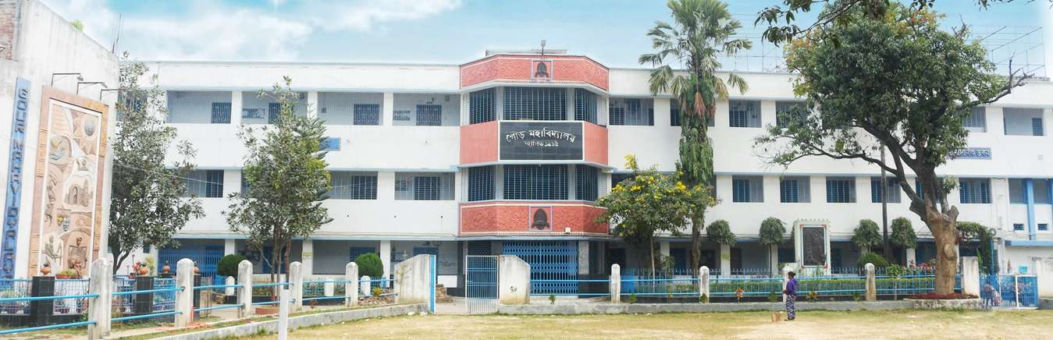

Teaching- Learning Process:
Student centric methods, such as experiential learning, participative learning and problem solving methodologies are used for enhancing learning experiences:
Answer: Yes, 19 Departments conduct various student centric activities throughout the year. The learning becomes more experiential, participatory and socialistic by organizing activities like Seminar/Workshop,Assignment,Student Seminar, Tour/ Field visit and preparation of Project report, Wall Magazine, Quiz,Debates,and writing articles. Different committees organize cultural programme , and extension/outreach activities. Our students actively participate in co-curricular activities.

- Seminar/Workshop:Gour Mahavidyalaya Alumni Association organized a National level seminar on “”. The basic objective is to bring together academicians and experts from different parts of the country and abroad to exchange knowledge and ideas. It provides an in-depth analysis of subjects and update the knowledge of the participants and students .Our Teachers and Students participated .

- PARTICIPATORY LEARNING:
(a)Assignment:
Students are asked to submit assignments to check their level of understanding on the subject.

(b) Students conduct seminar on a particular topic.Students prepare seminar paper under the guidance of Teachers,and read out that papers in presence of Teachers,and rest students. Students gain the following skills through the process of organizing seminar : Skills of Group Interaction ,Skills of integrative discussion, skills of critical evaluation ,skills of exploring and mining a Text.

(c) Tour/Field visit and submission of project report: Studentsare also taken to field/ industry visits, study tours in India. It exposes them to the world of practical knowledge .Preparation of project report creates interest in research work.

(d).Wall Magazine: Students organize exhibition,and show their creativity.

(e). Group discussion: Class room discussion on various topics are our regular features. It stimulates students interest and provides an opportunities to the student for freedom of thought and free exchange of different views.

(f) Quiz,Viva-Voice, :Quiz, Viva-voice,group discussion are held from time to time to keep the students in a competitive environment and to check the overall progress of the students.

(g). Writing articles: The college promotes creativity amongst students by encouraging them to publish articles in the college e- magazine and wall papers.

- Problem solving Methods :19 Departments provide students tasks that inculcate in them problem solving skills.

- Attendance:

