Department
Of English

E
Gour Mahavidyalaya
Established 1985
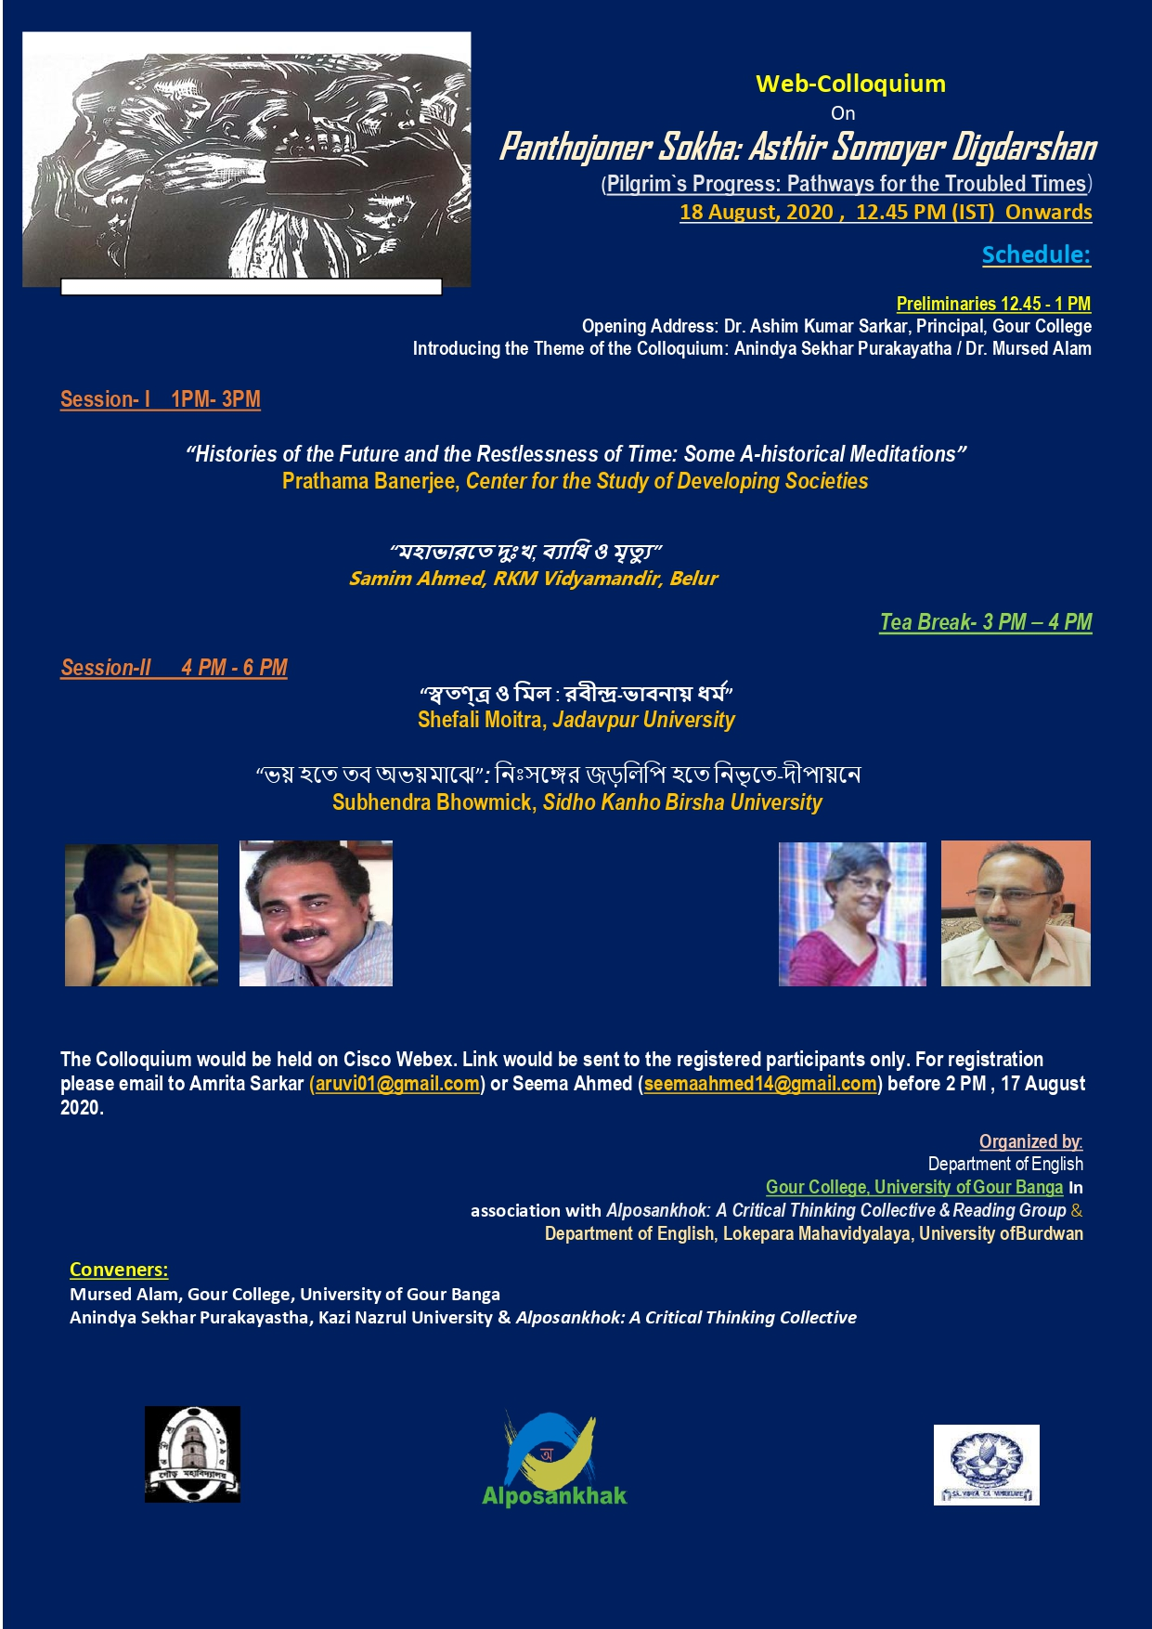
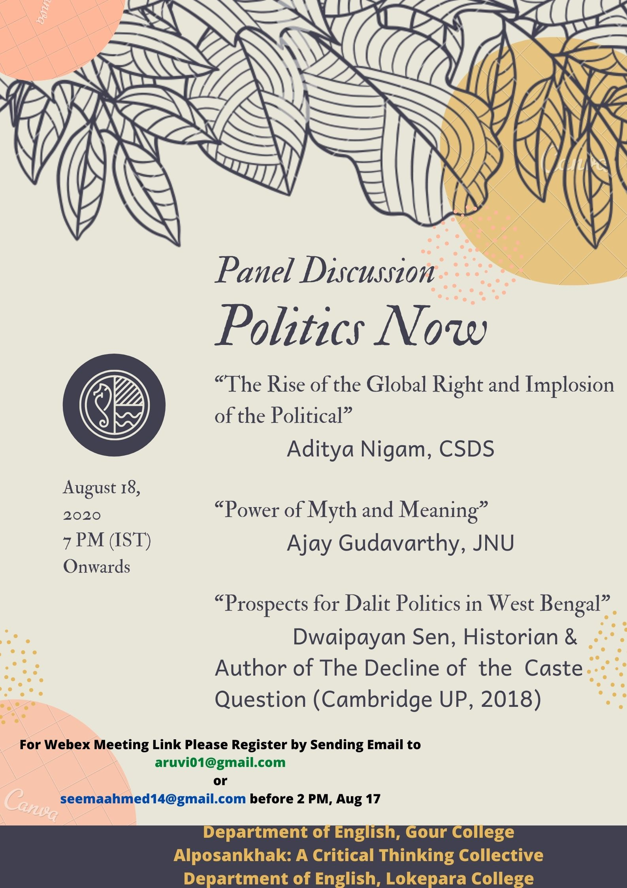
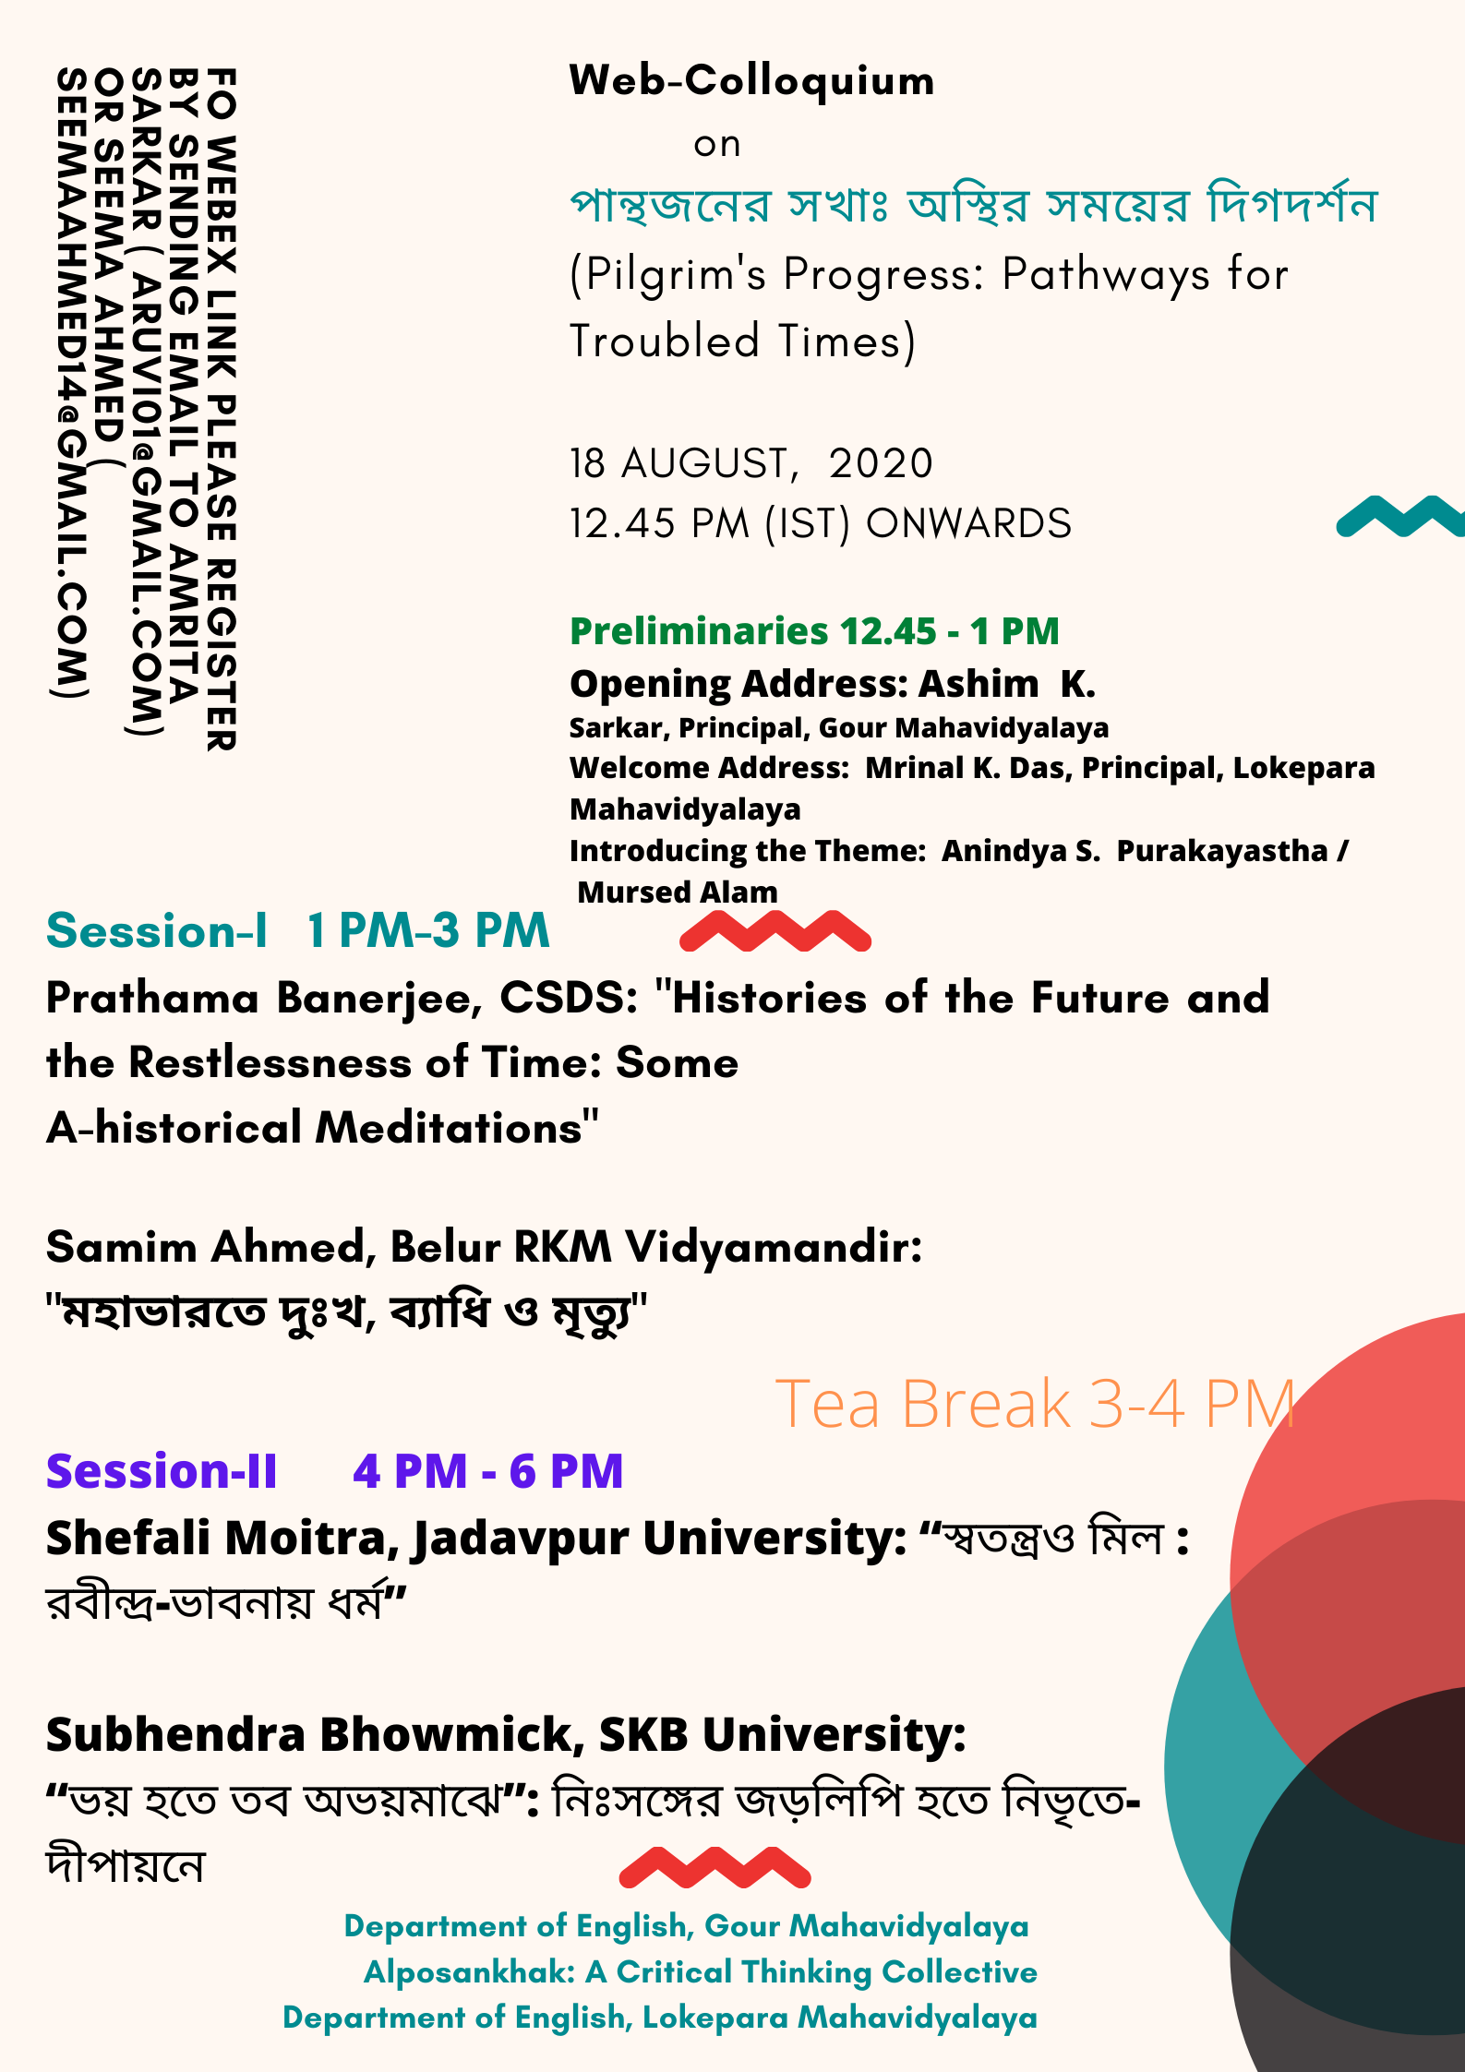
Web-Colloquium
On
Panthojoner Sokha: Asthir Somoyer Digdarshan
(Pilgrim’s Progress: Pathways for the Troubled Times)
&
Panel Discussion
on
Politics Now
organized by
Department of English, Gour Mahavidyalaya, Malda, West Bengal
In collaboration with
Alposankhak : A Critical Thinking Collective
&
The Department of English, Lokepara Mahavidyalaya
18 August, 2020 (12 Noon to 6 PM)
Concept Note/ Objective
The weird present, plagued with the constant phobia of imminent death has forced us into deeper philosophical and ontological uncertainties. We wake up each morning as if to play dice with Death. One may recall here the cinematographic image of Bergman`s The Seventh Seal in which the Knight endeavors to checkmate Death. The hauntology and scare of death tend to corrode all our epistemic foundational planks. Unmooring us, thus, from some of our strongly held political and cultural certainties and triumphalism of modernity, it has led to gloom, anxiety, ennui and terror – a Nietzschean version of nihilism. But is not dejection also an ontological precondition to creatively re-imagine our futures? Who are our sokhas/inmates who can embalm our current Bergmanian ‘cries and whispers’? Who can ferry us across this current crisis of disease, global socio-political disorder and death? What lessons can we derive from similar troubles in the past? How can our poets, philosophers, artists and critical thinkers help us rebuild our bare and fragile existence? Does the present crisis also promise a leap to a new political future beyond the torturous visions of the current myopia? Can we think beyond our normative frames of western modernity and capitalist plunder? Can a new culture of faith heal our wounds and re-enchant the world? This colloquium seeks to explore possible pathways in these troubled times.
Speakers & Topic
Prathama Banerjee, Professor, Center for the Study of Developing Societies (CSDS), New Delhi: Histories of the Future and the Restlessness of Time: Some A-historical Meditations
Samim Ahmed, Associate Professor, Belur Ramkrishna Mission Vidyamandir, Belur: Sorrow, Disease and Death in the Mahabharata
Shefali Moitra, Former Professor, Department of Philosophy, Jadavpur University. Difference and Harmony: Tagore’s Idea of Religion
Subhendra Bhowmick, Assistant Professor, Sidho Kanho Birsha University: From the Burrow of My Fear unto Thy House of Fearlessness: From a Loner’s Inert Statement to a World of Silence and Light

Panel Discussion on Politics Now

Panelists:
Aditya Nigam, Professor, Center for the Study of Developing Societies (CSDS): The Rise of Global Right and Implosion of the Political

Ajay Gudavarthy, Associate Professor, CPS, Jawaharlal Nehru University: Power of Myth and Meaning
Dwaipayan Sen, Historian ( formerly Amherst College, USA and Author of The Decline of the Caste Question: Jogendranath Mandal and the Defeat of Dalit Politics in Bengal, Cambridge University Press, 2018): Prospects for Dalit politics in West Bengal

Outcome of the Colloquium and Panel Discussion:
The objectives of the web-colloquium and panel discussion are successfully met and the participants benefitted from lively discussions on issues relating to the socio-cultural and political fallout of the ongoing pandemic. The outcome of the web-colloquium and panel discussion can be summarized thus:
- One primary objective of both the colloquium and the panel discussion was to take stock of the implications of the ‘crisis’ thrust upon us by the pandemic for socio-cultural, intellectual and political spheres. The esteemed speakers and panelists discussed the issues pertaining to the ‘crisis’ and presented their perspectives about the futures that are to emerge post-pandemic.
- Speakers delivered their talk from variety of perspectives- from historical to the literary to the sociological- on the ‘crisis’ that helped the participants, specially the students, very much to understand the present ‘troubled times’ in historical and cultural contexts.
- There were deliberations on the thoughts of ‘our’ thinkers- poets, social and political thinkers such as Tagore or the great poet of Mahabharata- in battling the present ‘crisis’ and their imagining a new future.
- The panel discussion on Politics Now stimulated discussions on the political implication of the present ‘crisis’, how the authoritarian regimes across the globe are using it to impose their hold and how it also exposes the present capitalist model of development generating hopes of a post-capitalist social order. The panel discussion was extremely helpful in thinking through the politics –both during and after the pandemic.

Conveners:
Dr. Mursed Alam, Assistant Professor & HoD, Department of English, Gour Mahavidyalaya
Prof Dr. Anindya Sekhar Purakayastha, Department of English, Kazi nazrul University
Organisers in- Charge

Amrita Sarkar, Assistant Professor, Department of English, Gour Mahavidyalaya
Seema Ahmed, Assistant Professor, Department of English, Lokepara Mahavidyalaya

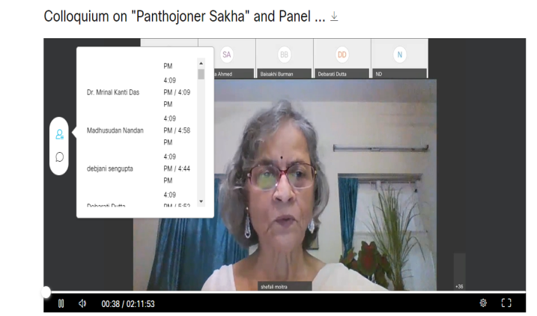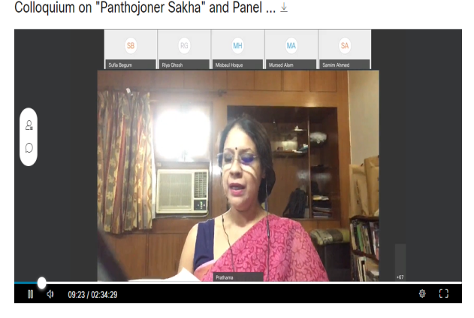

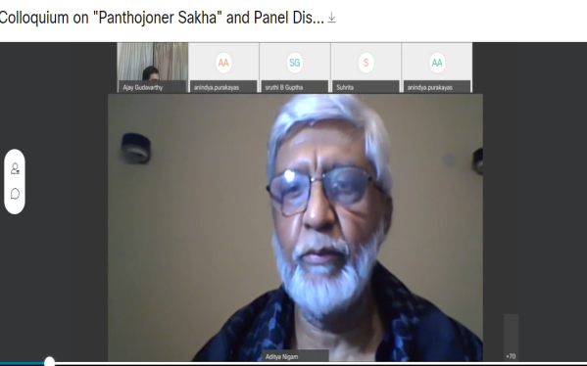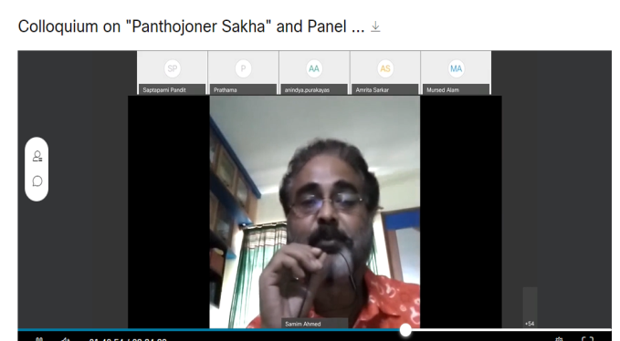
Department of English
Gour Mahavidyalaya
Established 1985

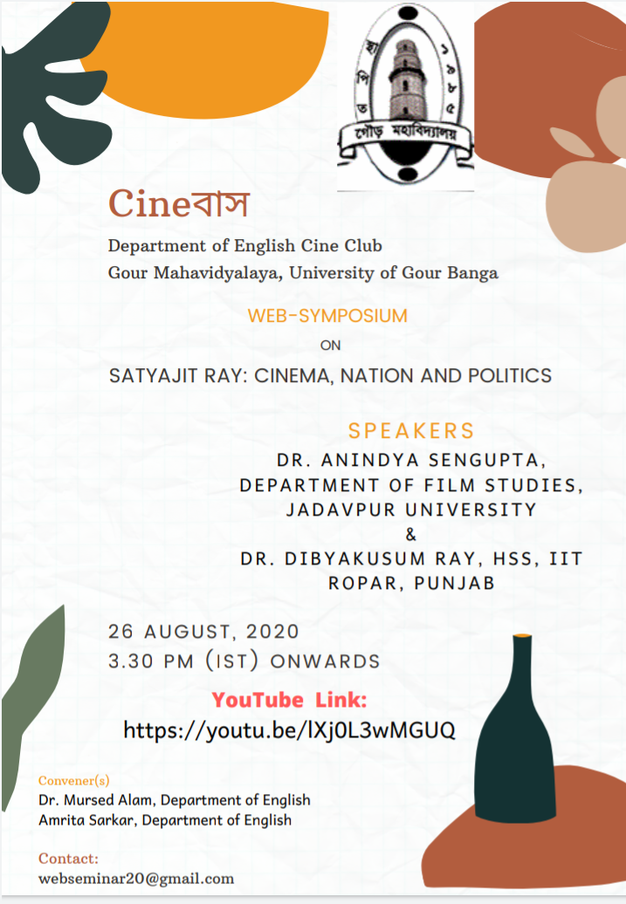

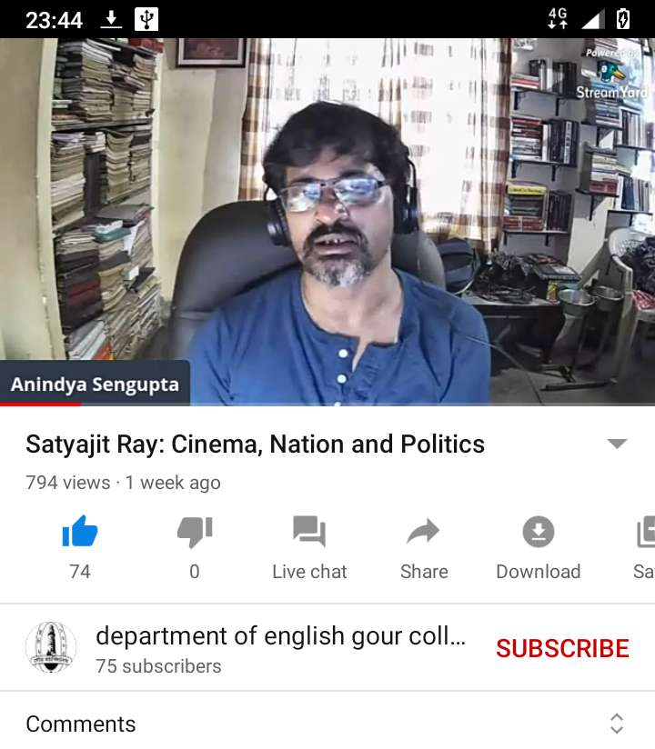
Web-symposium
on
Satyajit Ray: Cinema, Nation and Politics
organized by
Cinebus, the Cineclub of the Department of English, Gour Mahavidyalaya, Malda, West Bengal
28 August 2020 (1- 4.30 PM)

Objective
Satyajit Ray, the auteur, is one of the path-breaking figures of Indian cinema. This web-symposium is organized to commemorate his birth centenary. The objective of the symposium is to understand Satyajit Ray and his cinema in the wider context of world cinema as well as in relation to the changing dynamics of postcolonial India.

Speakers & Topics
Dr. Anindya Sengupta, Assistant Professor, Department of Film Studies, Jadavpur University: The End of an Era, the Arrival to a New Era: Reading the Apu Trilogy in 2020
Dr. Dibyakusum Ray, Assistant Professor, Department of Humanities and Social Sciences, IIT Roper, Punjab: Nation, Politics and Subject: Satyajit Ray’s Film’s and the Liminal Quest

Outcomes:
The objectives of the web-symposium are successfully met and the participants benefitted from lively discussions on issues relating to the films and film-making of Satyajit Ray vis-à-vis the Indian nation. The outcome of the web-colloquium and panel discussion can be summarized thus:
- The speakers discussed the cinema and film-making style of Satyajit Ray that helped the students better understand one of the significant film-makers of the twentieth century.
- There were discussions on the politics of Ray’s films and how he analysed the changing Bengali/ Indian society in the postcolonial India. For the students who study postcolonial literatures and cultural politics a discussion on similar issues through an analysis of the films of Ray was very helpful.

Convener of the Workshop
Mursed Alam, Assistant Professor & Head, Department of English, Gour Mahavidyalaya
Organising Secretary
Amrita Sarkar, Assistant Professor, Department of English, Gour Mahavidyalaya

Screenshots of the Events:
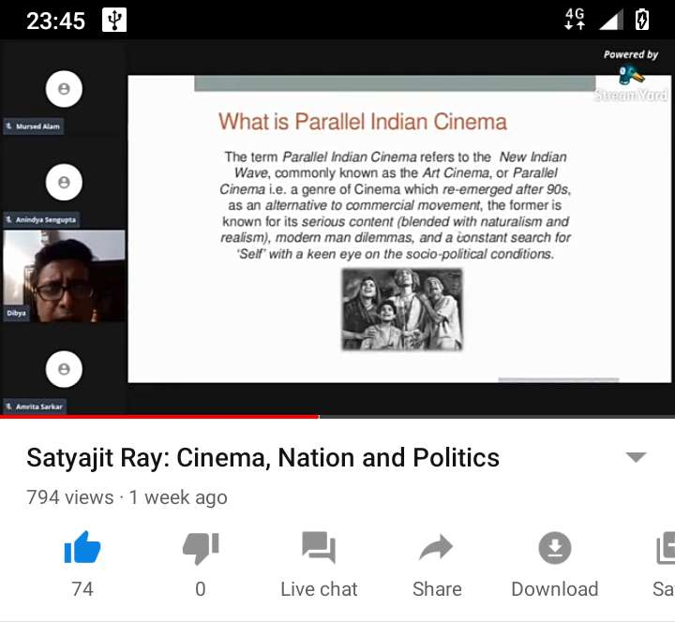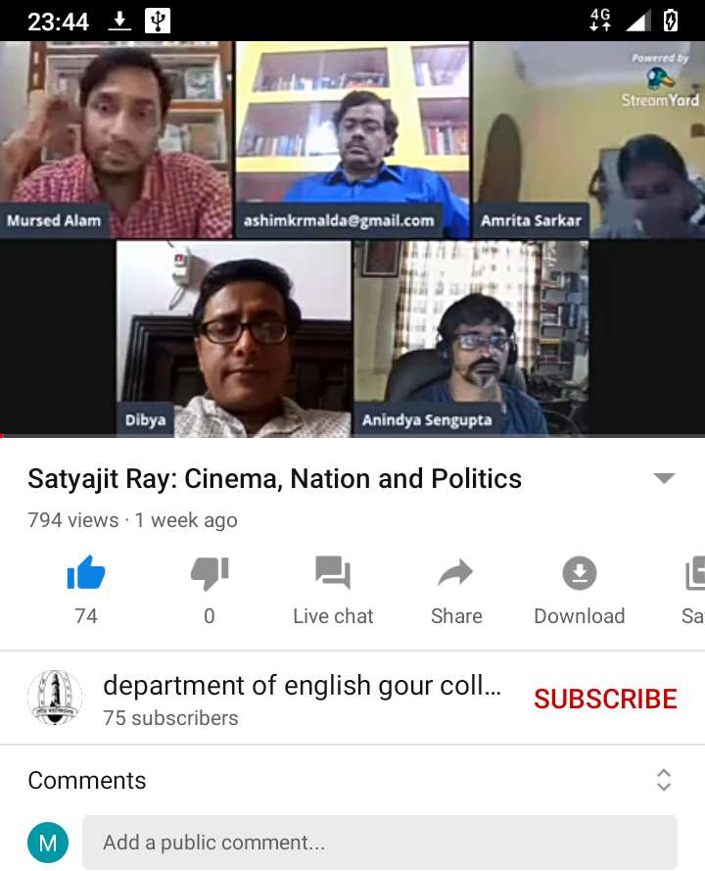

Department of English
Workshop
on
Gour Mahavidyalaya
Established 1985
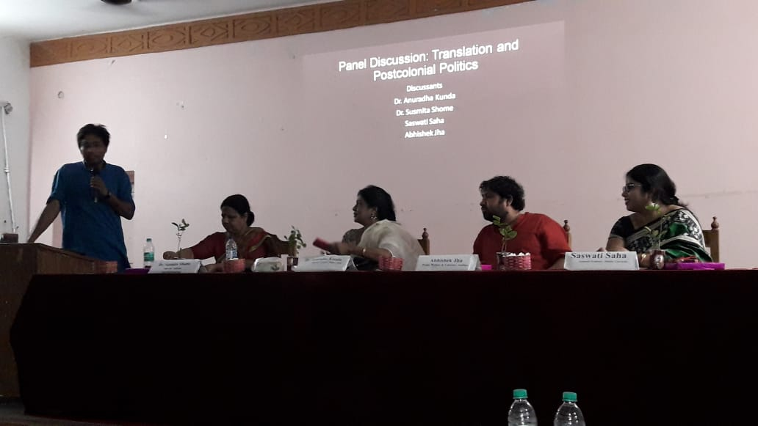

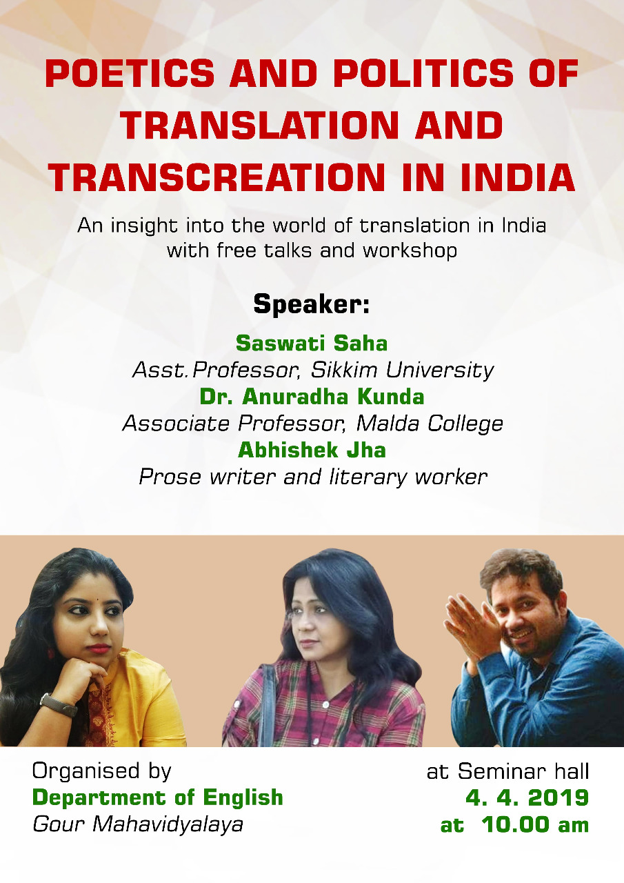
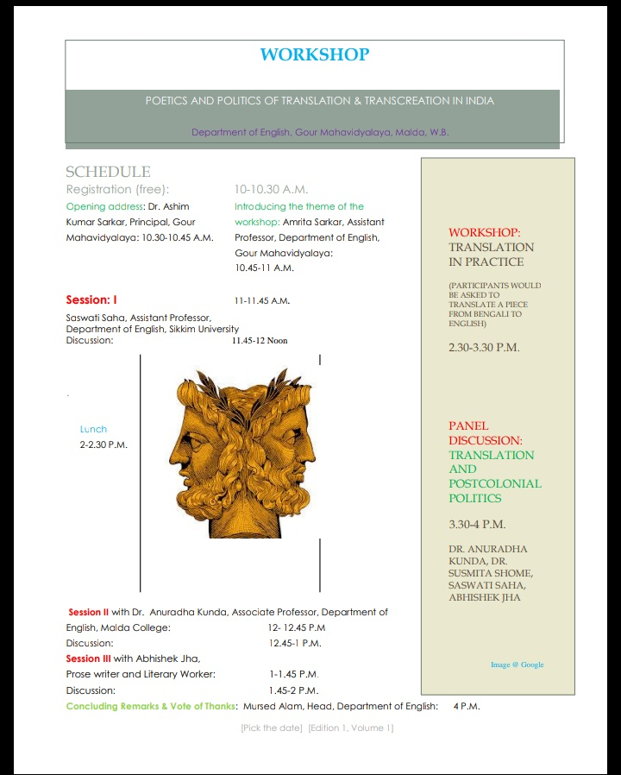
Poetics and Politics of Translation and Transcreation in India
Department of English, Gour Mahavidyalaya, Malda, West Bengal.
4 April, 2019 (10 AM to 4 PM)

Concept Note/ Objectives
Translation as a cultural practice is fraught with political overtones. The translation of a literary text often leads to its greater visibilisation and dissemination of its ideas and grounded politics. Translation may also lead to greater understanding between cultures and societies. This workshop seeks to discuss the poetics and politics of translation. This would be discussed theoretically and through a translation of a particular text the practical know-hows of translation would be discussed. To meet these objectives, the workshop would include lectures by scholars on different topics relating to the poetics and practice of translation. There would also be a Panel Discussion on Translation and Postcolonial Politics.

Speakers:
- Dr. Anuradha Kunda , Associate Professor, Malda College & Painter, Translator and Creative Writer
Translation in Practice: Workshop with Dr. Anuradha Kunda
- Saswati Saha, Assistant Professor , Department of English, Sikkim University
Theories of Translation: Poetics and Politics of Translation in India
- Abhishek Jha, Prose-writer and Literary Worker
Politics of Translation: Translating Mia Poetry and Stories from Kashmir

Panel Discussion: Translation and Postcolonial Politics
Panelists:
Dr. Susmita Shome, Associate Professor, Department of Bengali, Gour Mahavidyalaya
Dr. Anuradha Kunda , Associate Professor, Malda College & Painter, Translator and Creative Writer
Saswati Saha, Assistant Professor , Department of English Sikkim University
Abhishek Jha , Prose-writer and Literary Worker

Outcome of the Workshop
The objective of workshop is successfully met and the participants benefitted from lively discussions on issues relating to translation. The outcome of the workshop can be summarized thus:
- The invited speakers delivered lectures on the changing theoretical perspectives on translation. The students were enlightened by the debate on translation and/ transcreation.
- There was a session titled Translation in Practice in which Dr. Anuradha Kunda , herself a creative writer and translator asked the participants to translate a section of a particular text. The students came up with their own translation and there was a lively and engaged discussion on the issues one needs to be aware of when translations a particular text. The session was particularly helpful for the students and learnt the nitty-gritty of translation.
- There was a panel discussion on translation and postcolonial politics which led to engaged discussion between the panelists and the participants. The faculty members, too, participated in the discussion.
- The urgency of translating text from other cultural locations into local languages as well as translating local language-text to English or other Indian languages such as Hindi was felt for a better understanding between different cultures. The students were encouraged to take up translation as a course in their future academic endeavor.

Convener of the Workshop
Mursed Alam, Assistant Professor & Head, Department of English, Gour Mahavidyalaya
Organising Secretary
Amrita Sarkar, Assistant Professor, Department of English, Gour Mahavidyalaya.

Snaps of the Workshop
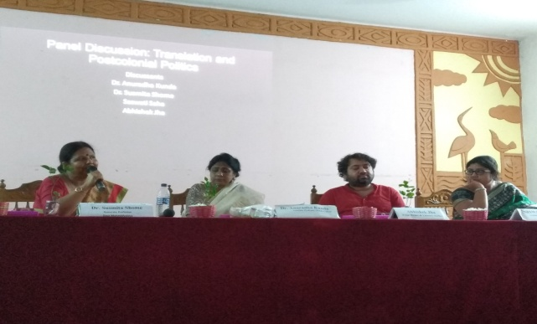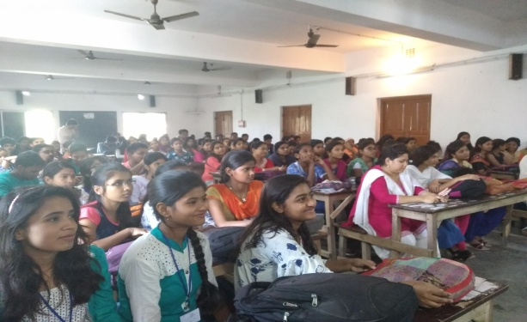

Workshop
Department of English
on
British Poetry: Text and Context
Gour Mahavidyalaya
Established 1985

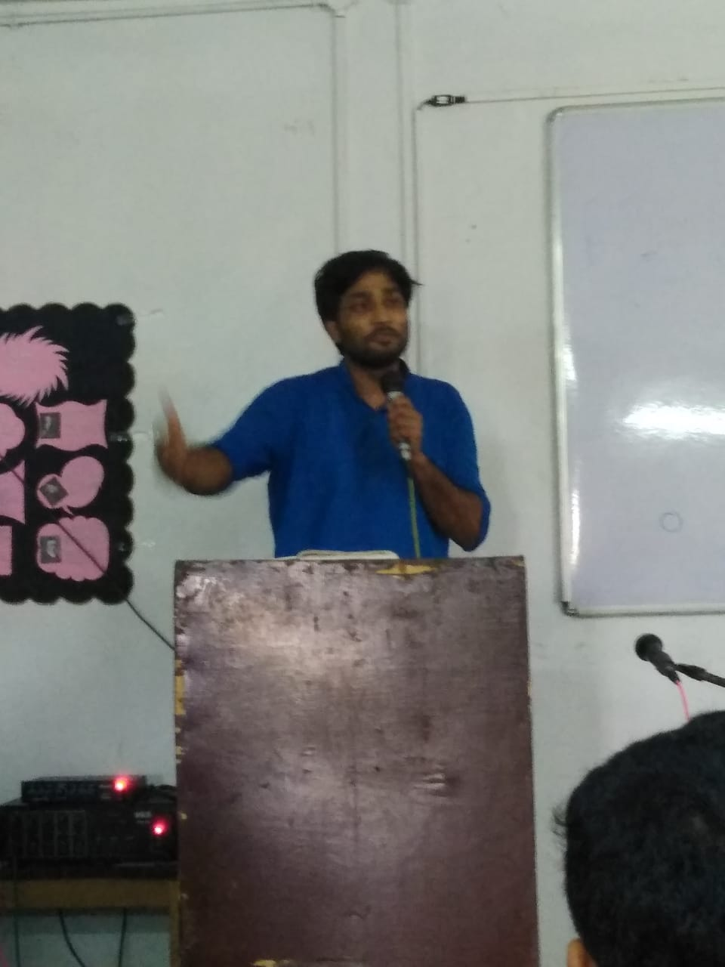

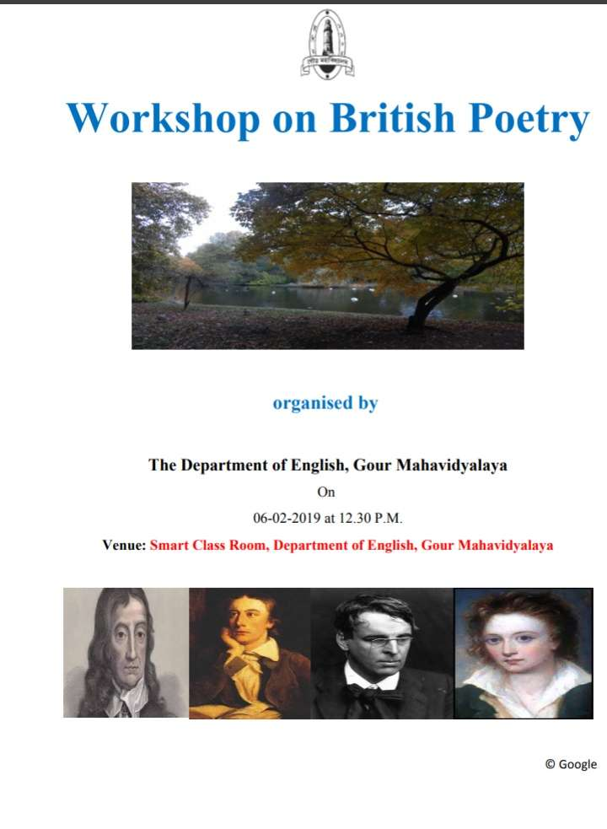
Department of English, Gour Mahavidyalaya, Malda, West Bengal.
2 February, 2019 (1 AM to 4 PM)

Objectives
The primary objective of this workshop was to engage the students of the department in critically analyzing British poetry. We left the time-span for unspecified and invited the students to come-up with their own analysis of particular poets/ poems. We also wanted the students to learn the art of presentation before their friends and teachers and tackle the questions asked by the participants on their reading of the poets and poems.

Speakers & topics:
As it was a student- centric workshop where students learn how to critically analyse a poem and present their reading before others, the presenters/ speakers were mainly the students of the departments. The teachers, too, presented to initiate the discussion.
Teachers:
- Mursed Alam, Assistant Professor & HoD, Department of English, Gour Mahavidyalaya : Reading the Romantics in the Anthropocene
- Amrita Sarkar, Assistant Professor, Department of English, Gour Mahavidyalaya : Intercultural Exchange and Poetry: The Influence of French poetry on Modern British Poets
- Koushik Goswami, Guest Faculty, Department of English, Gour Mahavidyalaya: Reading Modern British Poetry: Text and Context
Students:
- Ripon Sk
- Chhotan Mandal
- Mamoni Roy
- Sayanta Dey Sarkar
- Sudipta Mandal

Outcome of the Workshop
The objective of workshop is successfully met and the participants benefitted from discussions on issues relating to British poetry. The outcome of the workshop can be summarized thus:
- The teachers delivered lectures on the changing nature of British poetry from the Neo-classical period to the modern period. The students who are reading British poetry as part of the syllabus could relate to and took part in discussions after the talks.
- There was a session on the intercultural exchange of poetic ideas and forms and the impact of French poetry on modern British poets such as Eliot and Yeats and their influencein turn on modern Bengali poets such as Buddhadeb Basu, Bishnu Dey, Jibanananda was discussed. The students benefitted from such discussions.
- There was a discussion on reading British poets such as the romantics in the present context of anthropocene, climate change etc. The students were encouraged to contextualize and comtemporanise their reading of poets belonging to different ages.
- One important aspect of the workshop was to encourage the students to present their own reading of poems. As some of the students came up with their own reading of poets both from and outside the syllabus, the workshop achieved its stated purpose.

Convener of the Workshop
Mursed Alam, Assistant Professor & Head, Department of English, Gour Mahavidyalaya
Organising Secretary
Amrita Sarkar, Assistant Professor, Department of English, Gour Mahavidyalaya.

Snaps of the Workshop

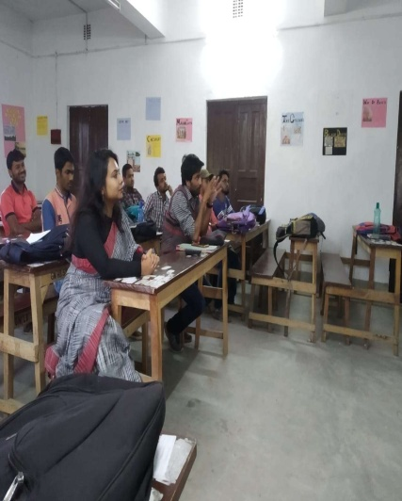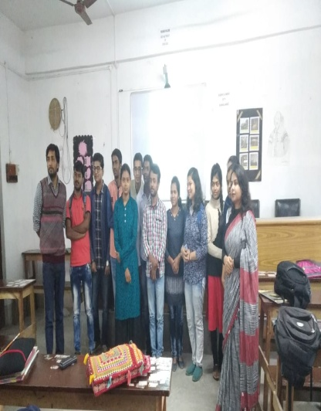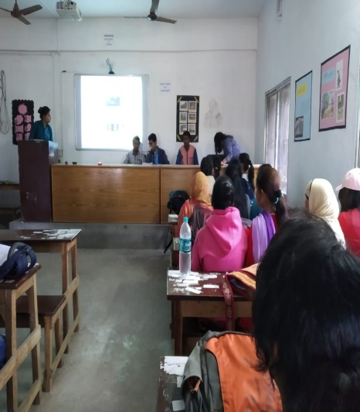

Workshop
Department of English
on
English Language Teaching with Special Focus on Phonetics
Organized by
Gour Mahavidyalaya
Established 1985

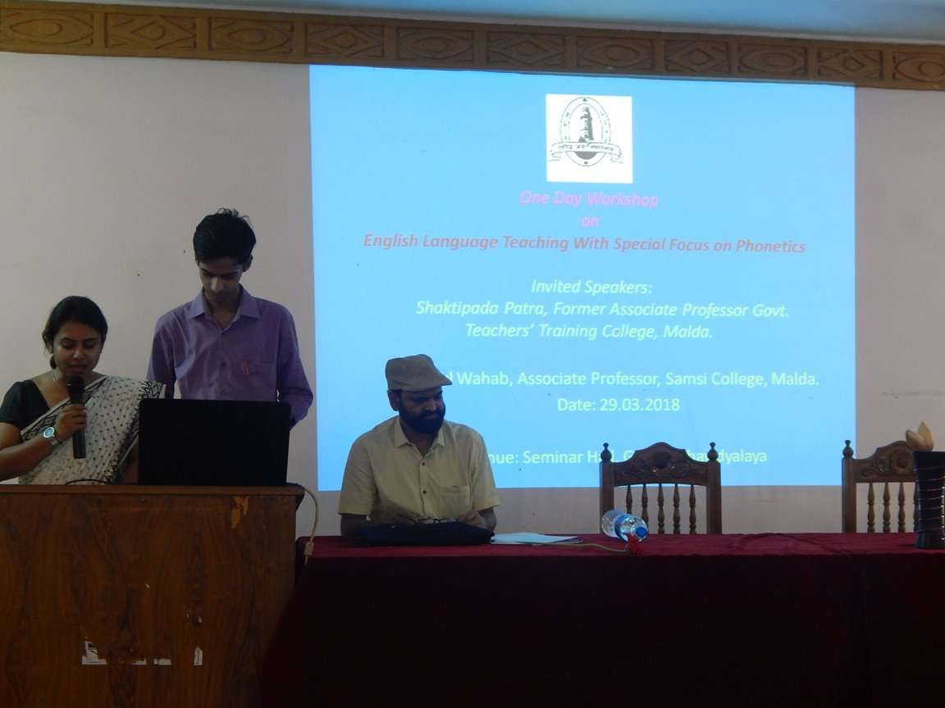
Department of English, Gour Mahavidyalaya, Malda, West Bengal.
29 March, 2018 (10 AM to 4 PM)
Objective:
The Primary objective of the workshop is to acquaint the students with the various facets of the English language- its genesis, evolution and its present dynamics and changing features. This would be done with a focus on those aspects of the English language that are on the syllabus. The aim is to give the students the expert views on those issues.
Speakers:
- Saktipada Patra, former Associate Professor, Govt Teachers’ Training College, Malda, West Bengal.
- Abdul Wahab, Associate Professor, Samsi College, Malda, West Bengal.
Outcome:
- The stated objectives of the workshop are fulfilled as the students got the opportunity to hear two experts with training in international and national institutes like University of London and EFLU. The students learnt the changing features of the language they are reading literature in.
- This workshop also helped the students to understand issues of phonetics and daily usage relating to English language that would help them better speak the language with proper accent and pronunciation.
Snaps of the Workshop
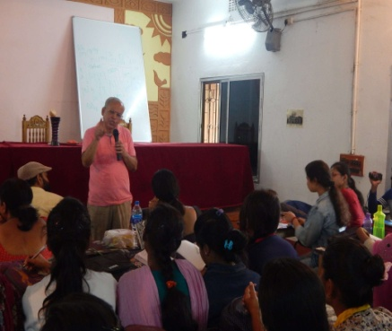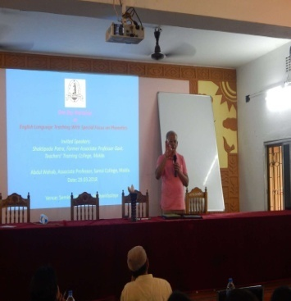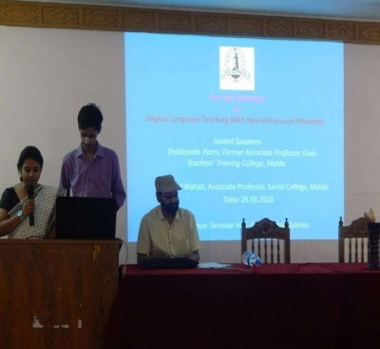
Department of English
Seminar Talk
On
Indian Poetry in English: Nation, Culture and Language

Organized by
Gour Mahavidyalaya
Established 1985

Department of English, Gour Mahavidyalaya, Malda, West Bengal.
13 February, 2019 (10. 30 AM to 4 PM)
Gour Mahavidyalaya
Established 1985

Objective:
This seminar on Indian Poetry in English is organized to map the terrain of Indian English Poetry. The basic objective is to acquaint the students with the landscape Indian English poetry and the major thematic preoccupations of the Indian English poets.

Speaker
Prof Himadri Lahiri, former Professor, Department of English and Cultural Studies, Burdwan University and the currently associated with Netaji Open University, Kolkata Campus.

Outcome:
The stated objective of the seminar is fulfilled as the speaker exhaustively discussed the various thematic preoccupations of the major Indian English poets. The students hugely benefitted from Prof Lahiri’s engaging and lively presentation and discussion.
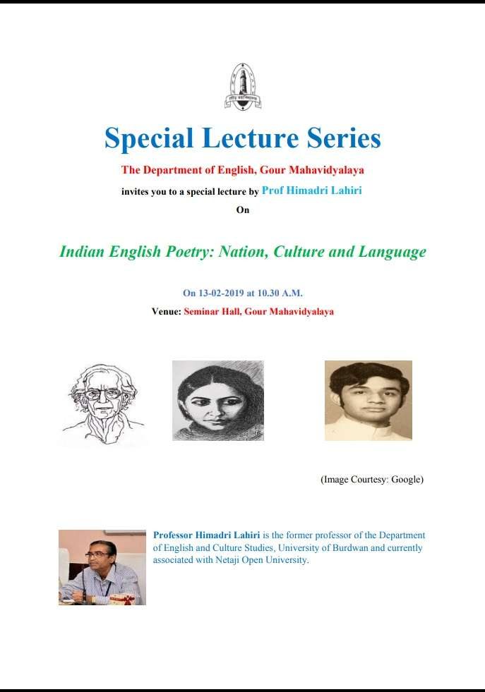

Student webinar
Department of English
on
Victorian Era: Society, Culture & Literature
Organized by
Department of English, Gour Mahavidyalaya, Malda, West Bengal.
Gour Mahavidyalaya
Established 1985

12 September, 2020 (12 Noon to 3 PM)
Objectives
The primary objective of this workshop was to engage the students of the Department of English in critically analyzing the Victorian Era, a significant period in British history and culture. The idea was to engage the student to learn and present their views on the political, social, cultural and intellectual aspects of the Victorian period. An additional objective was to engage the student in some academic activity during the ongoing pandemic that has left them confined to their homes.

Speakers & topics:
As it was a student- centric webinar where students learn how to critically analyse a particular literary period, the presenters/ speakers were mainly the students of the departments. The teachers, too, presented to initiate the discussion.
Teachers:
- Mursed Alam, Assistant Professor & HoD, Department of English, Gour Mahavidyalaya : Victorian literature: Text and Context
- Amrita Sarkar, Assistant Professor, Department of English, Gour Mahavidyalaya : Reading Victorian Women Novelists in the Contemporary Times
Students:
- Sobuj Sarkar: Critiquing Utilitarianism: Reading Dickens’ Hard Times.
- Sufia Begum: Reading Emily Bronte Today
- Suman Mandal: The Conflict between Science and Faith in the Victorian Period
- Ayesha Siddiqua: The New Woman in the Victorian Period

Outcome of the Workshop
The objective of webinar is successfully met and the participants benefitted from discussions on issues relating to Victorian society and culture. The outcome of the workshop can be summarized thus:
- The teachers delivered lectures on the intellectual and cultural milieu that shaped Victorian literature. The students who are reading British poetry as part of the syllabus could relate to and took part in discussions after the talks.

- One important aspect of the workshop was to encourage the students to present their own reading on the Victorian Era. As some of the students came up with their own reading of poets and novelists- both from and outside the syllabus, the webinar achieved its stated purpose.

Conveners of the webinar
Sobuj Sarkar
Sufia Begum
Mentors:
Dr. Mursed Alam, assistant Professor & HoD, Department of English, Gour Mahavidyalaya
Amrita Sarkar, Assistant Professor, Department of English, Gour Mahavidyalaya.

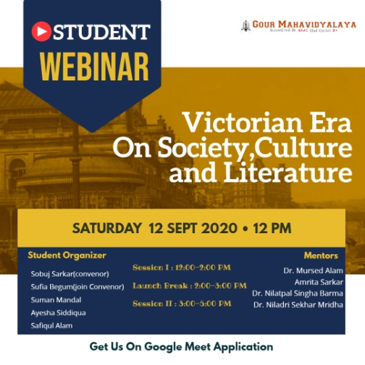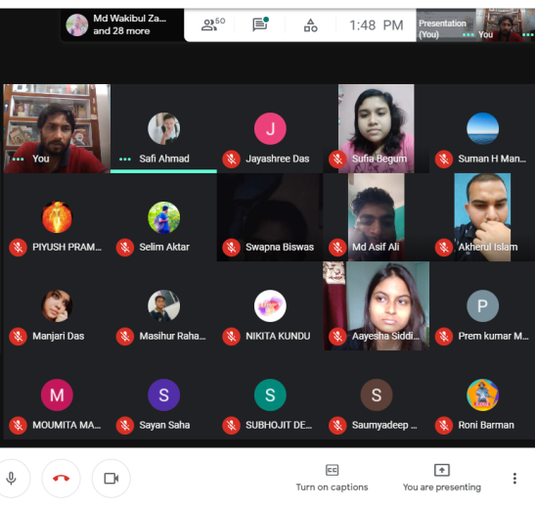

Group Discussion
Department of English
on
Literature in a Time of Crisis
Organized by
Department of English, Gour Mahavidyalaya, Malda, West Bengal.
Gour Mahavidyalaya
Established 1985

26 may, 2021 (12.30 Noon to 2.30 PM)
Objectives
The primary objective of this Group Discussion was to invite the students to critically reinterpret the texts they are reading keeping in mind their life-world under the ongoing pandemic.
Modus Operandi
We divided the Students of Semester- IV into five groups and gave each group a topic to discuss. The leader of each group would initiate the discussion and other members can supplement her points.
Groups & Topics
Group 1: How Can We Stop Being ‘Ghosts’ in this Pandemic Crisis?
Group 2: After Reading “Ghosts” What Would be Your Idea of Happy Family?
Group 3: “Abhigyanam Shakuntalam” and the Concept of Love Today.
Group 4: Shen Te as Red Volunteer: Possibilities of Care for Others in a heartless World.
Group 5: Wong as a migrant Worker without a Train Ticket

Outcome:
The students thoroughly enjoyed the discussions. They learnt themselves how to apply the texts they are reading in understanding the life-situations around them. They asked for more such discussions in future.
