DEPARTMENT: HISTORY
2021-22
2.3 Teaching- Learning Process
2.3.1 Student centric methods, such as experiential learning, participative learning and problem solving methodologies are used for enhancing learning experiences

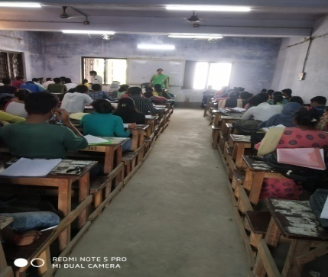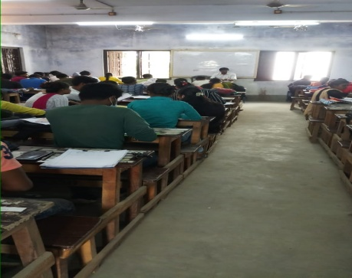
ADVANCE LEARNERS CLASS:13.12.2022 SLOW LEANERNS CLASS TEST:26.12.2022
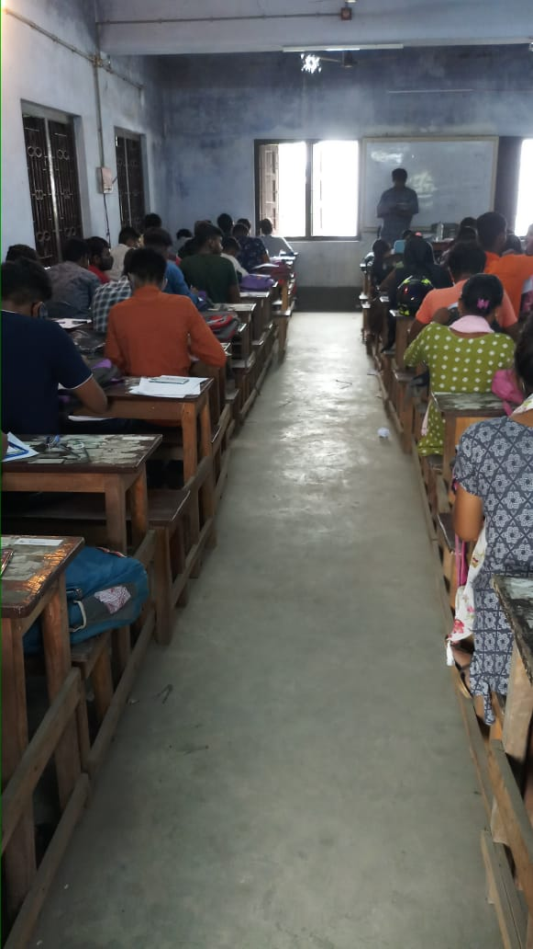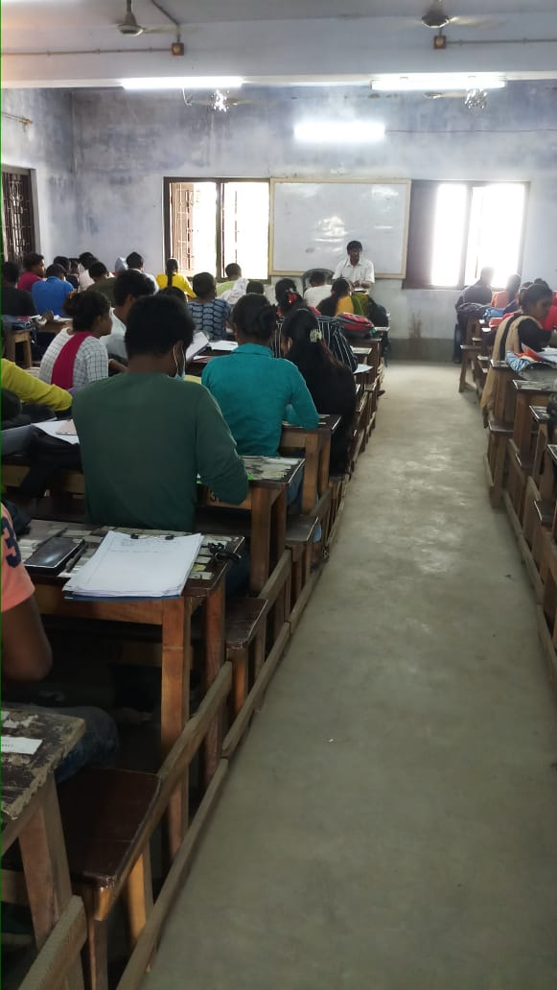
SEM-IV-STUDENT SEMINAR:26.12.2022 SLOW LEARNERS CLASS ,CLASS TEST, ASSIGNMENT:17.12.2022

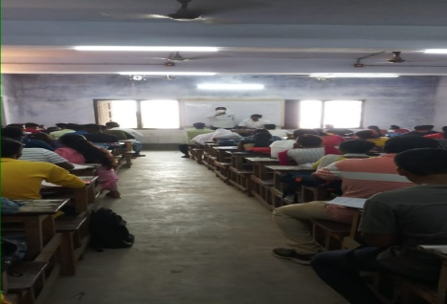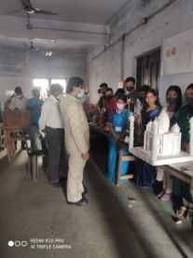
MENTOR-MENTEE PROGRAMME:8.8.2022 EXHIBITION: ALL SEMESTERS:24.03.2023

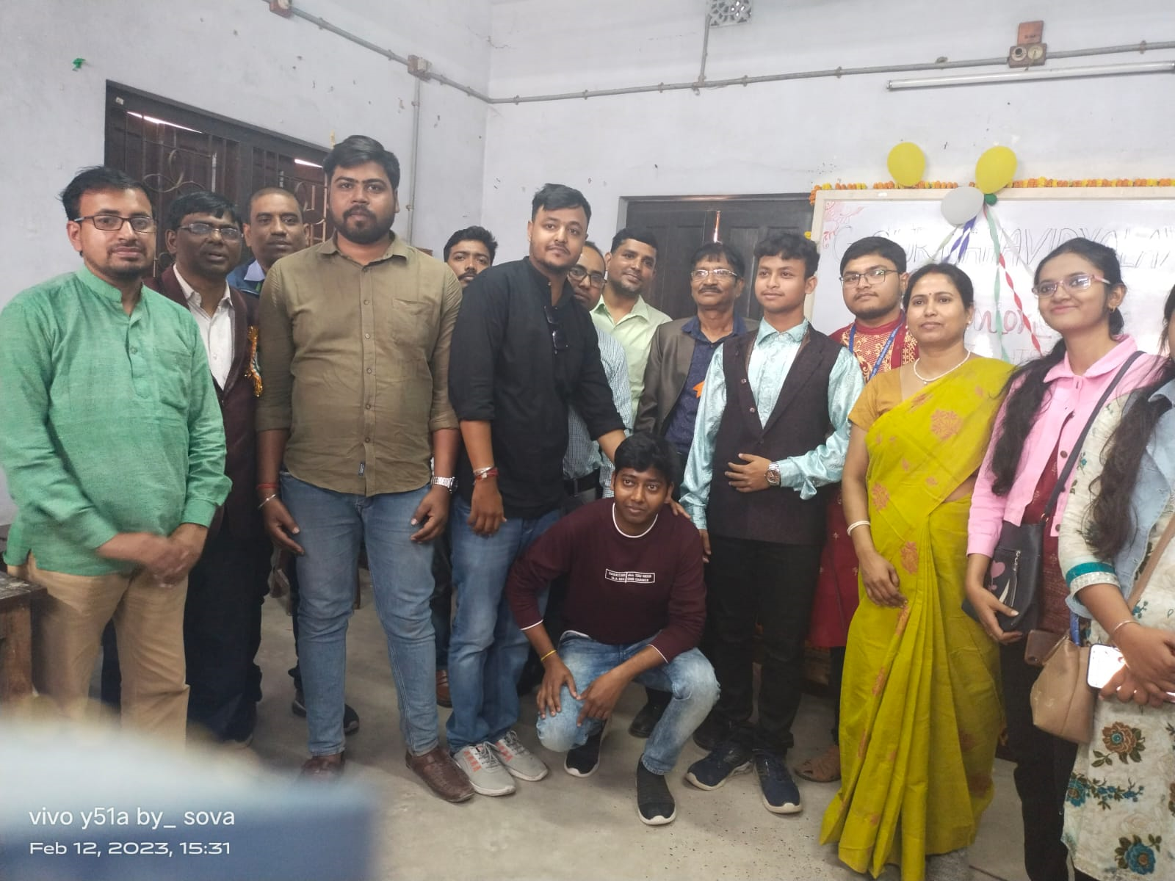
REUNION: ALUMNI ASSOCIATION12.02.2023
