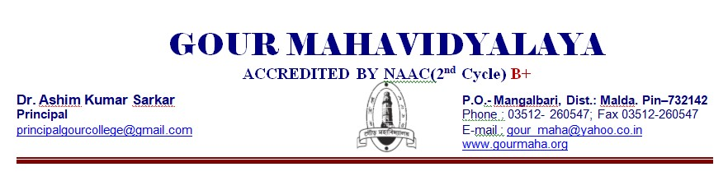
DEPARTMENT: HISTORY
2021-22
2.2 Catering to Student Diversity
2.2.1 The institution assesses the learning levels of the students and organises special Programmes for advanced learners and slow learners
Response: The Department of History, Gour Mahavidyalaya, Mangalbari, Malda, has Assessment system of the students and special programmes for advanced learners and slow learners.
Group-A: Teacher: Dr.P.K.Kundu,Associate Professor
Name of Students | Day and Date | Time | Topic
1219HISH0357 ABHIJIT HALDER  1219HISH0358 AJMAL HOSSAIN  1219HISH0359 AMAN NANDi  1219HISH0360 ANISHA RAM  1219HISH0361 ANJANA TUDU  1219HISH0362 ARAB SK  1219HISH0363 ARINDAM SINGHA  1219HISH0364 ASHISH HALDER  1219HISH0365 BAPAN MANDAL  1219HISH0366 BEAUTI SHILL  1219HISH367 BEAUTY KHATUN  1219HISH0368 BAGGOLIPI MANDAL  1219HISH0369 BIDYUT PAUL  1219HISH0370 BISWAJIT SAMADDAR  1219HISH0372 BONYOTA BASAK  1219HISH0373 CHAITALI SARKAR  1219HISH0374 CHHOTAN MANDAL  1219HISH0375 CHUMKI HALDER  1219HISH0376 DEBANSHU CHAUDHURY  1219HISH0377 DEBI DAS  1219HISH0378 DUPATI MANDAL  1219HISH0379 FALGUNI RAY  1219HISH0380 GOLAPI SINGHA  1219HISH0381 JABA CHOWDHURY  1219HISH0382 JAHANGIR ALAM  1219HISH0383 JAYEETA GHOSH  1219HISH0384 JIU DAS | 12.12.2022  16.12.2022  26.12.2022 | 4 P.M.-5 P.M. | DC-8-History of India-1707-1818 A.D.-Orientalism;Utilitarianism;Classical Political Thought
Group:B:Dr.SupriyaBiswas,AssociateProfessor
Name of Students |  | Time ,Day,Topic | Topic
1219HISH0376 | DEBANSHU CHAUDHURY | 13.12.2022;14.12.2022-4 P.M.-5 P.M. | DC-8- Rise of English Power in Bengal,Anglo-Sikh Relation;Anglo-Maratha Relation
1219HISH0377 | DEBI DAS
1219HISH0378 | DUPATI MANDAL
1219HISH0379 | FALGUNI RAY
1219HISH0380 | GOLAPI SINGHA
1219HISH0381 | JABA CHOWDHURY
1219HISH0382 | JAHANGIR ALAM
1219HISH0383 | JAYEETA GHOSH
1219HISH0384 | JIU DAS
1219HISH0385 | KAINAJ KHATUN
1219HISH0386 | KISHAN MAHARA
1219HISH0387 | LAKSHMAN MANDAL
1219HISH0388 | MAFRUDA KHATUN
1219HISH0389 | MANASI SANYAL
1219HISH0390 | MANDIRA DAS
1219HISH0391 | MD JISAN ALI
1`219HISH0392 | MD NAJIR HOSSAIN
1219HISH0393 | MD RAIHAN ALI
1219HISH0394 | MITALI SAHA
1219HISH0395 | MOHITOSH SINGHA
1219HISH0396 | MOON BASAK
Group:C:Dr.KrishnoMohanMandal,State Aided College Teacher
Name of Students |  | Time ,Day,Topic | Topic
NAKIR HOSSAIN |  | 15.12.2022;16.12.2022;17.12.2022-4 P.M.-5 P.M. | DC-9-Bengal renaissance, Revolt of 1857; Modern Press;Young Bengal Movement, Rajaram Mohan Ray, Iswar Chandra Vidyasagar
NISHA BISWAS
NITYANANDA GHOSH
OBAIDUR RAHAMAN
PABITRA BARMAN
PANKAJ GHOSH
PARTHO MANI
PAYEL GHOSH
PHULIKAGHOSH
PINKI HALDER
POULAMI DAS
PRITI BASAK
PRITI MANDAL
PRITOM KUMAR SARKAR
RAJU SK
RAKHI SARKAR
RUKSENA KHATUN
SABANA KHATUN
SK.WASIM
SISIR GHOSH
SNIGHDHA SARKAR
SUCHITRA DAS

Group:D:ArunimaGhosh,State Aided College Teacher
Name of Students |  | Time ,Day,Topic | Topic
TAIMUR RAHAMAN |  | 27.12.2022;28.12.2022-4 P.M.-5 P.M. | DC-10- Beginning of Indian Nationalism, Extremist Movement; Indian National Congress
ABHIJIT BASAK
ADHIR HALDER
ADITYA RAY
AKASH MANDAl
AKHI BISWAS
AMAL RABIDAS
AMRIT RAJBANSHI
ANAMIKA RAJBANSHI
ANJALI KHATUN
ARIF SK
AROBINDO GHOSH
ASIF IQBAL
SUCHITRA DAS
TAMA BAIDYA
TOUHN HOSSAIN
UTTAM MANDAL
WRICK KUMAR DAS
KALYAN RAJBANSHI
TAIMUR RAHAMAN
ABHIJIT BASAK
ADHIR HALDER

Group:E:SayantiPandey,State Aided College Teacher
Name of Students |  | Time ,Day,Topic | Topic
1219GENA1460 SUBHANKAR MANDAL |  | 29.12.2022;30.12.2022 | DC-10- Rise of Gandhiji, INA , Subhash Chandra Bose; Integration of Indian States
1219 GENA1526 SUMIT MANDAL
1219GENA1596 TANMOY PODDAR
1219 GENA1611 TAPASI MALLIK
1219 GENA1626 TAHIDUR MOMIN
1219 GENA 1633 TULI SARKAR
1219GENA1645 UJJAWAL MITRA
1219GENA 1649 UMME KULSUM
1219GENA 1661 YUDHISTHIR MANDAL
1219GENA 1108 RESHMA KHATUN
1219GENA1111 RESHMI MUNDA
1219GENA 1119 RIMI MANDAL
1219 GENA 1124 RINa CHOUDHURY
1219 GENA 1136 RIYA DAS
1219GENA 1146 RIYANKA DAS
1219GENA 1164 RUBEL HOQUE
1219 GENA 1166 RUBINIUR KHATUN
1219 GENA 1174 RUMA MURMU
1219 GENA 1219 SAIKAT DAS
1219 GENA 1332 SENAUL HOQUE
1219 GENA 1396 SINTU SK
1219 GENA 1399 SK RAJU
1219 GENA 1411 SOMNATH GHOSH
1219 GENA 1437 SOURAV PRAMANIK
1219 GENA 0547 JYOTI SAHANI

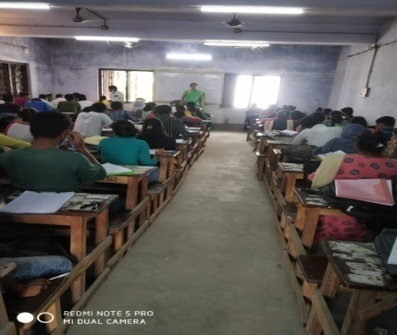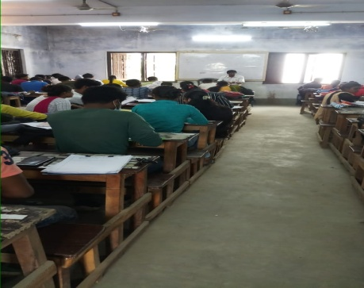
ADVANCE LEARNERS CLASS:13.12.2022 SLOW LEANERNS CLASS TEST:26.12.2022

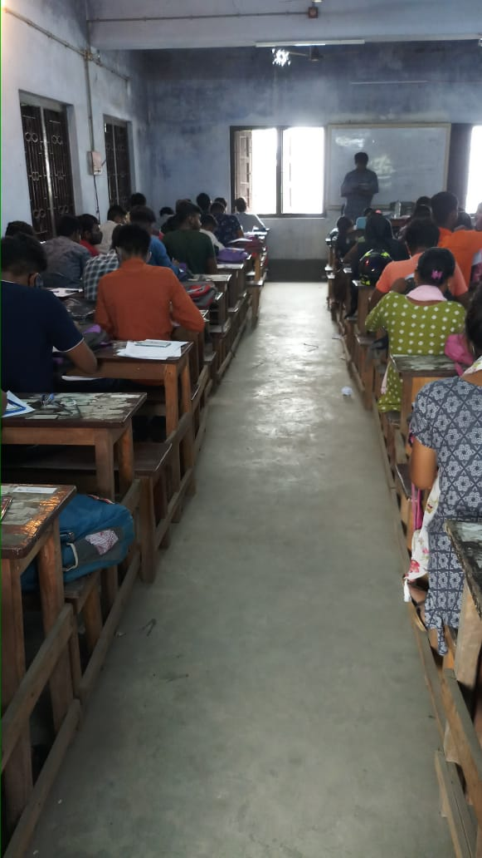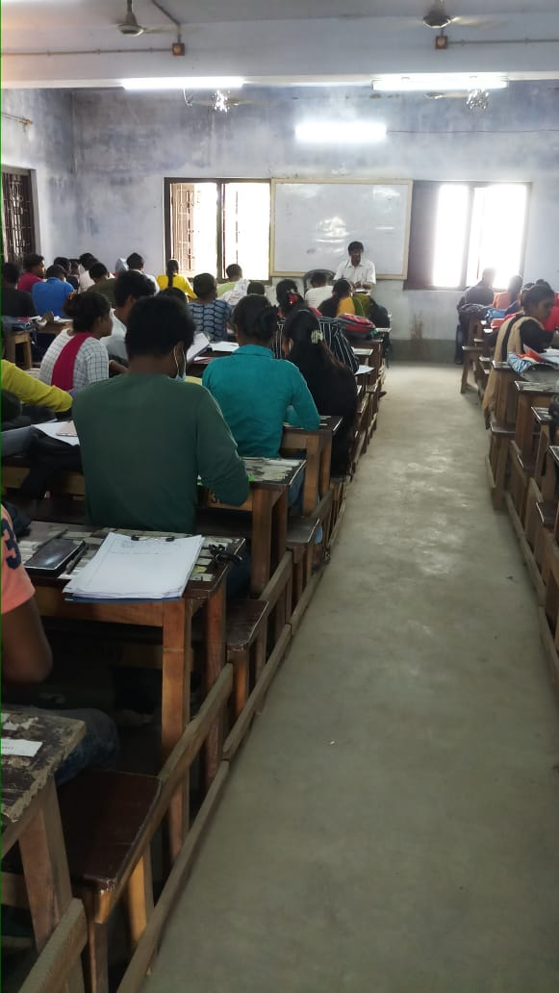
SEM-IV-STUDENT SEMINAR:26.12.2022 SLOW LEARNERS CLASS ,CLASS TEST, ASSIGNMENT:17.12.2022

