GOUR MAHAVIDYALAYA,MANGALBARI,MALDA
DEPARTMENT: HISTORY
2.3.1.Student centric methods, such as experiential learning, participative learning and problem solving methodologies are used for enhancing learning experiences: a. Students conduct seminar on a particular topic and take active part in organizing various extra and co-curricular events which help them in developing their management skills.
b.Participative learning: In participative learning, the students are given certain topics which are of utmost importance both academically and practically, they are then divided into groups and asked to read various articles or write ups and then to analyze and reflect on it. In this way they get an opportunity to conceptualize the theoretical aspects. They prepare project reports. They are also taken to field/ industry visits, study tours in India. It exposes them to the world of practical knowledge to enhance their skills and abilities.
c. Problem solving methodologies: The Institute further follows problem solving methodologies by challenging the students with assignments on regular basis to check their level of understanding on the subject.
d. Moreover, viva-voice, group discussion are held from time to time to keep the students in a competitive environment and to check the overall progress of the class.
e.Students organize exhibition and show their creativity.

NOTICE
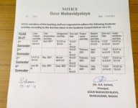 | 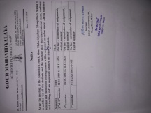 |  | 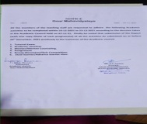 | 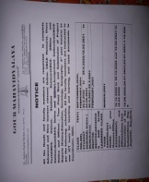 |  | 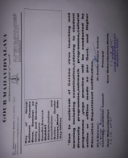
DOCUMENTS:2019-20:2020-21
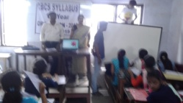 |  |  |  |  | 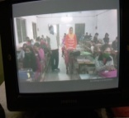
Orientation: Offline:11.07.2019 |  | Orientation : Online:08.09.2020 |  |  | Class Test:12.12.2019
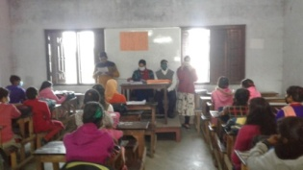 |  |  |  |  | 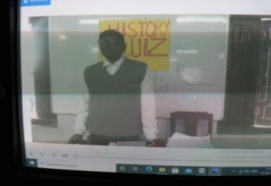
Offline: Student Seminar:18.12.2020 |  | Online Student Seminar:20.03.2021 |  |  | Quiz:20.03.2021
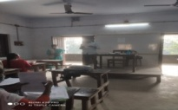 |  | 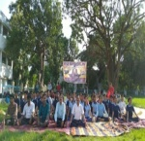 |  |  | 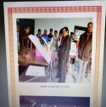
Group Discussion:14.12.2019 |  | Yoga Practice:30.08.2019 |  |  | Exhibition
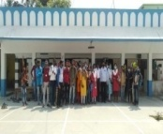 |  | 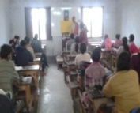 |  |  | 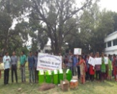
Study Tour:12.04.2021: Old Malda Gurudwara |  | Submission of Project |  |  | Participation in Outreach Programme: Swachh Bharat Abhiyan
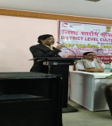 |  | 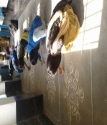 |  |  | 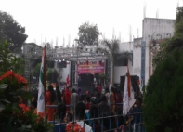
 |  | Participation in Cultural Programmee and Competetion:14.1.2020 |  |  | Participation in Cultural Programmee

