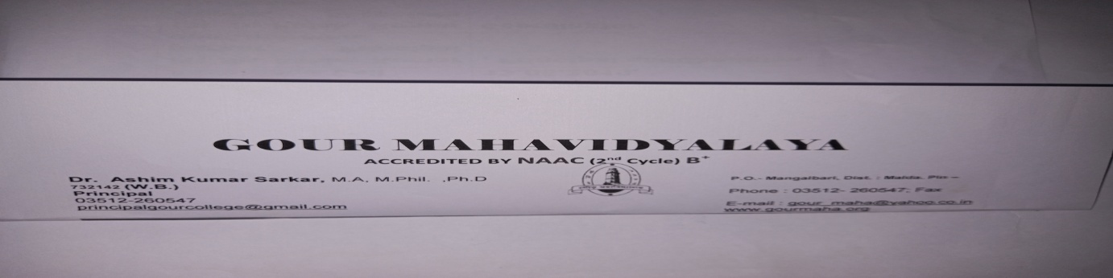
GOUR MAHAVIDYALAYA,MANGALBARI,MALDA
DEPARTMENT: HISTORY

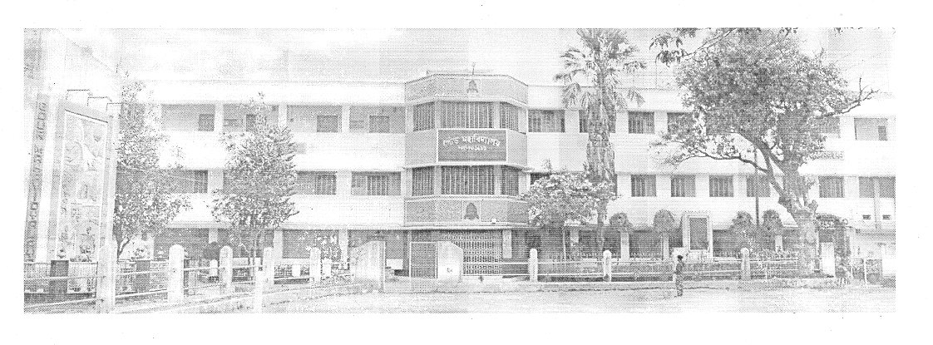
Advanced learners and slow learners:
2.2. Catering to Student Diversity :
2.2.1.The institution assesses the learning levels of the students and organizes special Programmes for advanced learners and slow learners:
Yes, Gour Mahavidyalaya, Mangalbari, Malda, has Assessment system of the students and special Programmes for advanced learners and slow learners.
a.After on line admission is over, Academic Council of Gour Mahavidyalaya fix the date of orientation programme in consultation with Coordinator of IQAC. All the Heads of 19 Departments convene meeting of Departmental Academic Council and chalk out a plan for teaching and learning.
b.Initially faculty members conduct orientation programme and interact with the students to ascertain their background, subject stream, medium of education, aptitude match for the current programme, subject combination, examination system and areas of their interest.Power point presentation is followed during orientation programme.
c.Faculty members use ICT tools during classes.
d.Moreover, each faculty during the class hours identifies the slow or advance learners by interacting with them and on the basis of % of marks obtained in the last H.S. examination.
e.During the course of time, a systematic evaluation process is used to assess the learning levels of the students. This evaluation process consist of written examination, open book test, group discussion and presentation, project report, practical examination with viva, written assignment, test and class performance.
f. Link for the proof of tutorial class schedule: Special programs for slow learners
a.For Slow learners special classes and class test are conducted.
b.Slow learners take the advantage of tutorial classes conducted by the faculty for one to one interaction.
c.Faculty members conduct extra classes for slow learners after class hours like after 3 P.M.
d.Faculty members supply them study materials( Xerox copy).
e.Faculty members check their home task
f.Faculty mentors provide their mentees one to one counseling on improvement areas.
g. Remedial coaching class are arranged.
h. Link for the proof of tutorial class schedule and Remedial class schedule.
i.Online special classes from 4.8.2020 to 25.8.2020 Special programs for advance learners
a.Tutorial examinations are conducted.
b.Learning needs of the advance student are further fulfilled by activities such as
c.Advanced learners also attend Workshops/ Seminars/ Symposiums to keep them updated on various advancements
. d.Academic Committees of 19 Departments of our Institute conduct special lectures,student seminar to improve skills of the students.
e.Advanced students can access INFLIBNET through faculty members’ assistance.

CLASS ROUTINE

MEETING: DEPARTMENT: HISTORY
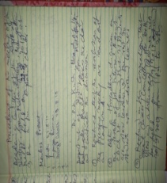 | 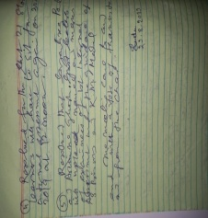

NOTICE
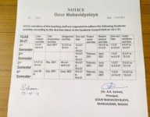 | 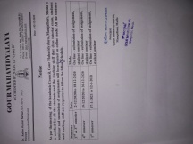 | 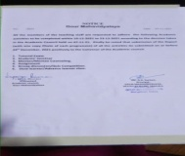 | 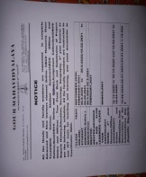 | 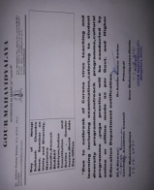

Name of the student:2019-20 | % of marks obtained in H.S.exam and identification of Advanced and Slow Learners
BANYATA BASAk | 79%-Advancedlearner
PARTHA MANI | 75% -Advanced Learner
SANTANA MANDAL | 68% -Slow Learner
AMAN NANDI | 77%-Advanced Learner
UMME KUL SUM | 78%-Advanced Learner
AJMAL HUSSAIN | 69%-Slow Learner
PANKAJ GHOSH | 68%-Slow Learner
MASIDUR ISLAM | 70%-Advanced learner
MOON BASAK | 68% Slow learner
MUKESH MANDAL | 73%-Advanced learner
MAHITOSH SINGHA | 70%-Advanced learner
OBEIDUR RAHAMAN | 67%-Slow learner
NITYANANDA GHOSH | 65%-Slow learner
CHOTAN MANDAL | 72%-Advanced learner
TAINUR RAHAMAN | 61%-Slow learner
SUJIT KARMAKAR | 63%-slow learner
MRINMOY SAHA | 62%-Slow learner
ASHISH HALDER | 69%-Slow Learner
KAINAJ KHATUN | 68%-Slow Learner
SUBARNA PAUL | 70%-Advanced learner
DUPATI MANDAL | 68% Slow learner
GOLAPI SINGHA | 63%-Slow learner
ARINDAM SINGHA | 69%-Slow Learner
PABITRA BARMAN | 68%-Slow Learner
SABNAM BANU | 70%-Advanced learner
SUFAL HALDER | 68% Slow learner
DEBI DAS | 61%-Slow learner
TUHIN HOSSAIN | 63%-slow learner
SAHIDI ALAM | 68% -slow learner
MD NAZIR HUSSAIN | 64%Slow learner
BAPAN MANDAL | 73%-Advanced learner
BULOYAN RAJBANSHI | 69%-Slow Learner
SOMNATH SARKAR | 72%-Advanced learner
RAKHI SARKAR | 61%-Slow learner
DEBANSHU CHOWDHURY | 63%-slow learner
PRASENJIT KARMAKAR | 62%-Slow learner
FULIKA GHOSH | 69%-Slow Learner
ARAB SK | 68%-Slow Learner
PRITI BASAK | 70%-Advanced learner
PAULAMI DAS | 69%-slow learner
PRITAM KUMAR SARKAR | 66%-Slow learner
PINKI HALDER | 68%-Slow learner
MANASI SANYAL | 62%-Slow learner
BHAGYALIPI MANDAL | 67%-Slow learner
SUMI SAHA | 65%-Slow learner
BEUTY SHIL | 72%-Advanced learner
CHAITALI SARKAR | 61%-Slow learner
RUMA RAJBANSHI | 63%-slow learner
ANISHA RAM | 67%-Slow learner
MAFRUDA KHATUN | 61%-Slow learner
MD JAYESH ALI | 69%-Slow learner
TAMA BAIDYA | 67%-Slow learner
SISHIR GHOSH | 65%-Slow learner
SUJIT MANDAL | 72%-Advanced learner
KAMAL RAY | 61%-Slow learner
SNIGHDHA SARKAR | 63%-slow learner
SREYA CHOWDHURY | 62%-Slow learner
PAYEL GHOSH | 69%-Slow Learner
NISHA BISWAS | 68%-Slow Learner
SUBHOJIT GHOSH | 70%-Advanced learner
MITALI SAHA | 68% Slow learner
BIDYUT PAUL | 73%-Advanced learner
PRIYANKA HALDER | 70%-Advanced learner
BISWAJIT SAMADDAR | 65%-Slow Learner
JUI DAS | 63%-Slow learner
CHUMKI HALDER | 70% Advanced learner
SUCHITRA DAS | 65%-Slow learner
SUPARNA MANDAL | 64%-Slow learner
PUJA MANDAL | 62%-Slow learner
PURNIMA PAUL | 67%-Slow learner
MANDIRA DAS | 65%-Slow learner
PRITI MANDAL | 72%-Advanced learner
WRICK KUMAR DAS | 61%-Slow learner
SUCHITRA RAJBANSHI | 63%-slow learner
PANCHAMI RAJBANSHI | 67%-Slow learner
NANDIA RAJBANSHI | 61%-Slow learner
ROHIT MOMIN | 69%-Slow learner
MD WASIM AKRAM | 67%-Slow learner
SABANA KHATUN | 65%-Slow learner
RUKSENA KHATUN | 72%-Advanced learner
NAKIR HOSSAIN | 61%-Slow learner
SAFIQUL ALAM | 63%-slow learner
JABA CHOWDHURY | 68% -slow learner

2020-21: LIST OF ADVANCED AND SLOW LEARNERS

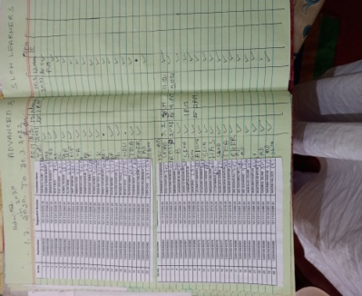 | 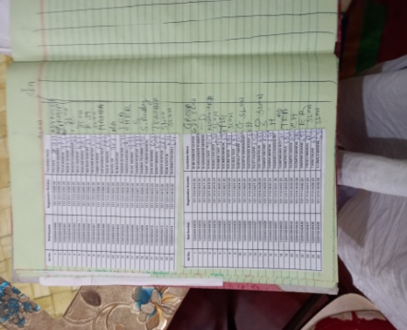 | 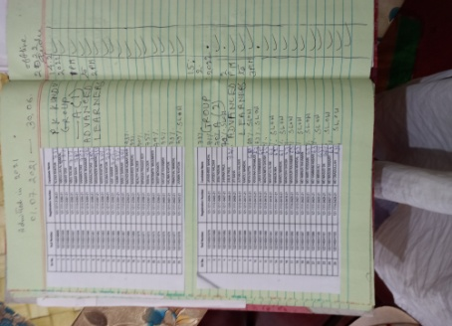

SIGNATURE
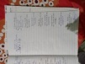 | 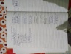 | 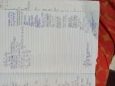 | 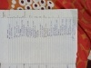 | 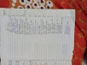 | 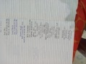
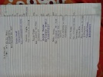 | 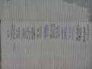 | 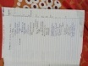 | 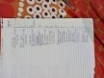 | 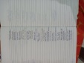

DOCUMENT

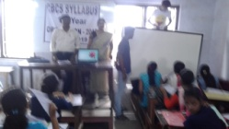 | 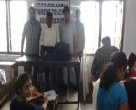 | 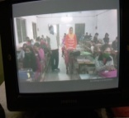 | 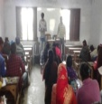 | 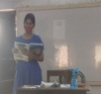 | 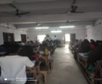
ORIENTATION:11.7.2019: S.BISWAS: K.M.MANDAL | SPECIAL CLASS: K.M.MANDAL | CLASS TEST:12.12.2019: S.BISWAS | S.BISWAS: STUDENT SEMINAR:9.12.2019 | K.M.MANDA:STUDENT SEMINAR:18.1.2021 | SPECIAL CLASS:14.12.-18.12.2019
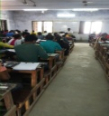 | 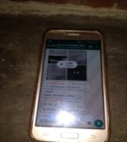 | 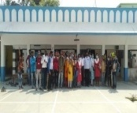 | 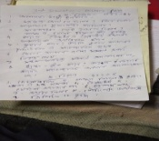 | 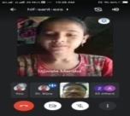 | 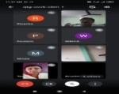
ADVANCED AND SLOW LEARNERS CLASS:21.4.2022 | CLASS: 2.4.2020 | TOUR:12.4.2021 | HISTORY: K.M.MANDAL,STATE AIDED COLLEGE TEACHER:WHATSAPP: 23.12.2020: SHARING STUDY MATERIALS: SLOW LEARNERS | STUDENT SEMINAR:20.3.2021: P.K.KUNDU | ONLINE CLASS:A GHOSH:21.03.2021

sufism
Inbox | x
Pulak Kumar Kundu <kumarkundupulak@gmail.com> | 3:30 PM (2 hours ago)
To ghoshpankaj2000@gmail.com:2.4.2020

https://www.google.com/url?sa=t&source=web&rct=j&url=https://shodhganga.inflibnet.ac.in/jspui/bitstream/10603/159349/4/04_chapter%25202.pdf&ved=2ahUKEwjficahvcnoAhUlzzgGHX8pD2cQFjACegQIBRAB&usg=AOvVaw2PngZS5bdoreBFoyEZU4Y4( study material through gmail: Sufism: INFLIBNET PDF

HISTORY: RESULT: PROGRESS REPORT
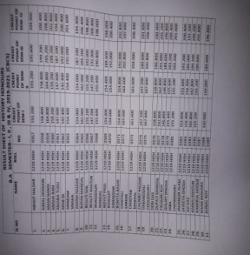 | 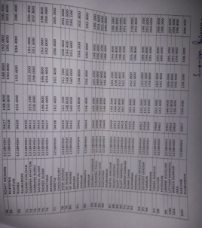 | 