GOUR MAHAVIDYALAYA,MANGALBARI,MALDA
DEPARTMENT: HISTORY
CLASS DIARY:2020-21- INCLUDING OTHER ACTIVITIES

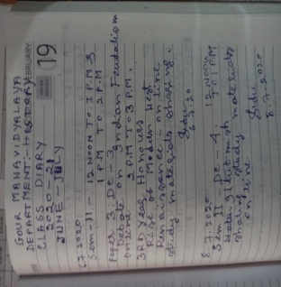 | 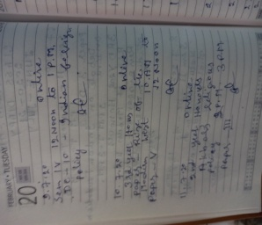 | 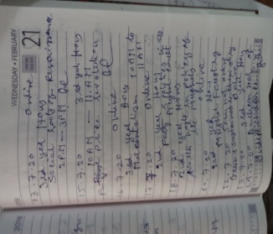
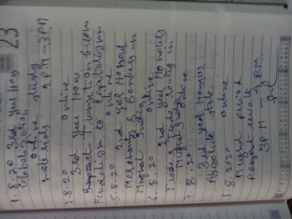 | 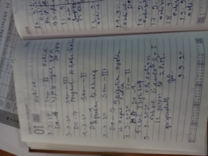 | 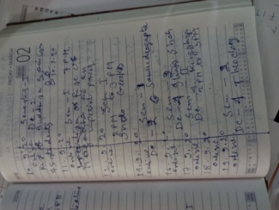
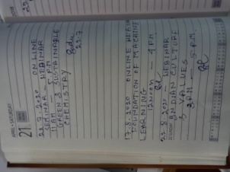 | 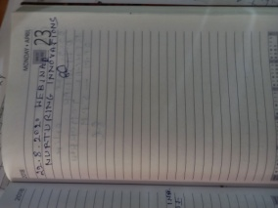 | 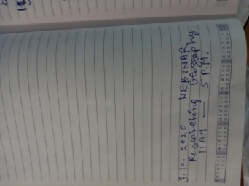
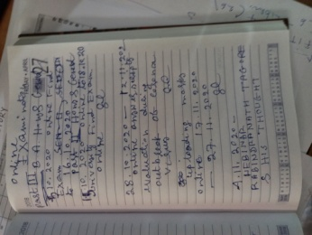 | 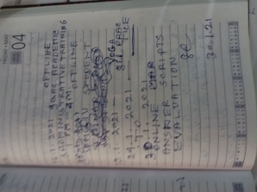 | 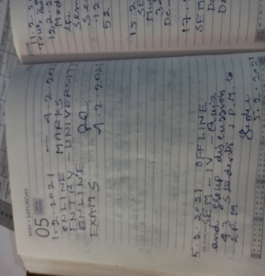
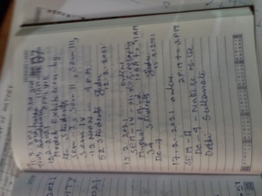 | 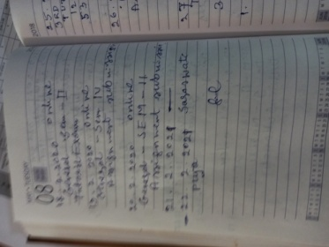 | 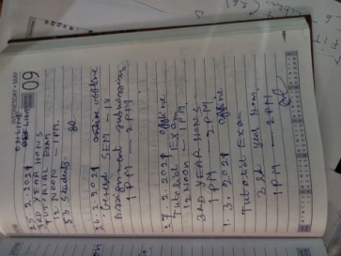
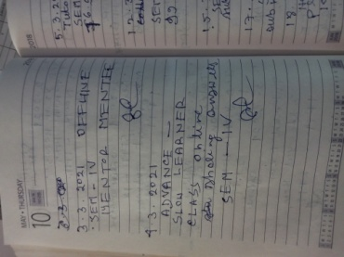 | 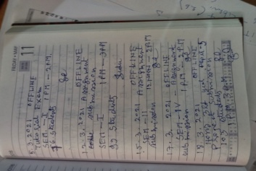 | 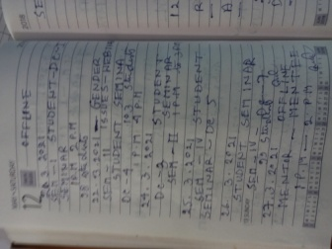

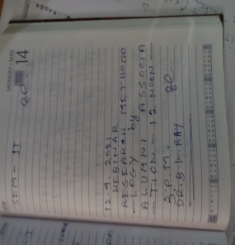 | 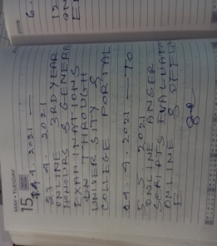 | 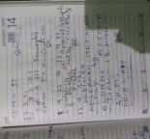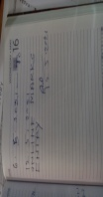
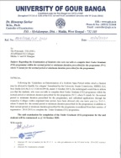 | 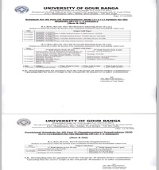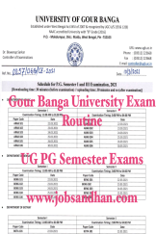 | 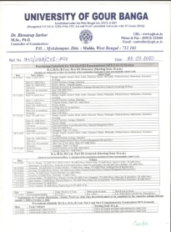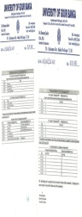
ONLINE EXAM : NOTICE | ONLINe EXAM: NOTICE | ONLINE EXAM: NOTICE
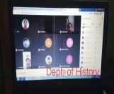 | 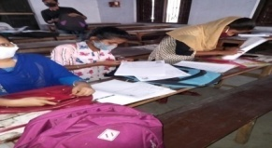 | 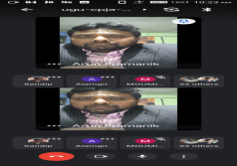
ONLINE ORIENTATION:8.9.2020: SEM:I | OFFLINE TUTORIAL EXAM:8.2.2021: SEM:II | STUDENT SEMINAR:20.12.2020
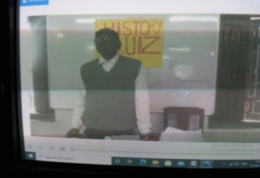 | 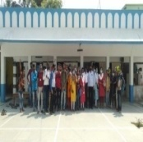 | 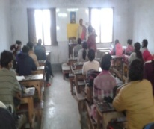
QUIZ:20.03.2021: OFFLINE | 18.03.2021: TOUR: OLD MALDA GURUDWARA | ADVANCE AND SLOW LEARNER:4.3.2021: OFFLINE: SEM: IV
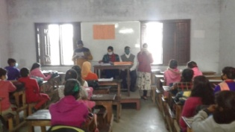 | 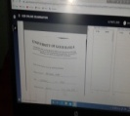 | 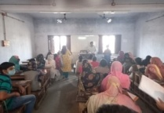
SUBMISSION OF ASSESSMENT AND STUDENT SEMINAR  26.03.2021: OFFLINE: SEM: IV | ONLINE EXAMINATION THROUGH THE PORTAL OF THEUNIVERSITY OF GOUR BANGA::15.10.2020: 3RD YEAR HONOURS | SUSMITA GUPTA:GENDER ISSUES-22.03.2021
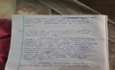  (HISTORY:PROVIDING STUDY MATERIALS: DR.P.K.KUNDU,ASSOCIATE PROFESSOR:ADVANCE And SLOW LEARNER CLASS: ONLINE:17.12.2020 | 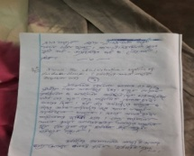  (HISTORY:PROVIDING STUDY MATERIALS: DR.P.K.KUNDU,ASSOCIATE PROFESSOR:ADVANCE And SLOW LEARNER CLASS: ONLINE:4.3.2021 | 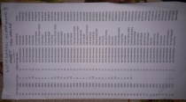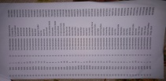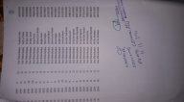  EXAMINER:3RD YEAR HONOURS

