GOUR MAHAVIDYALAYA,MANGALBARI,MALDA
DEPARTMENT: MATHEMATICS
CBCS: SEMESTER
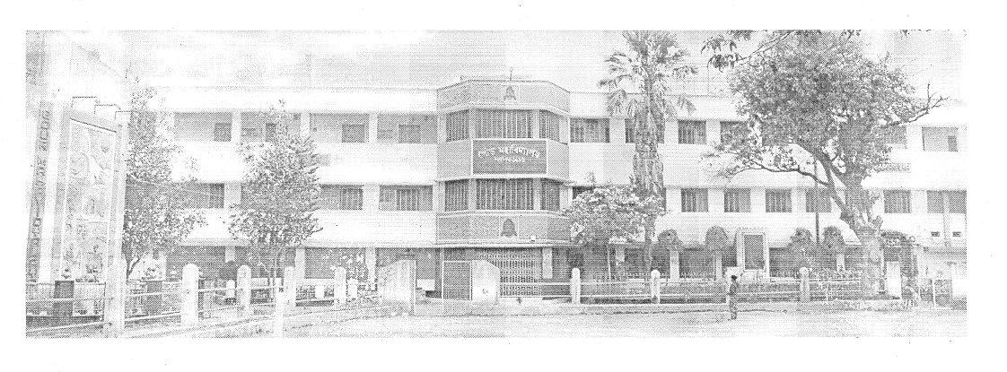
Process Manual for Slow Learners and Advanced Learners :Identification and Activities:2020-2021:
SPECIAL CLASS: ADVANCED AND SLOW LEARNERS:
Roles and Responsibilities of Subject Teacher: Subject Teacher is responsible for carrying out different aspects of slow learner and advanced learner identification and activities to be conducted Subject Teachers will be responsible for: Conducting class test on unit 1 of 18 marks and duration of one hour. Evaluation of class test answer sheets and preparing the class test result report of¬ class Preparing and maintaining report for whole class based on parameter decided for assessment of the learning levels of the students with their weightage Preparing separate list of slow and advanced learners¬ Preparing schedule for extra sessions/problem solving sessions/revision sessions for slow learners. Conducting the sessions for slow learners as per prepared schedule.
Maintaining the attendance of slow learners sessions and advanced learners:- Preparing the list of advanced assignments or list of tasks assigned to advanced learners. Preparing the report after the university result declaration of the current semester which shows- the improvement in performance of slow learners to close the loop. Maintain the all records for slow learners and advanced learners activity- Documents to be maintained- Cover page for Slow and Advanced learners Activity Report -result of class test/unit test- Report of marks obtained based on above parameter List of slow learners- List of Advanced Learners Schedule of activity for slow learners- Attendance record for session conducted for slow learners- Report of performance improvement for slow learners- List/Record of tasks given to advanced learners- Expected Outcome- Timely conduction of slow learners activities- Records based on student progress and observation. Improvement in University Result.
NEW AQAR AND SSR FORMAT:
2.2. Catering to Student Diversity:
2.2.1. The institution assesses the learning levels of the students and organises special Programmes for advanced learners and slow learners:
Answer:Yes, Gour Mahavidyalaya,Mangalbari,Malda, hasAssessment system of the students and special Programmes for advanced learners and slow learners.

- After online admission was over, the Academic Council of Gour Mahavidyalaya fixed the date of orientation programme in consultation with the Coordinator of IQAC. All the Heads of 19 Departments convene a meeting of the Departmental Academic Council and chalk out a plan for teaching and learning.
- Initially faculty members conduct orientation programmes and interact with the students to ascertain their background, subject stream, medium of education, aptitude match for the current programme, subject combination, examination system and areas of their interest.Power point presentation is followed during orientation programme.
- Faculty members use ICT tools during classes.
- Moreover, each faculty during the class hours identifies the slow or advanced learners by interacting with them.
- During the course of time, a systematic evaluation process is used to assess the learning levels of the students. This evaluation process consists of written examination, open book test, group discussion and presentation, project report, practical examination with viva, written assignment, test and class performance.
- Link for the proof of tutorial class schedule:
Special programs for slow learners
- For Slow learners special classes and class tests are conducted.
- Slow learners take the advantage of tutorial classes conducted by the faculty for one to one interaction.
- Faculty members conduct extra classes for slow learners after class hours like after 3 P.M.
- Faculty members supply them study materials( Xerox copy).
- Faculty members check their home task
- Faculty mentors provide their mentees one to one counseling on improvement areas.
- Remedial coaching classes are arranged.
- Link for the proof of tutorial class schedule and Remedial class schedule.
- Online special classes from 4.8.2020 to 25.8.2020
and again from 19.05.2021 to 24.05.2021.
Special programs for advanced learners
- Tutorial examinations are conducted.
- Learning needs of the advance student are further fulfilled by activities such as
- Advanced learners also attend Workshops/ Seminars/ Symposiums to keep them updated on various advancements.
- Academic Committees of 19 Departments of our Institute conduct special lectures,student seminars to improve the skills of the students.
e.Advanced students can access INFLIBNET through faculty members’ assistance.

ADVANCED | AND SLOW | LEARNERS | MEWORK

 | FORMAT
SPECIAL CLASS | NOTICE | HEAD OF THE INSTITUTION
SPECIAL CLASS | NOTICE | HEAD OF THE DEPARTMENT
CLASS ROUTINE | RESULT ANALYSIS | IDENTIFICATION OF ADVANCED AND SLOW LEARNERS
SPECIAL CLASS | PHOTO | ATTENDANCE SHEET
STUDENT SEMINAR | NOTICE | PHOTO
ASSIGNMENT | NOTICE | COLLECTION AND DISCUSSION-PHOTO
ADVANCED LEARNERS | MATERIALS SUPPLY | SOURCE: REFRENCE BOO/INFLIBNET-PHOTO
SLOW LEARNERS | SHARING OF FULL ANSWERS | PHOTO
FINAL RESULT | ANALYSIS | REMARKS

NOTICE : HEAD OF THE INSTITUTION
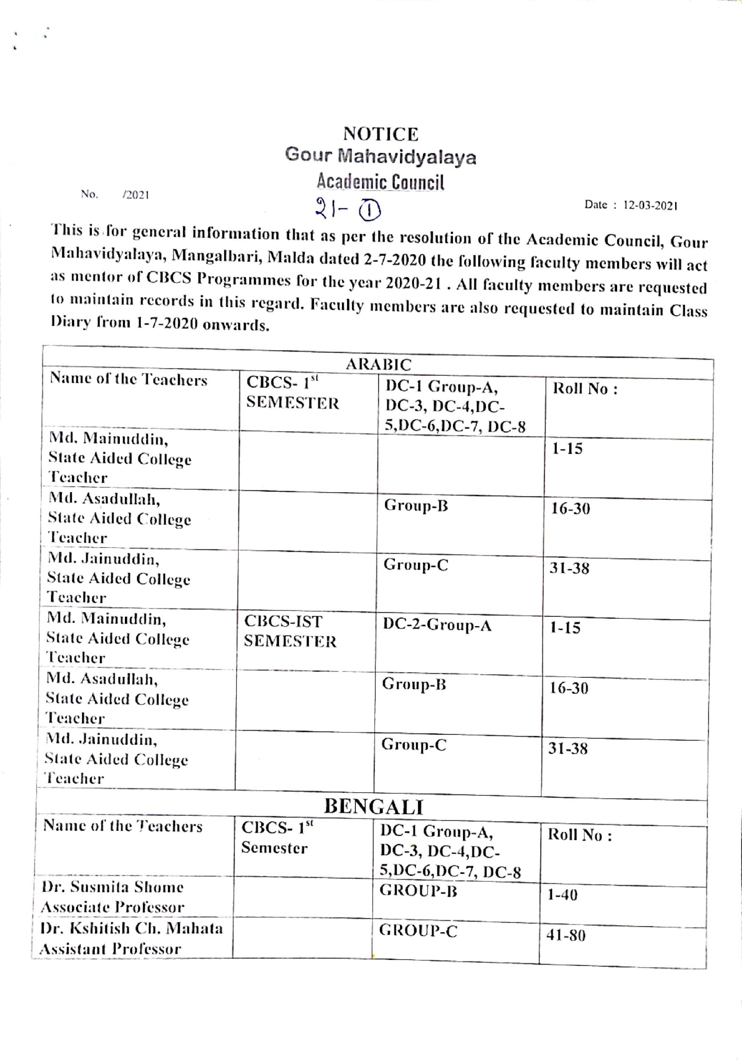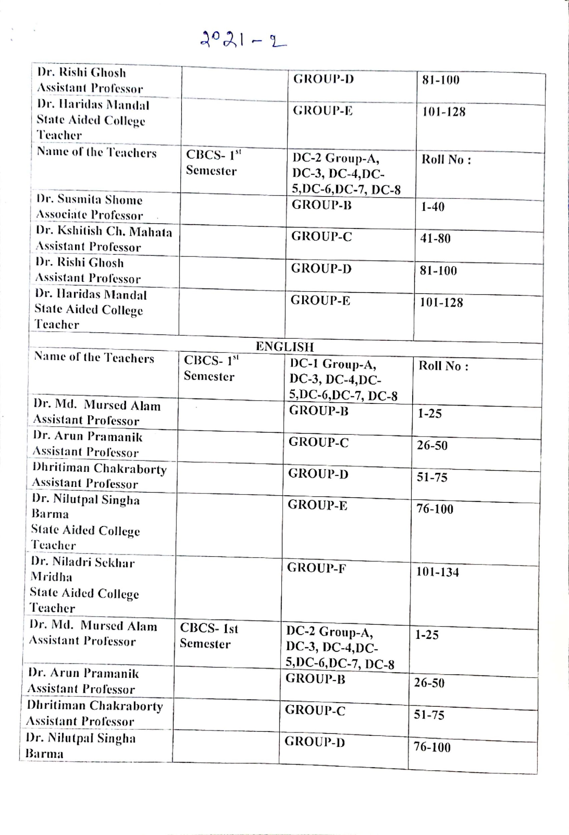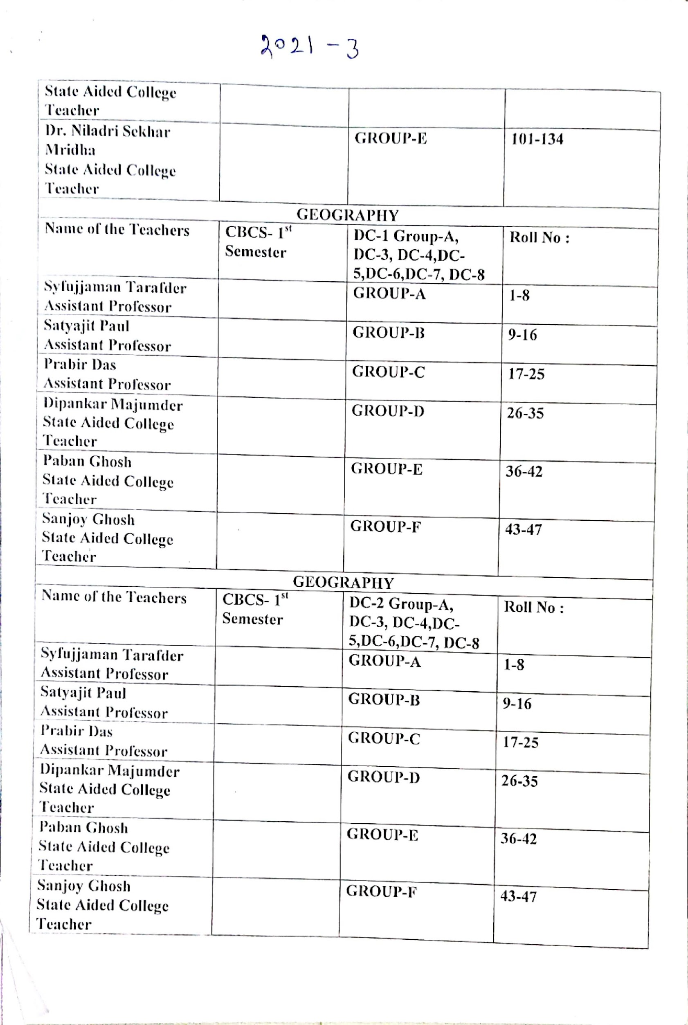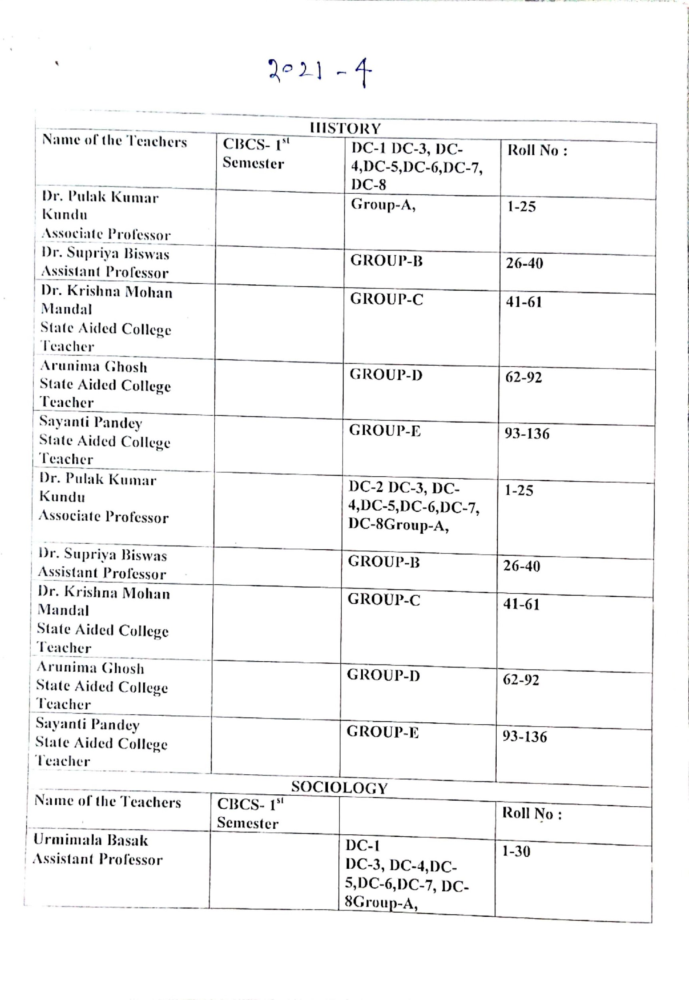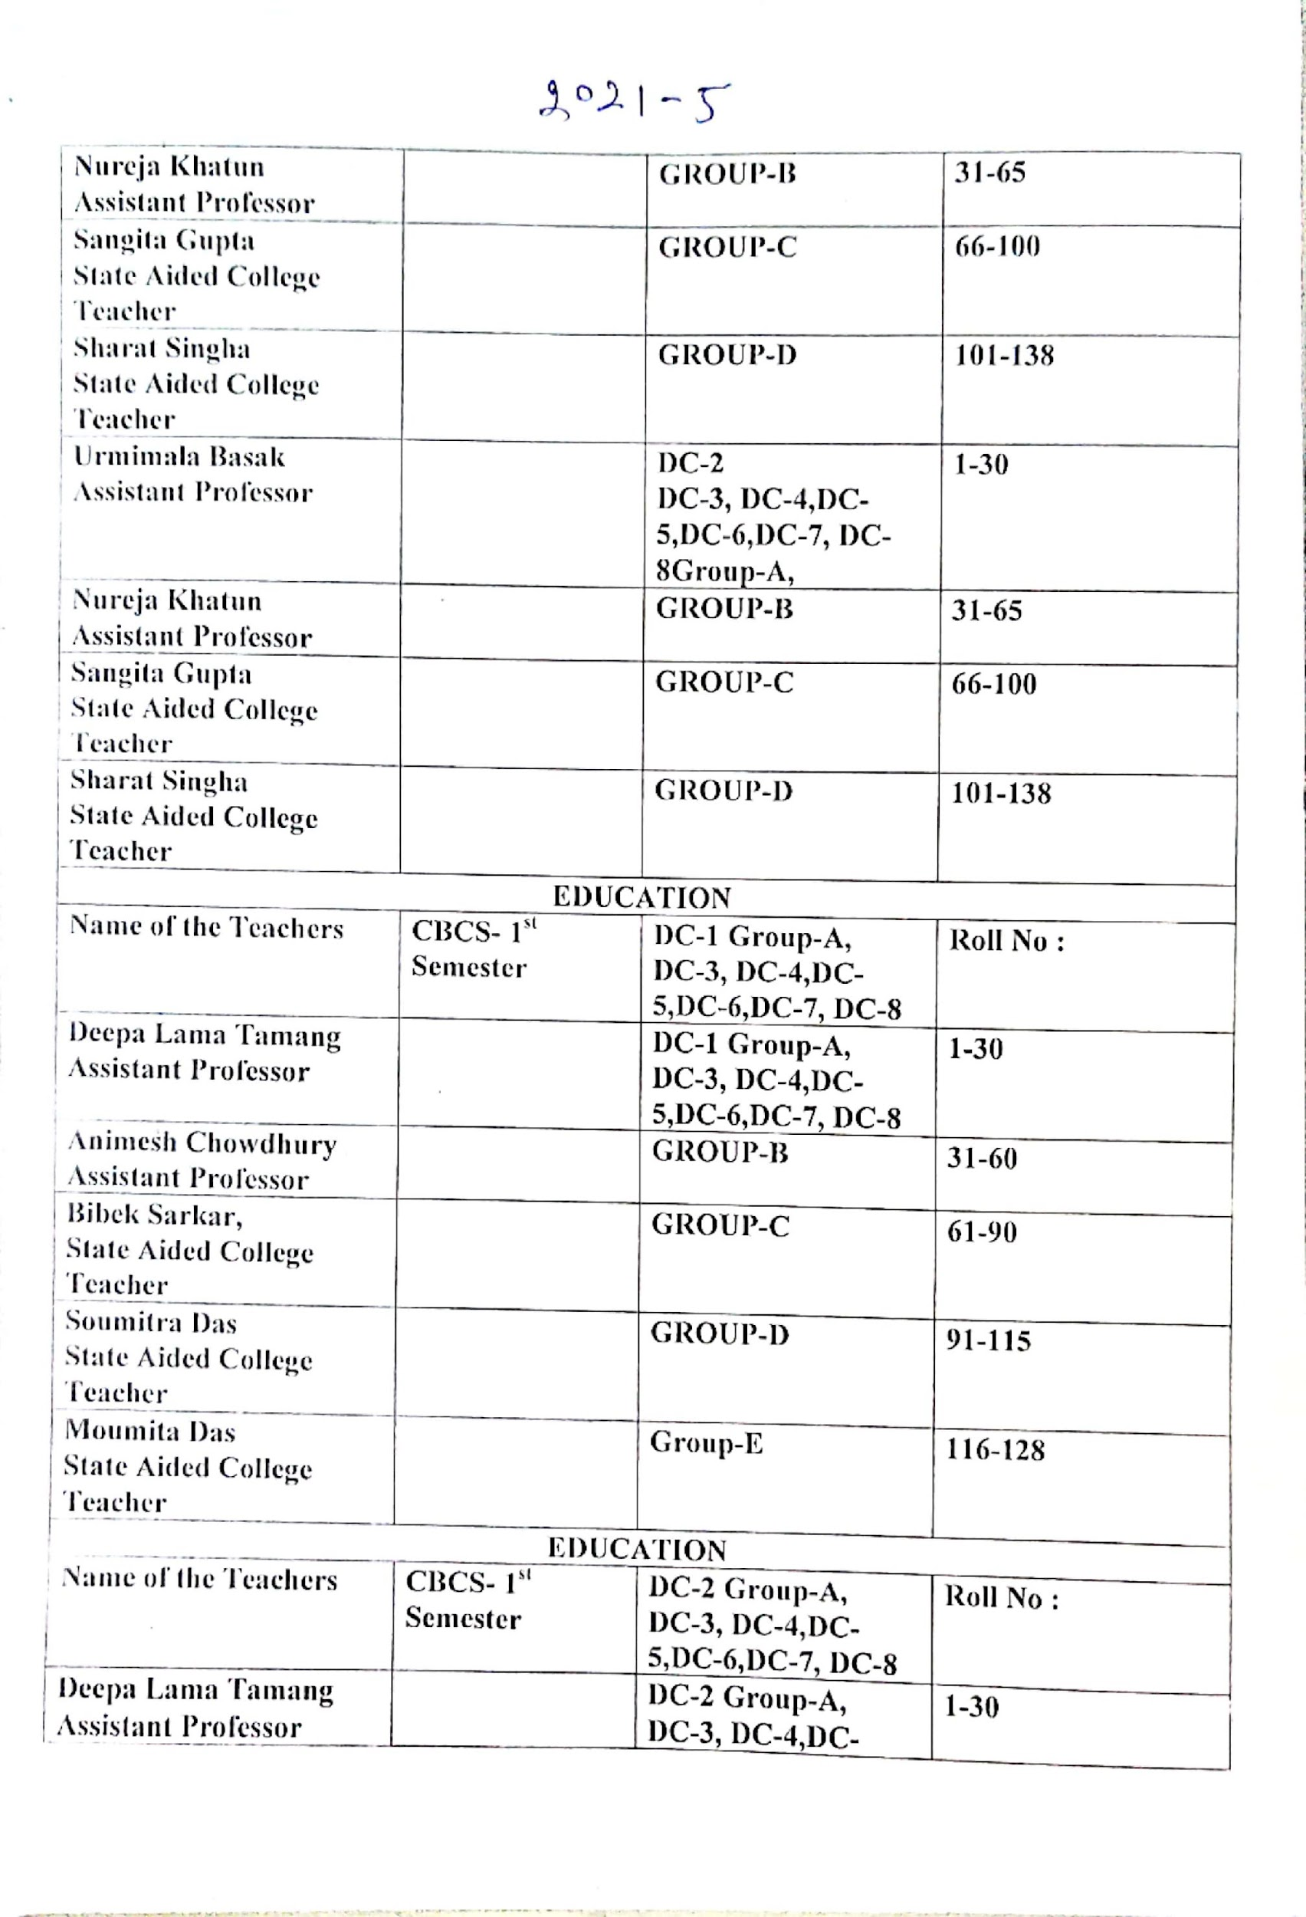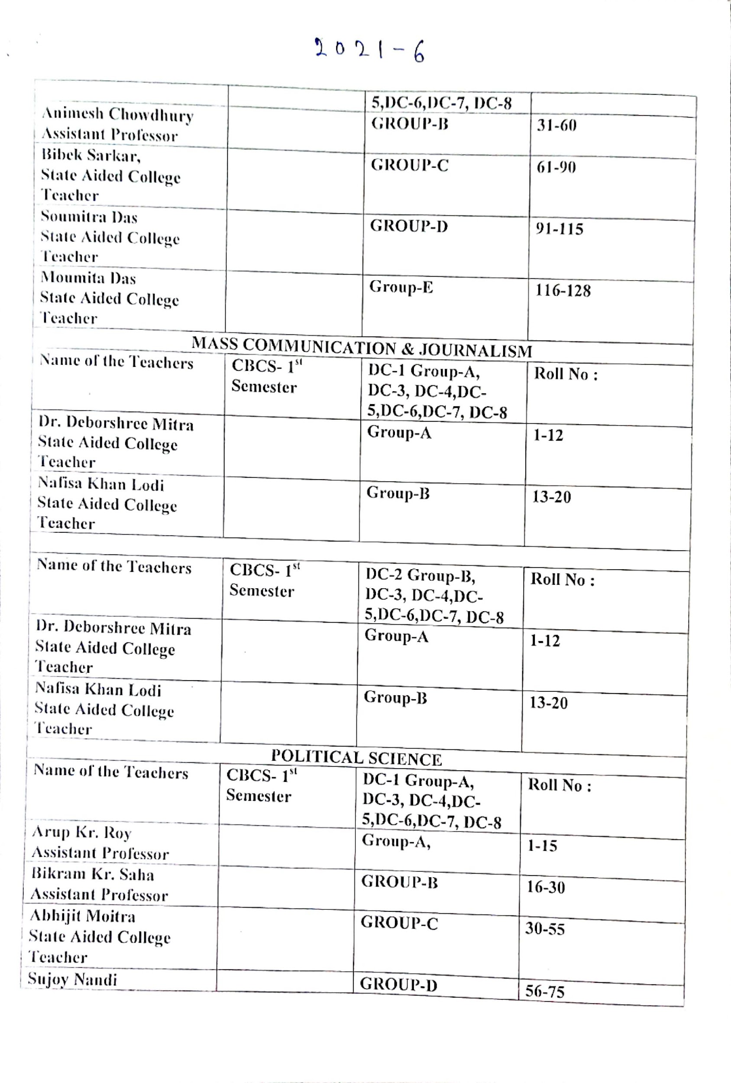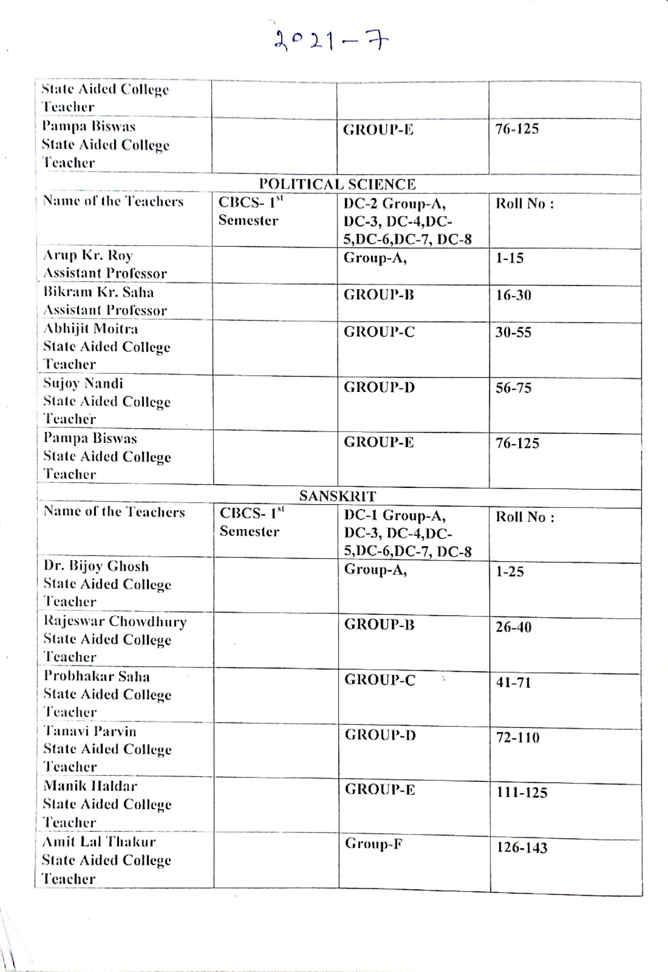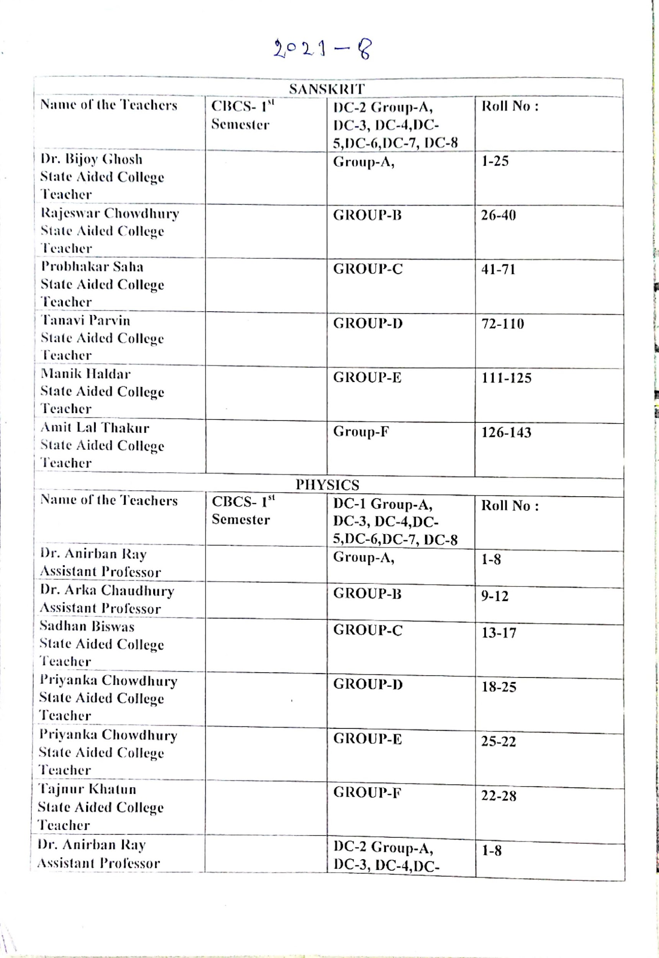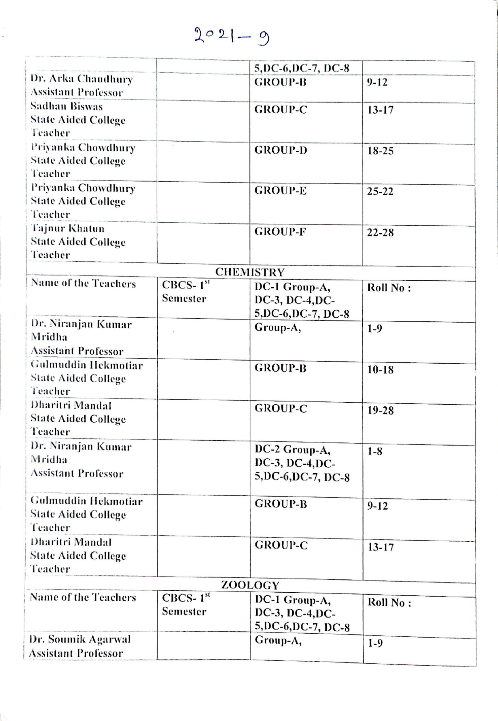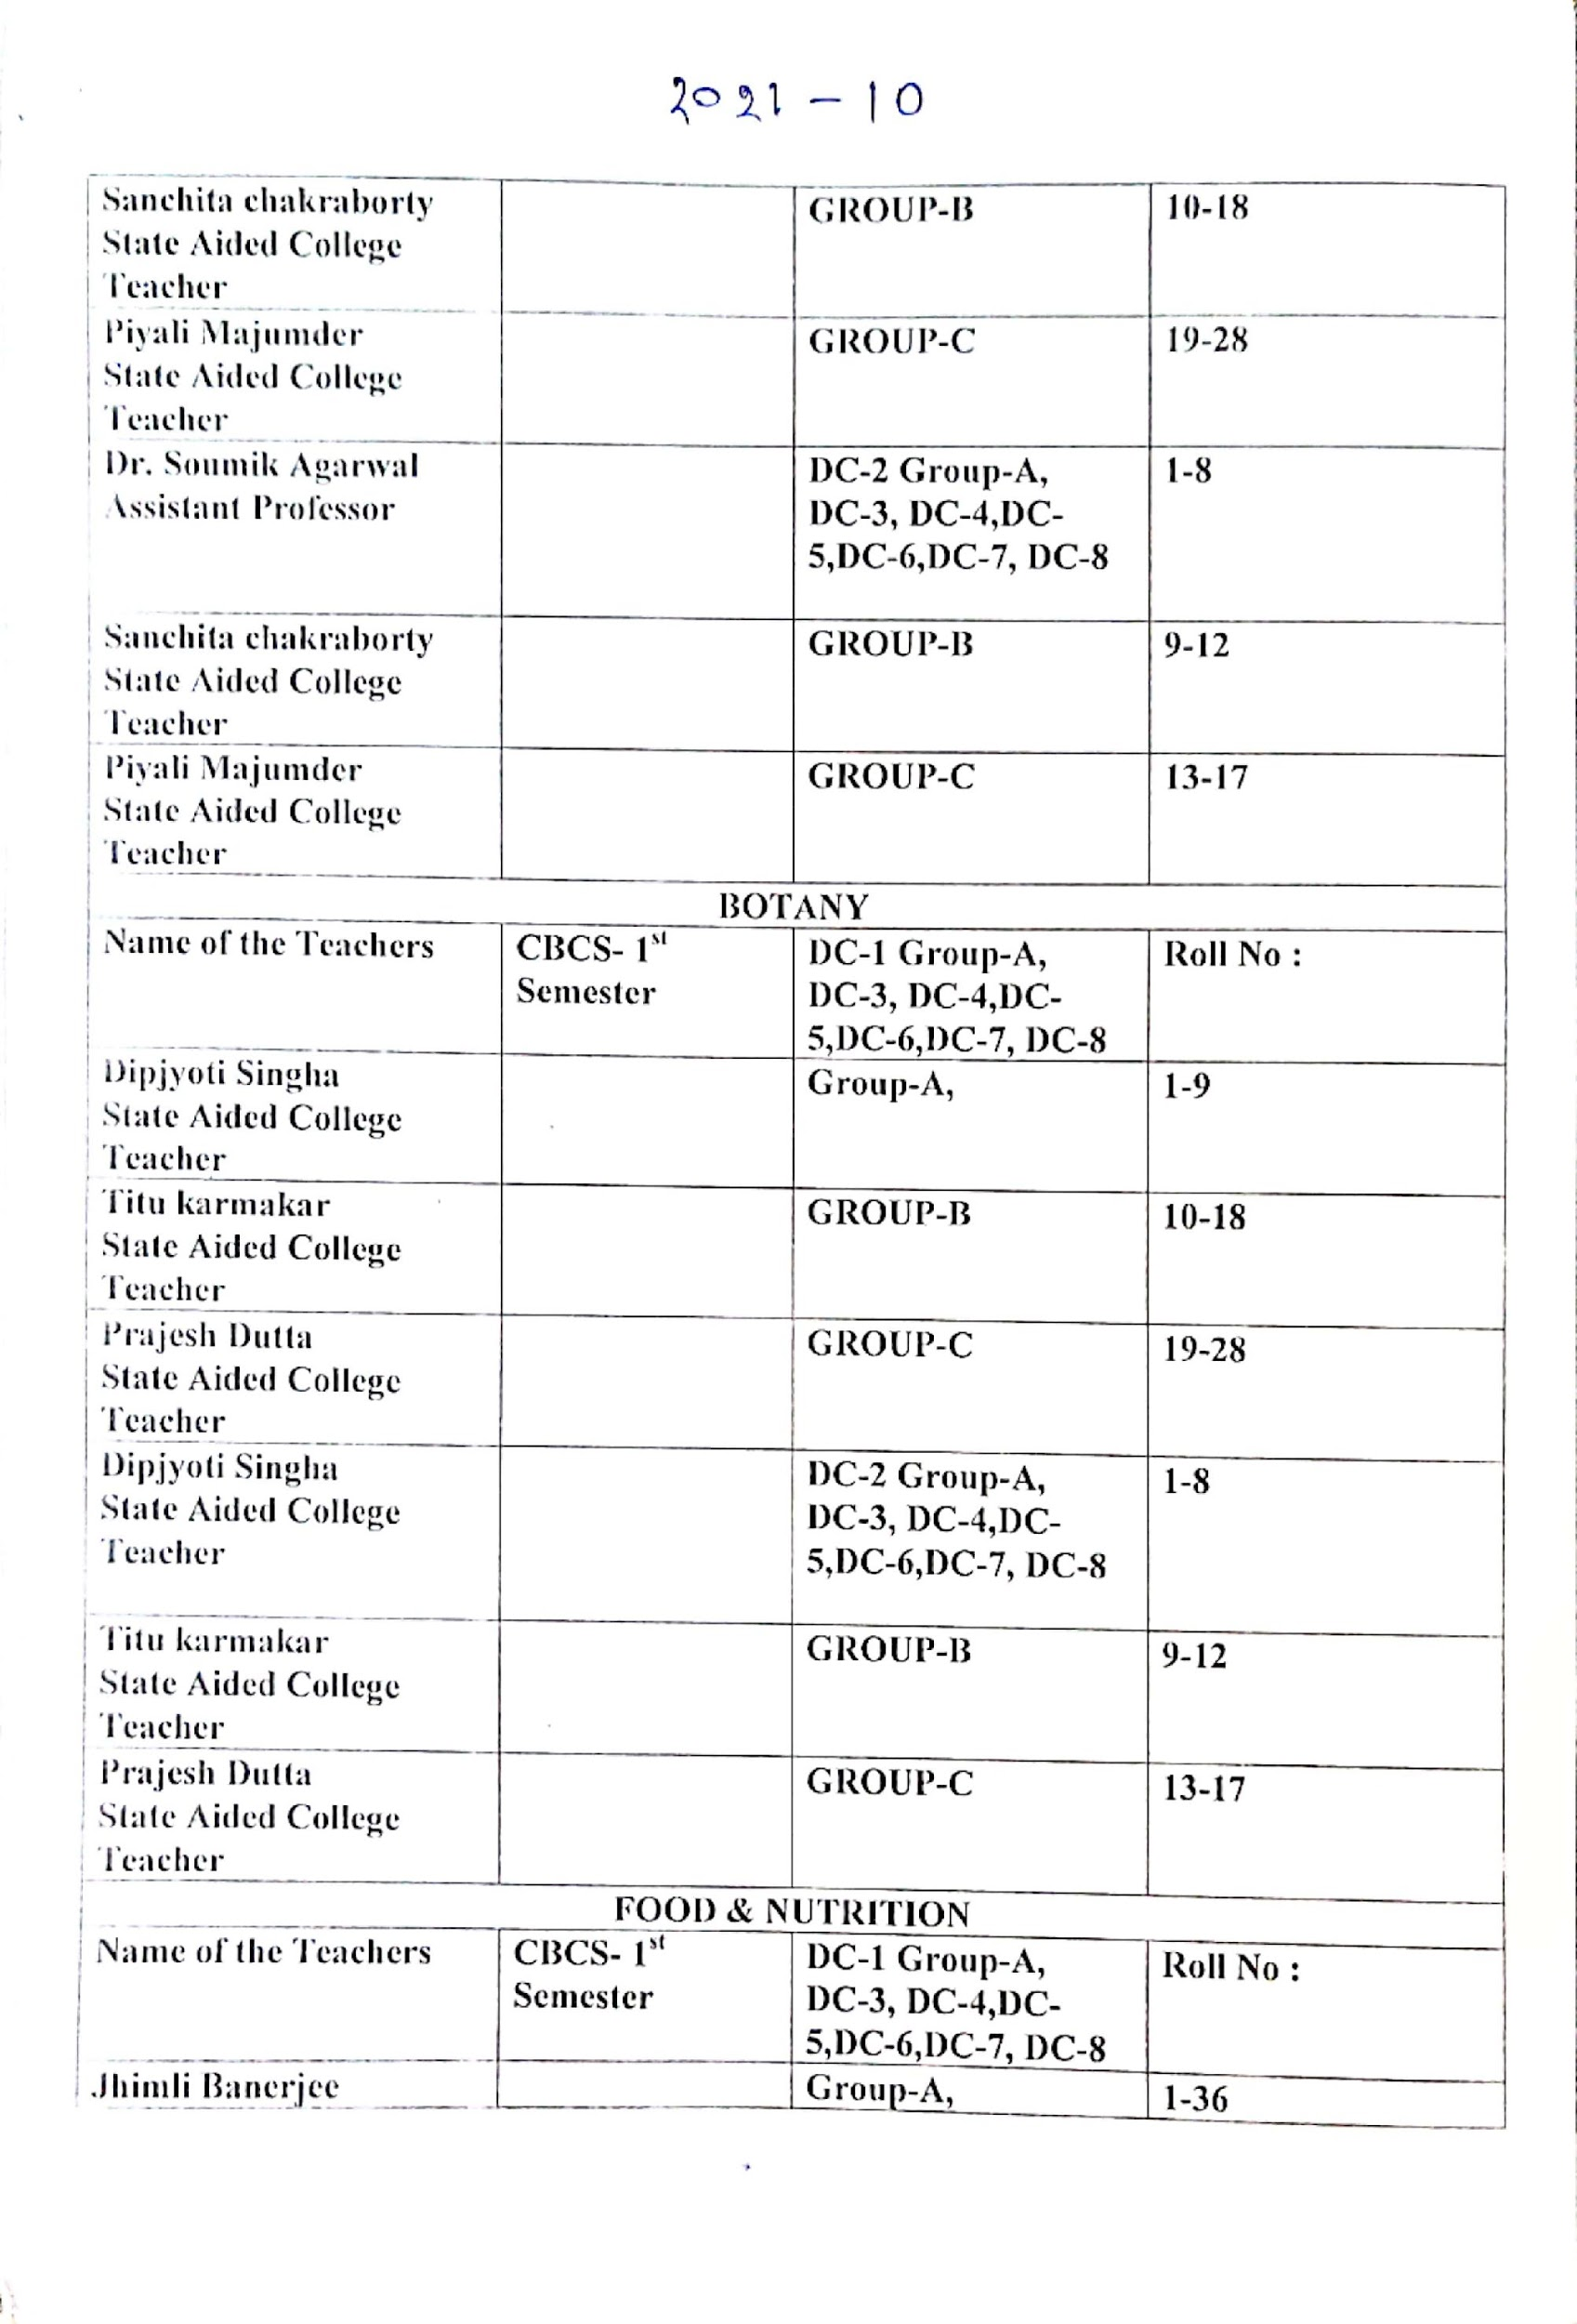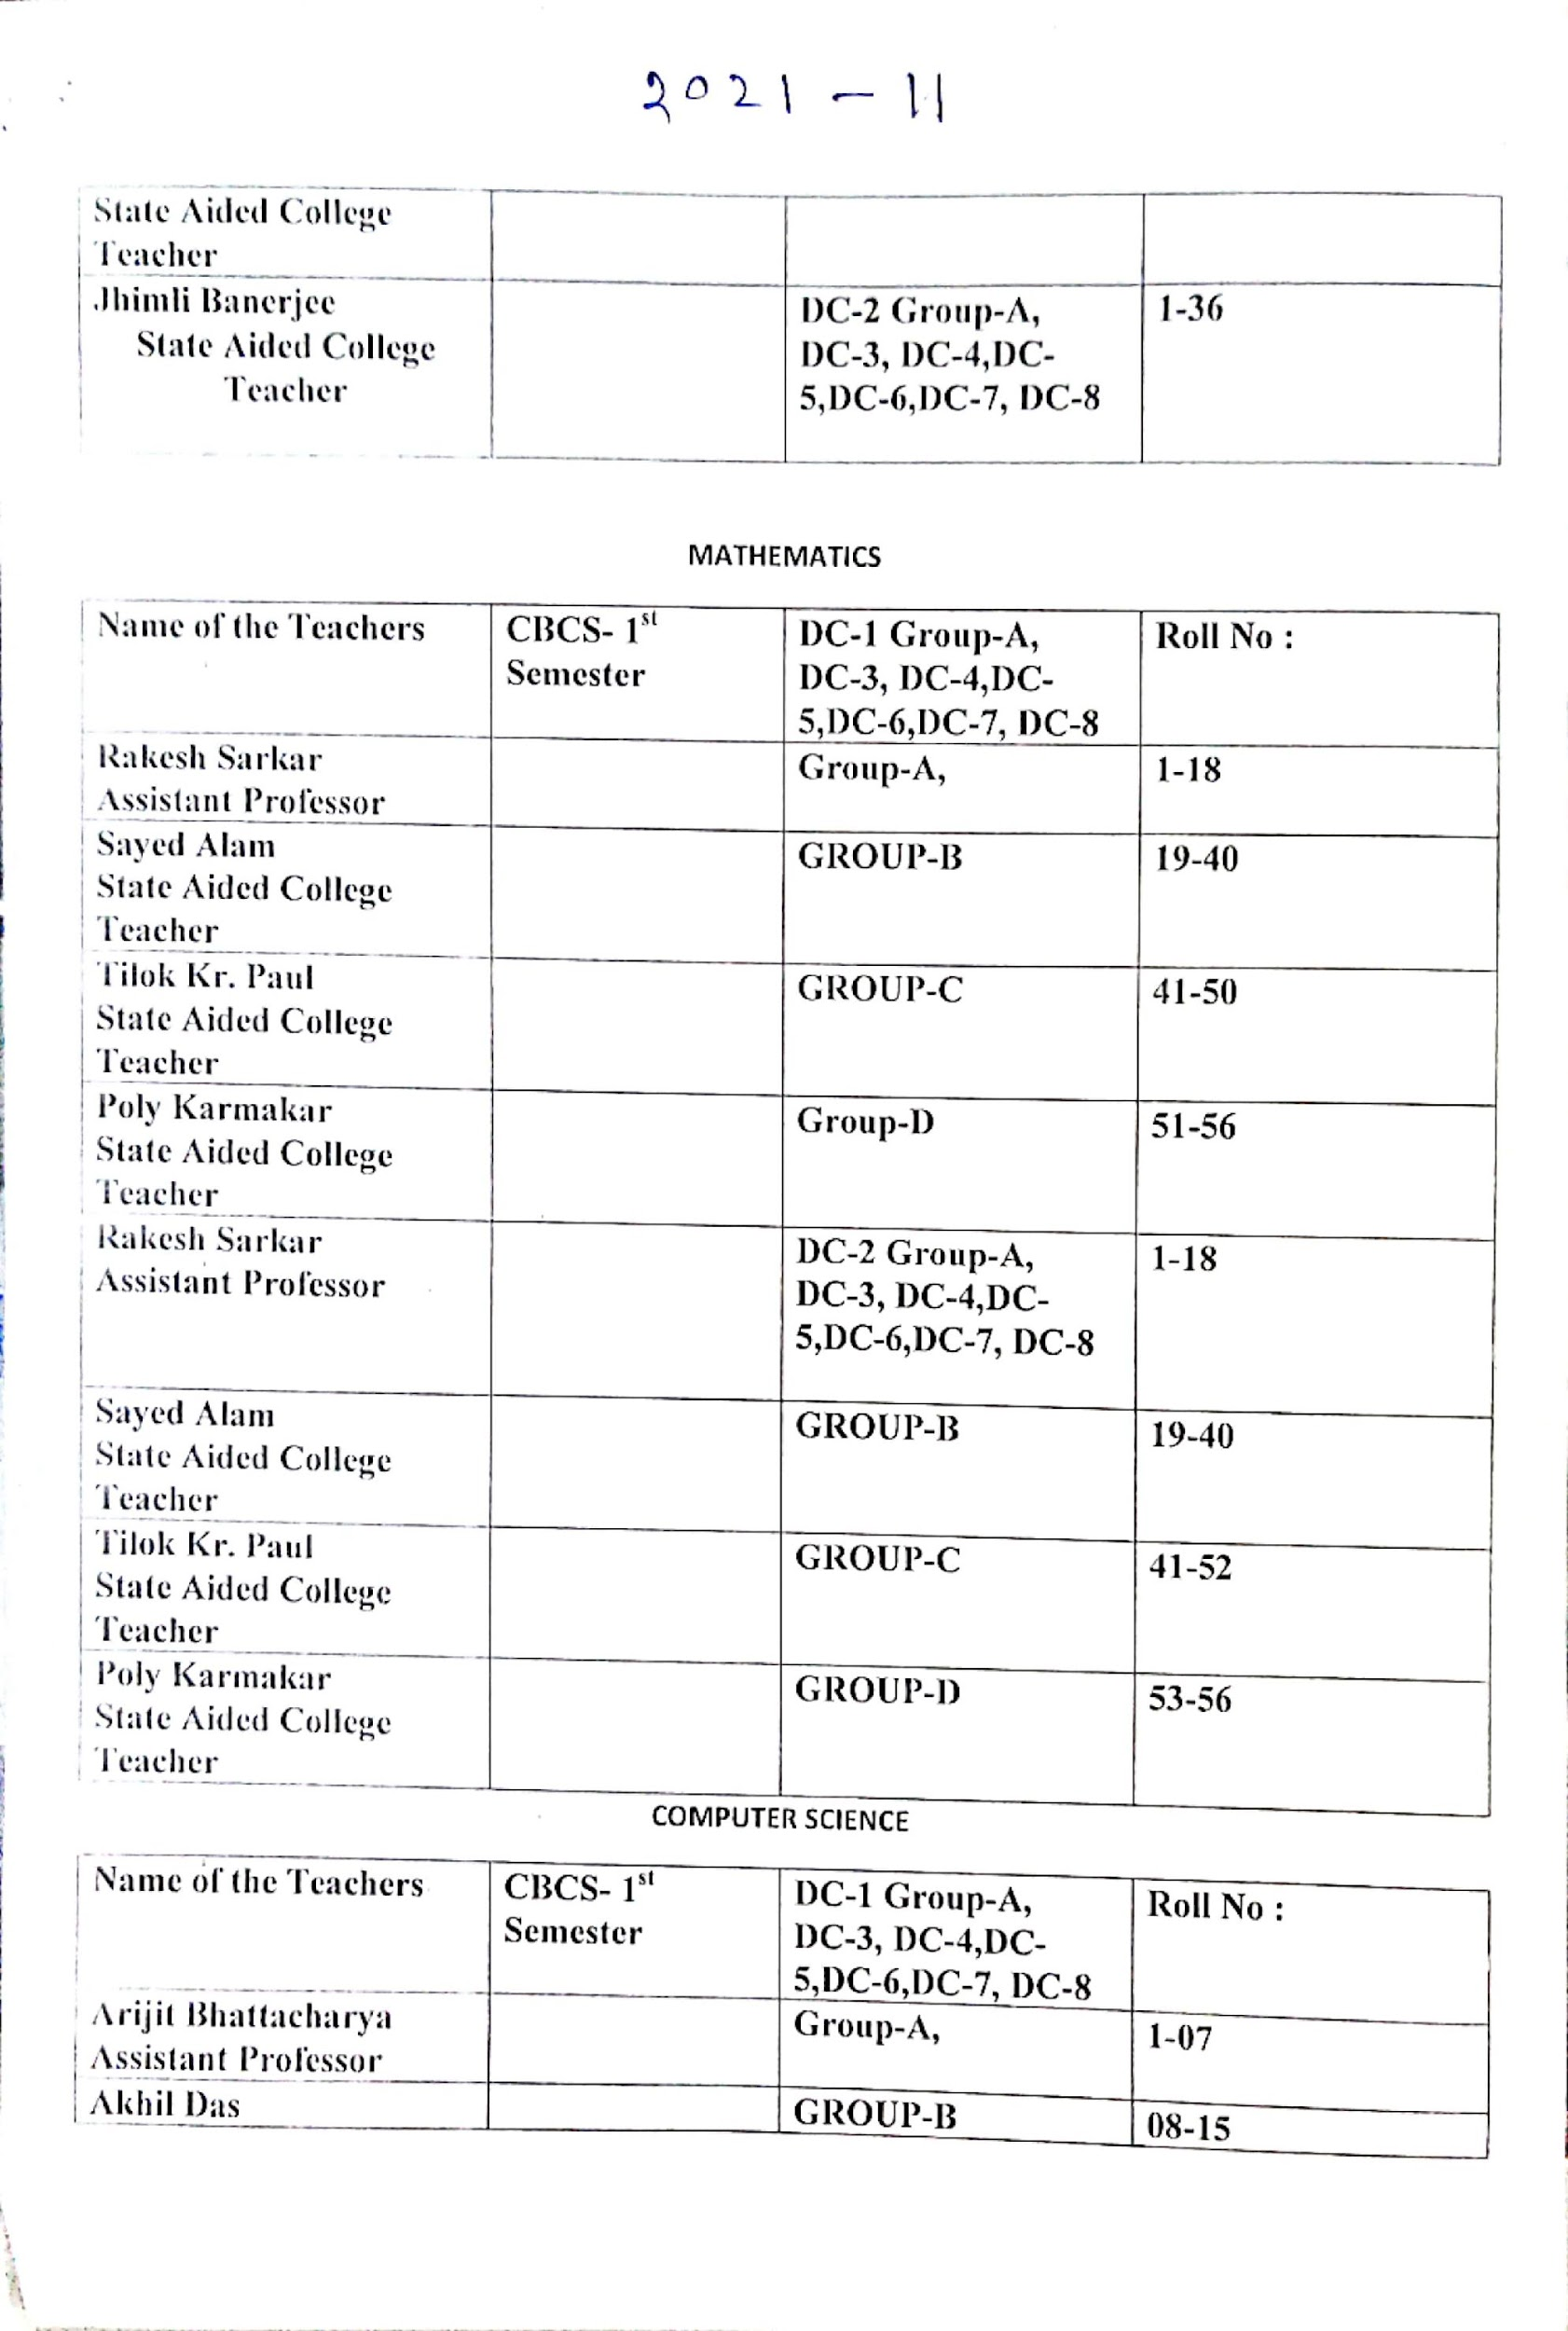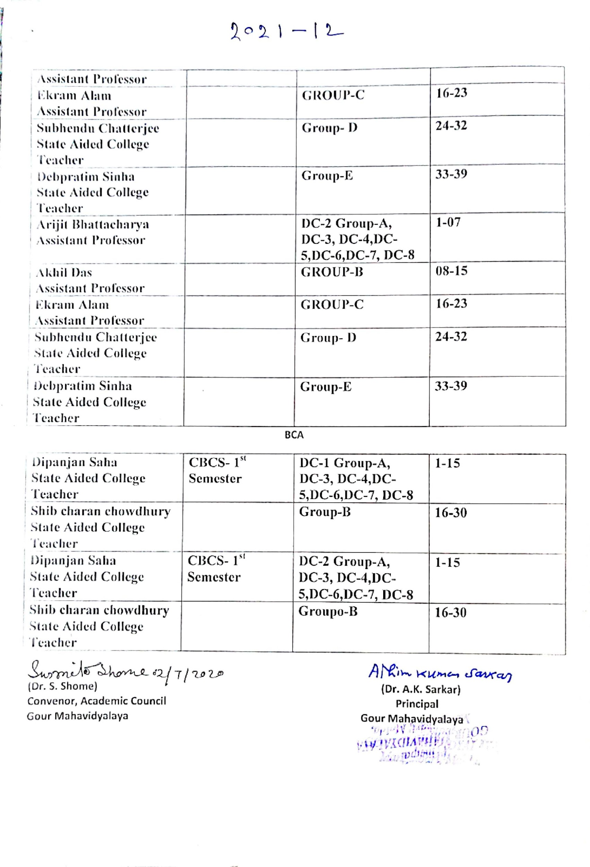

NOTICE

All the faculty members and students of Mathematics honours( 3rd semester and 1st semester are asked to note that their special classes concerning Advanced and Slow learners teaching and learning process would be held from 12.12.2020 to 19.12.2020.
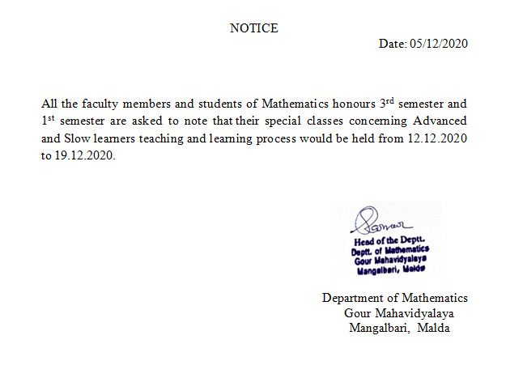

OFFLINE SPECIAL CLASS: ADVANCED AND SLOW LEARNERS:12.12.2020 to 26.12.2020

ADVANCE AND SLOW LEARNERS: CLASS ROUTINE
DATE AND TIME | 2nd SEMESTER | 2nd SEMESTER | 2nd SEMESTER
12.12.2020 | RAKESH SARKAR-GROUP-A- 12 Noon to 1 P.M.-DC-3-GROUP-A | TILAK KUMAR PAL-3 P.M. to 4 P.M.-DC-4-GROUP-B | MD SAHID ALAM 2 P.M. to 3 P.M.( GROUP-C)
14.12.2020 | TILAK KUMAR PAL-GROUP-D-11 A.M. to 12 NOON- DC-3-GROUP-C |  | RAKESH SARKAR- GROUP-2 P.M. to 3 P.M.-DC-4-GROUP-E
15.12.2020 | POLY KARMAKAR- SEM-1-DC-2- 2 P.M. to 3 P.M.-GROUP-A | RAKESH SARKAR S-3 P.M. to 4 P.M. -1-DC-1-GROUP-B | TILAK KUMAR PAL- SEM-1-DC-1-4 P.M. to 5 P.M.
16.12.2020 | RAKESH SARKAR- SEM-111-11 A.M. to 12 NOON-GROUP-A-DC-7 | TILAK KUMAR PAL- SEM-111- DC-5- 4 P.M> to 5 P.M. | MD SAHID ALAM-SEM-111-DC-6- 2 P.M> to 3 P.M.
17.12.2020 | TILAK KUMAR PAL- SEM-1- GROUP-D- 11 A.M> to 12 NOON | POLY KARMAKAR- SEM-1-DC-11-GROUP-E-2 P.M> to 3 P.M.
18.12.2020 | RAKESH SARKAR- SEM-111-11 A.M. to 12 NOON-GROUP-A-DC-7 | POLY KARMAKAR- SEM-111- DC-5- 4 P.M> to 5 P.M. | MD SAHID ALAM-SEM-111-DC-6- 2 P.M> to 3 P.M.
19.12.2020 | TILAK KUMAR PAL- SEM-111-11 A.M. to 12 NOON-GROUP-A-DC-7 | RAKESH SARKAR- SEM-111- DC-5- 4 P.M> to 5 P.M. | MD SAHID ALAM-SEM-111-DC-6- 2 P.M> to 3 P.M.

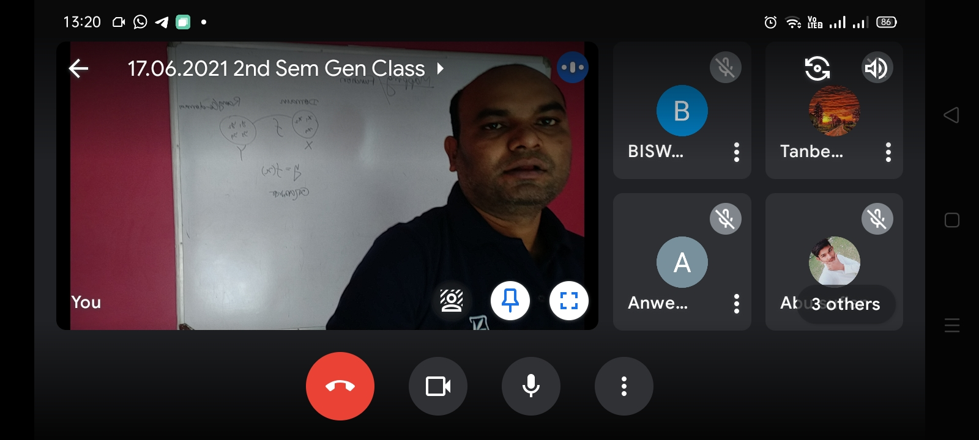  SEMESTER: 1:ADVANCED LEARNERS  12.12.2020: OFFLINE | 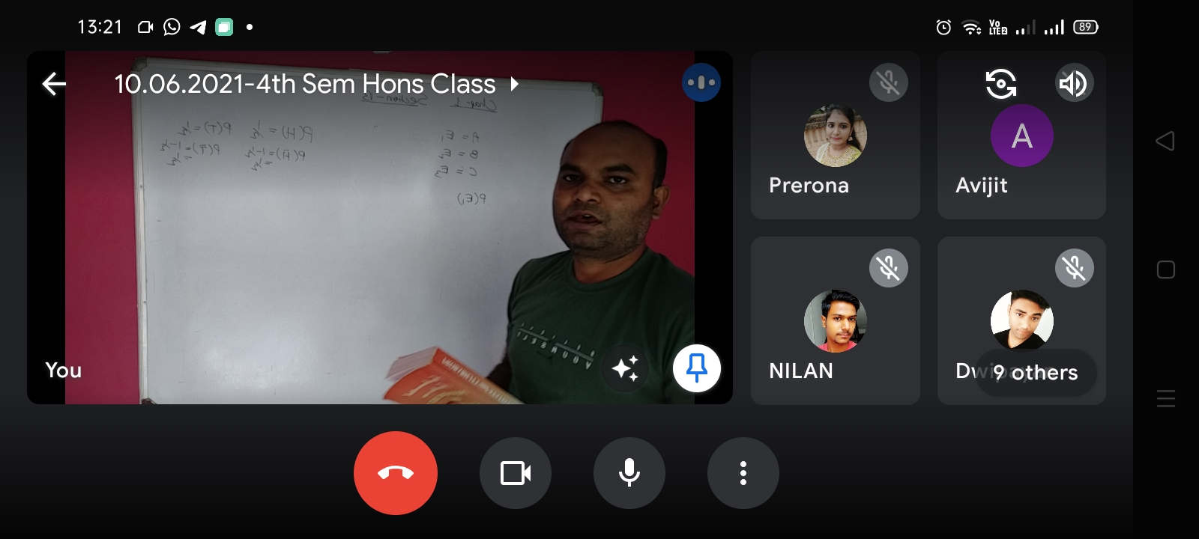  2nd SEMETER: SLOW LEARNERS:18.12.2020: OFFLINE | 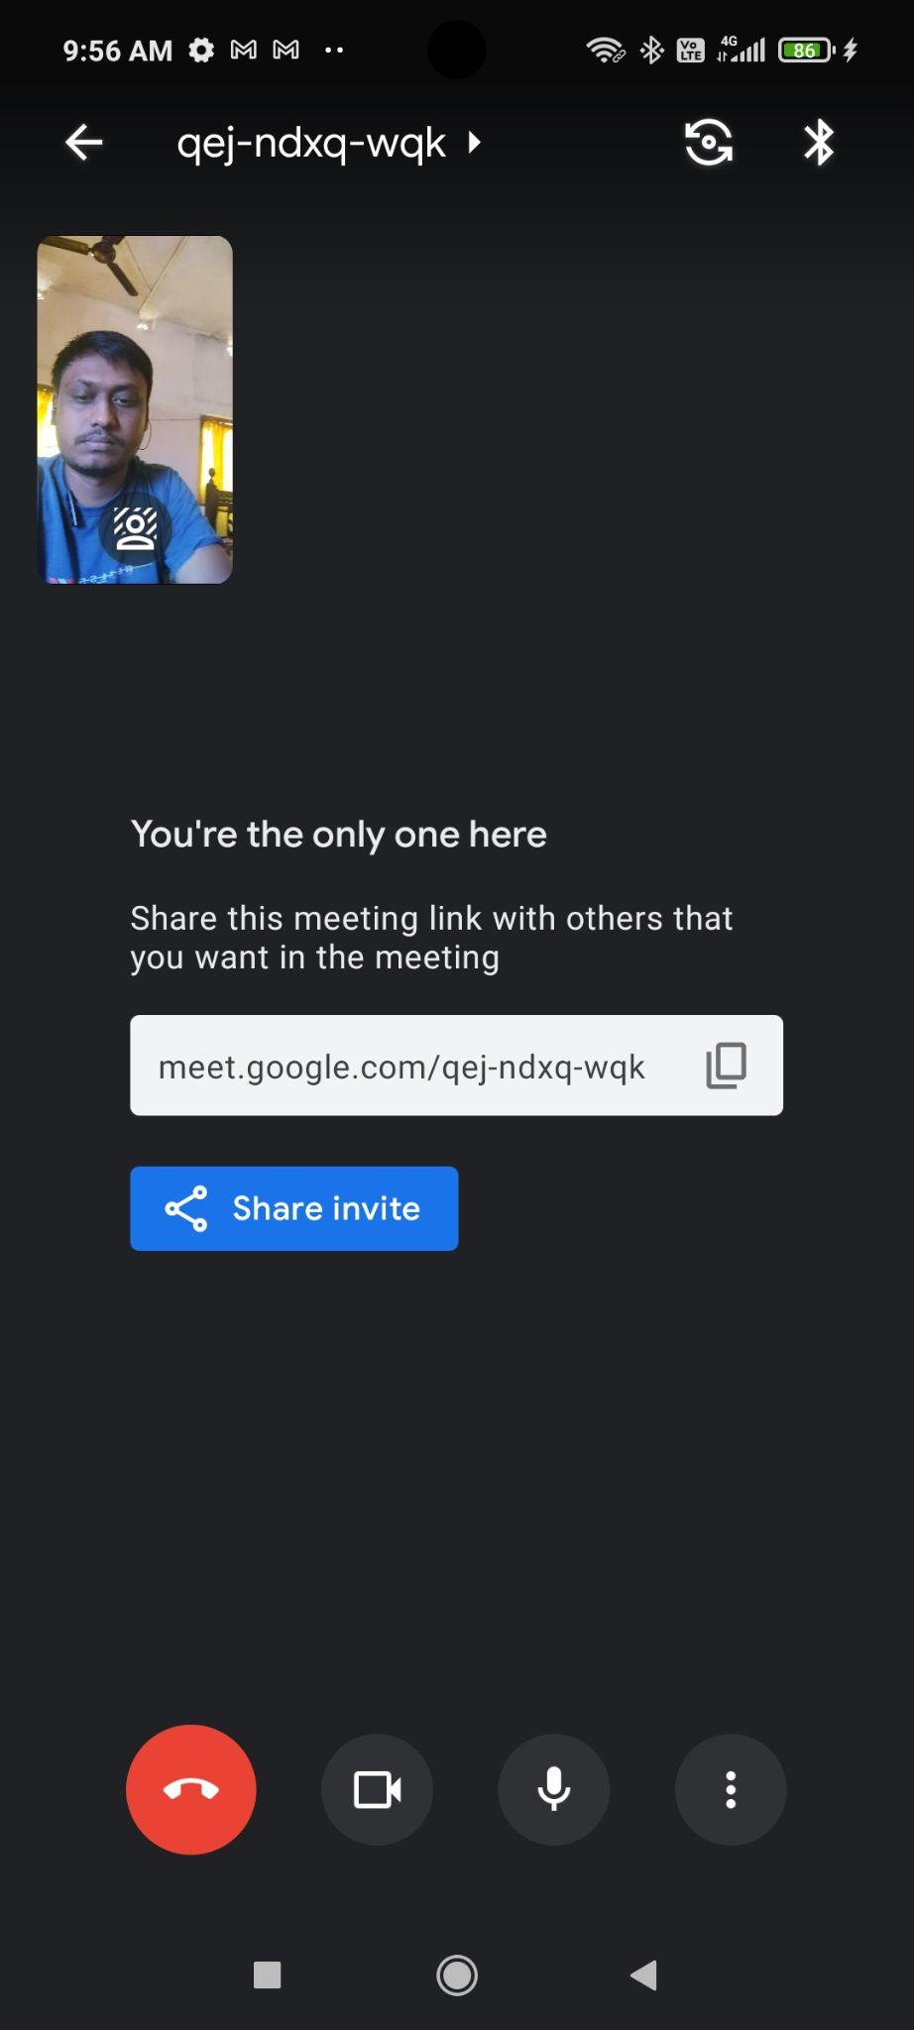  3rd SEMESTER: OFFLINE:14.12.2020

STUDENT-SEMINAR:SUBMISSION OF ASSIGNMENT:2020-2021
NOTICE: HEAD OF THE DEPARTMENT: MATHEMATICS
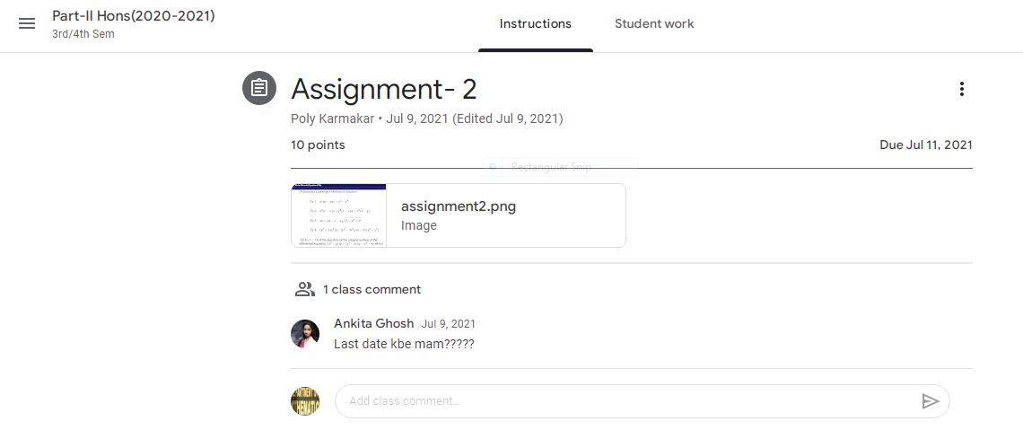

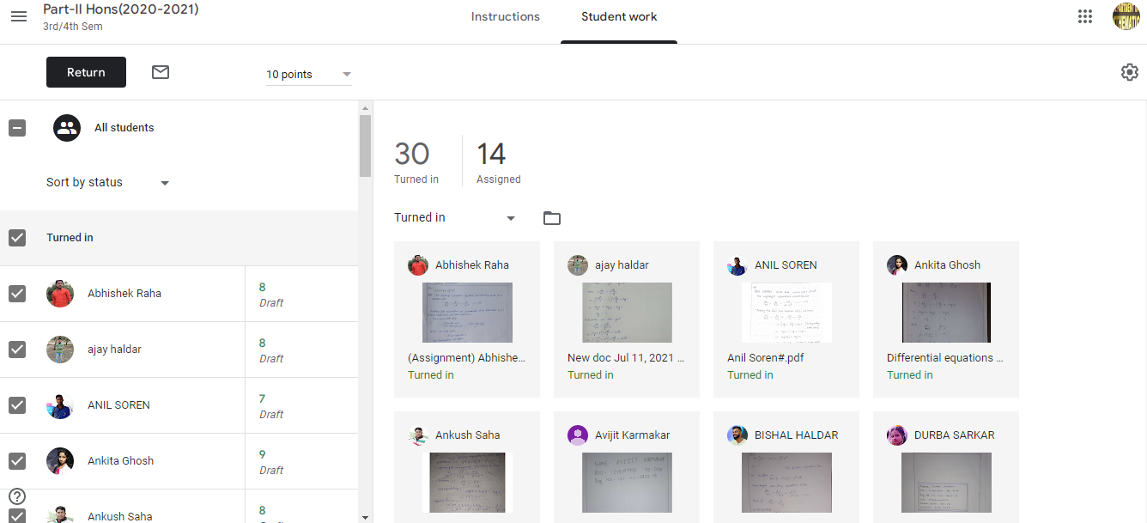

ADVANCED AND SLOW LEARNERS:IDENTIFICATION ON THE BASIS OF RESULT-2020-21
CBCS-SEMESTER-I,II
GROUP-A,TEACHER/MENTOR:RAKESH SARKAR,ASISTANT PROFESSOR:ADVANCED AND SLOW ADVANCED LEARNER

NAME OF THE STUDENT | SEMESTE-I-% -MARKS | SEMESTER-II-% -MARKS | REMARKS
ABHISHEK RAHA | 51% | 94% | IMPROVED SLOW LEARNER
AJAY HALDAR | 64% | 97% | IMPROVED ADVANCED LEARNER
ANIL SOREN | 52% | 89% | IMPROVED SLOW LEARNER
ANKITA GHOSH | 51% | 92% | IMPROVED SLOW LEARNER
ANKUSH SAHA | 60% | 67% | IMPROVED ADVANCED LEARNER
AVIJIT KARMAKAR | 44% | 91% | IMPROVED SLOW LEARNER
BAPI MANDAL | 38% | 90% | IMPROVED SLOW LEARNER
BISHAL HALDAR | 66% | 98% | IMPROVED ADVANCED LEARNER
CBCS-SEMESTER-I,II

GROUP-B- TEACHER/MENTOR- TILAK KUMAR PAL, STATE AIDED COLLEGE TEACHER: ADVANCED AND SLOW ADVANCED LEARNER
NAME | SEMESTE-I-% -MARKS | SEMESTER-II-% -MARKS | REMARKS
DURBA SARKAR | 73% | 97% | IMPROVED ADVANCED LEARNER
DWIPAYAN SAHA | 69% | 92% | IMPROVED ADVANCED LEARNER
FAHAMIDA AMIN | 67% | 92% | IMPROVED ADVANCED LEARNER
GOBINDA DAS | 68% | 93% | IMPROVED ADVANCED LEARNER
KHAILRUL ISLAM | 75% | 94% | IMPROVED ADVANCED LEARNER
MADHUSHREE SARKAR | 83% | 97% | IMPROVED ADVANCED LEARNER
MD ALIM SK | 46% | 93% | IMPROVED SLOW LEARNER
MD ARIF | 59% | 90% | IMPROVED ADVANCED LEARNER
CBCS-SEMESTER-I,II

GROUP-C- TEACHER/MENTOR-MD SAHID ALAM,STATE AIDED COLLEGE TEACHER: ADVANCED AND SLOW ADVANCED LEARNER
NAME | SEMESTE-I-% -MARKS | SEMESTER-II-% -MARKS | REMARKS
NILAN GUPTA | 71% | 96% | IMPROVED ADVANCED LEARNER
NURSAT JAHAN | 72% | 96% | IMPROVED ADVANCED LEARNER
PRANAB SHARMA | 79% | 96% | IMPROVED ADVANCED LEARNER
PRERONA ROY | 72% | 94% | IMPROVED ADVANCED LEARNER
RAJIB SARKAR | 40% | 90% | IMPROVED SLOW LEARNER
ROUSANARA BEGAM | 70% | 98% | IMPROVED ADVANCED LEARNER
RUPAM SAHA | 61 | 93% | IMPROVED ADVANCED LEARNER
SADIA NIHAR | 48% | 94% | IMPROVED SLOW LEARNER
GROUP-D- TEACHER/MENTOR-POLY KARMAKAR,STATE AIDED COLLEGE TEACHER: SLOW LEARNER

NAME | SEMESTE-I-% -MARKS | SEMESTER-II-% -MARKS | REMARKS
SAEDA TABASSUM | 58% | 94% | IMPROVED ADVANCED LEARNER
SAGAR GHOSH | 43% | 91% | IMPROVED SLOW LEARNER
SAHANAJ HOQUE | 43% | 92% | IMPROVED SLOW LEARNER
SK RAJESH | 64% | 94% | IMPROVED ADVANCED LEARNER
SOURAV GHOSH | 71% | 96% | IMPROVED ADVANCED LEARNER
SRINATH MURMU | 62% | 91% | IMPROVED ADVANCED LEARNER
SUBHAJIT MANDAL | 62% | 88% | IMPROVED ADVANCED LEARNER
SUBHRADEEP DAS | 63% | 90% | IMPROVED ADVANCED LEARNER
TINA SAHANI | 41% | 92% | IMPROVED SLOW LEARNER

NOTICE

All the faculty members and students of Mathematics honours( 4th semester and 2nd semester are asked to note that their special classes concerning Advanced and Slow learners teaching and learning process would be held from 19.05.2021 to 22.05.2021.
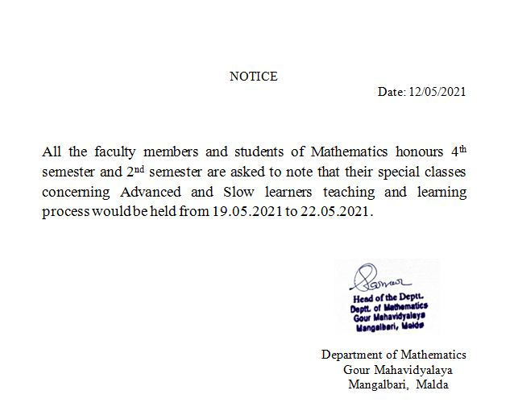

ADVANCED AND SLOW LEARNERS: CLASS ROUTINE
DATE AND TIME | SEM-IV-DC-8  Tilak Kumar Pal & Poly Karmakar | SEM-IV-DC-9  Rakesh Sarkar | SEM-IV-DC-10:  Md Sahid Alam
19.05.2021 | 11.30A.M. to 12.15 P.M.( GROUP-A) | 3 P.M. to 4 P.M.( GROUP-B) | 2 P.M. to 3 P.M.( GROUP-C)
20.05.2021 | GROUP-D-10 A.M. to 11 A.M. | GROUP- A-10 A.M.to 11 A.M. | 10. A.M. to 11 A.M.-GROUP-C
21.05.2021 | 11.30A.M. to 12.15 P.M.( GROUP-A) | 3 P.M. to 4 P.M.( GROUP-B) | 2 P.M. to 3 P.M.( GROUP-C)
22.05.2021 | GROUP-D-10 A.M. to 11 A.M. | GROUP- A- -10 A.M.to 11 A.M. | 10. A.M. to 11 A.M.-GROUP-C
22.05.2021 | -- | -- | GROUP-A,3 P.M. to 4 P.M.
20.05.2021 | GROUP-D-11 A.M. to 12 NOON- SEMESTER-11-DC-3-GROUP-D | GROUP- A--10 A.M.to 11 A.M.-SEMESTER-11-GROUP- A AND B-DC-4 | SEMESTER-11-10. A.M. to 11 A.M. GROUP-B-DC-4
22.05.2021 | SEMESTER-11- 10 A.M. to 12 NOON- SEMESTER-11-DC-4-GROUP-A | GROUP- A-2 P.M.to 3 A.M.-SEMESTER-11-GROUP- B -DC-3 | SEMESTER-11-4 P.M. to 5 P.M. GROUP-C-DC-4

ONLINE SPECIAL CLASS:ADVANCED AND SLOW LEARNERS:19.05.2021 to 24.05.2021
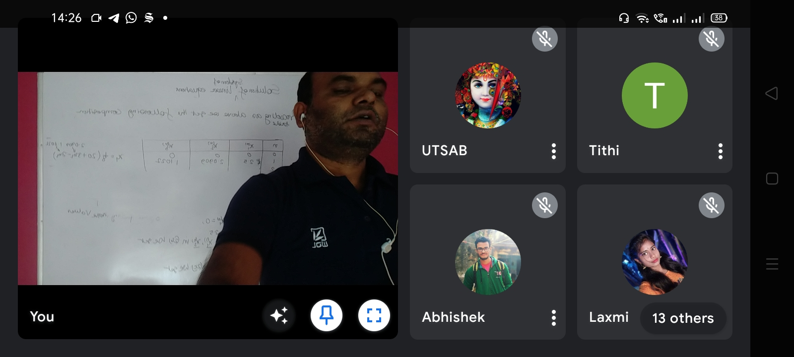  (ClASS: ADVANCED LEARNERS:RAKESH SARKAR, ASSISTANT PROFESSOR: 4-SEMESTER-20.5.2021) | MD SAHID ALAM: 4th SEMESTER;21.05.2021 | 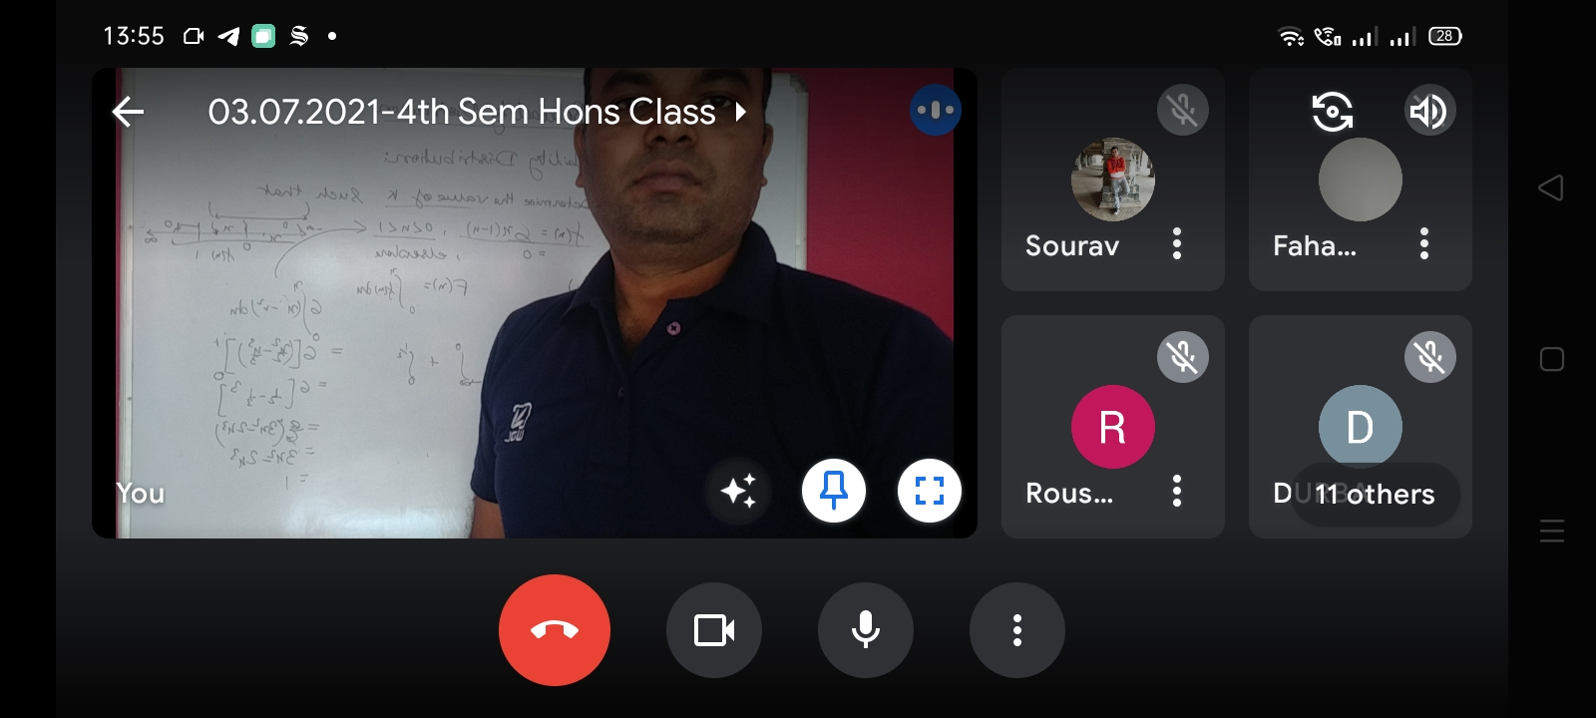  ONLINE CLASS:SEMESTER-4-RAKESH SARKAR, ASSISTANT PROFESSOR: :21.05.2021
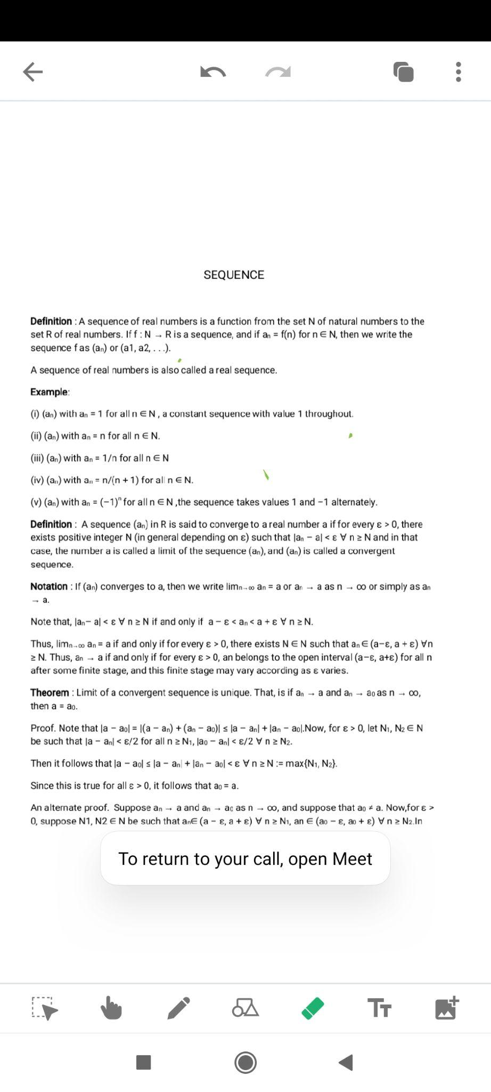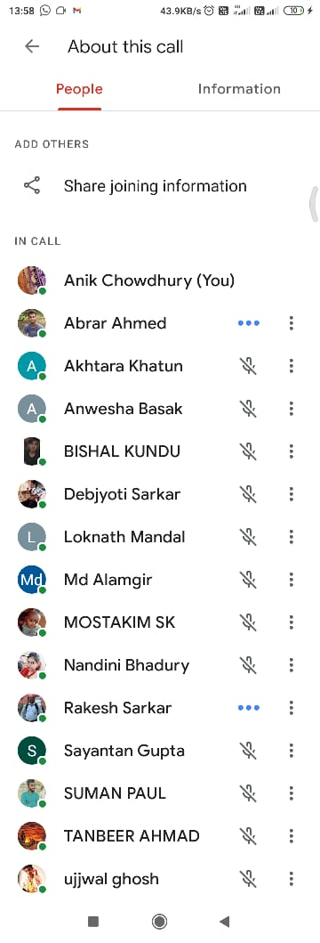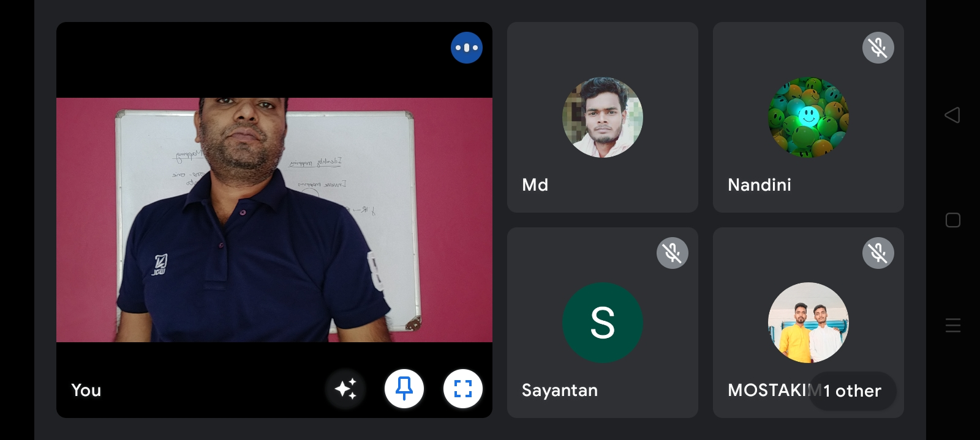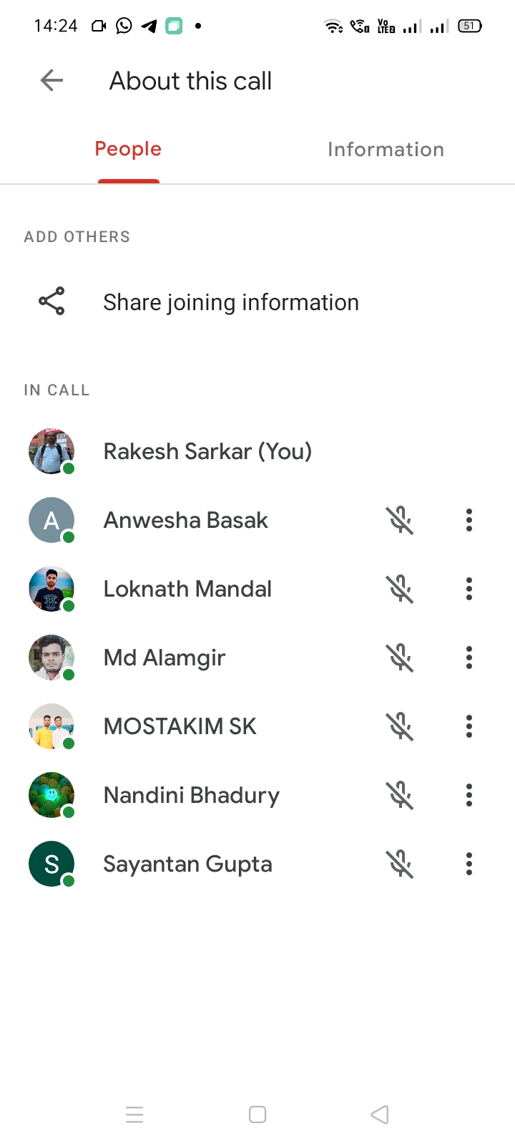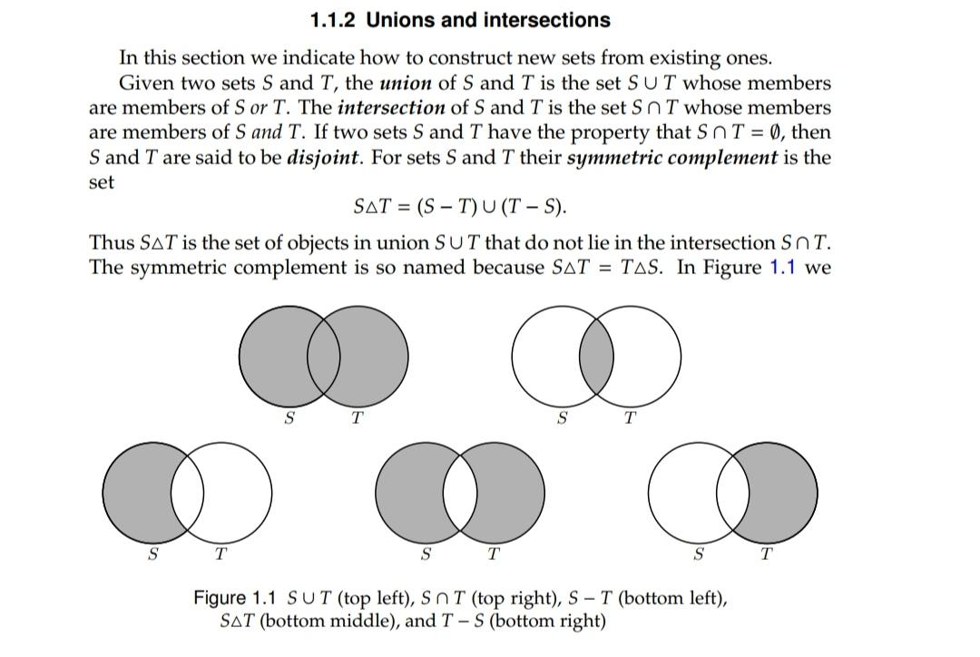

The institution assesses students’ learning levels and organises special programmes for both slow and advanced learners
