GOUR MAHAVIDYALAYA,MANGALBARI,MALDA
DEPARTMENT: HISTORY
2.3. Teaching- Learning Process:
2.3.1.Student centric methods, such as experiential learning, participative learning and problem solving methodologies are used for enhancing learning experiences:
Answer: Yes, 19 Departments conduct various student centric activities throughout the year. The learning becomes more experiential, participatory and socialistic by organizing activities like Seminar/Workshop,Assignment,Student Seminar, Tour/ Field visit and preparation of Project report, Exhibition, Quiz,Debates,and writing articles. Different committees organize cultural programme , and extension/outreach activities. Our students actively participate in co-curricular activities.
1.EXPERIMENTAL LEARNING: One example of experiential learning is going to the zoo or factory or Yoga centre and learning through observation and interaction with the environment, as opposed to reading about animals, production system in a factory or practice of Yoga from a book. Thus, one makes discoveries and experiments with knowledge firsthand, instead of hearing or reading about others' experiences.

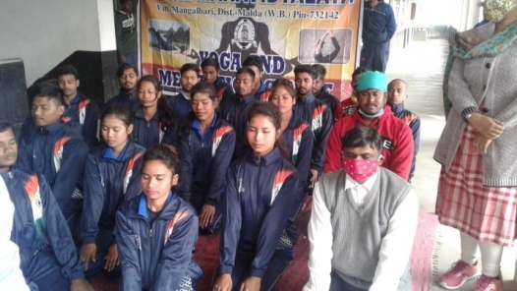
PRACTICAl: YOGA PRACTICE:18.04.2021)
2.Seminar/Workshop:Gour Mahavidyalaya Alumni Association organized a National level seminar on “Research Methodology”. The basic objective is to bring together academicians and experts from different parts of the country and abroad to exchange knowledge and ideas. It provides an in-depth analysis of subjects and update the knowledge of the participants and students .Our Teachers and Students participated .

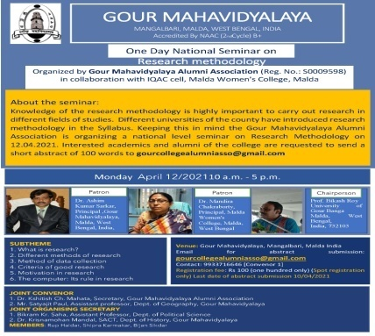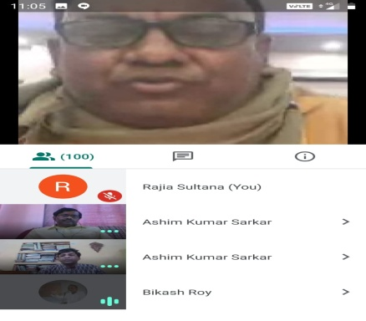

( NATIONAL LEVEL SEMINAR: RESEARCH METHODOLOGY:ONLINE:12.04.2021)

3. PARTICIPATORY LEARNING: (a)Assignment:
Students are asked to submit assignments to check their level of understanding on the subject.

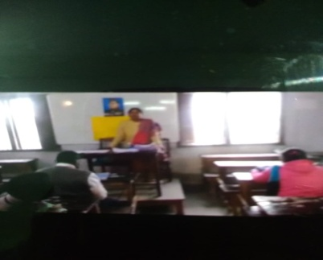
04.03.2021
( ASSIGNMENT COLLECTION : OFFLINE AND DISCUSSION:18.12.2021)

(b)Students conduct seminar on a particular topic.Students prepare seminar paper under the guidance of Teachers,and read out that papers in presence of Teachers,and rest students. Students gain the following skills through the process of organizing seminar : Skills of Group Interaction ,Skills of integrative discussion, skills of critical evaluation ,skills of exploring and mining a Text.

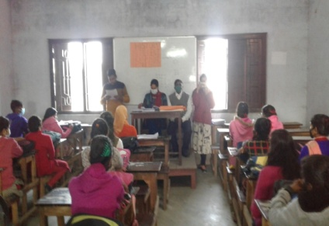
SEMESTER-111- TOPIC:DC-4:MUGHAL LAND REVENUE SYSTEM: DATE:23.12.2020: OFFLINE

(c)Tour/Field visit and submission of project report: Studentsare also taken to field/ industry visits, study tours in India. It exposes them to the world of practical knowledge .Preparation of project report creates interest in research work.

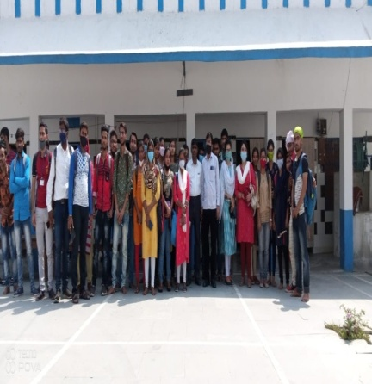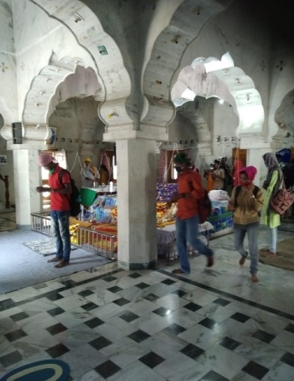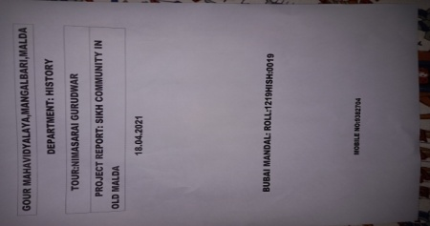

(TOUR: NIMASARI : GURUDWAR:12.04.2021)( PROJECT REPORT: EXAMPLE)

(d).Exhibition: Students organize exhibition,and show their creativity.
(e) Drawing competition:Our students participate in drawing competition.Drwing competetion helps them to develop their creative skills .

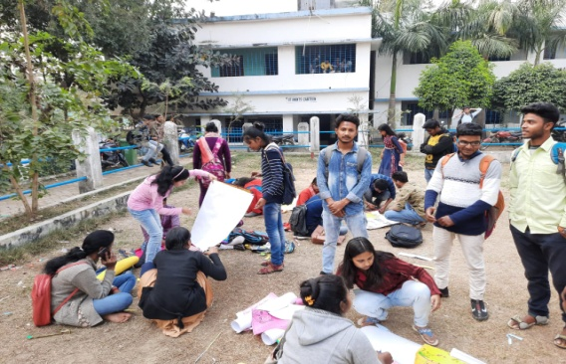
DRAWING COMPETETION

(f). Group discussion: Class room discussion on various topics are our regular features. It stimulates students interest and provides an opportunities to the student for freedom of thought and free exchange of different views.

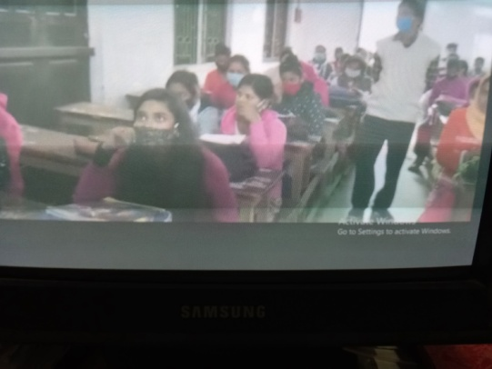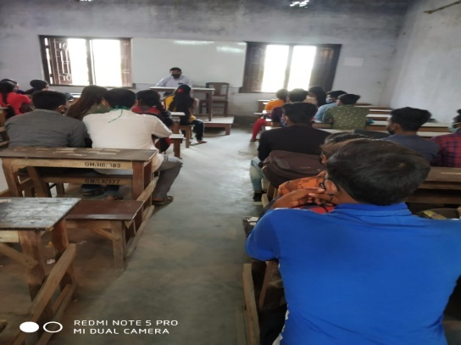

(GROUP DISCUSSION: SEMESTER-ii-05.03.2021,SEMESTER-IV-06.03.2021)

(f) Quiz,Viva-Voice, :Quiz, Viva-voice,group discussion are held from time to time to keep the students in a competitive environment and to check the overall progress of the students.

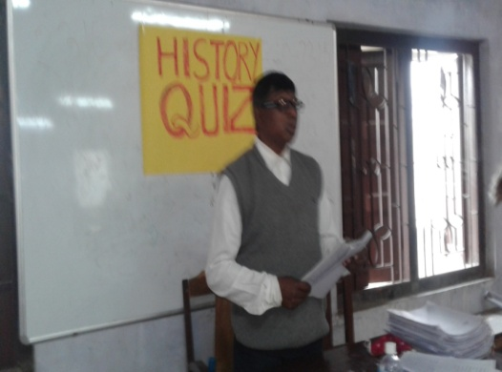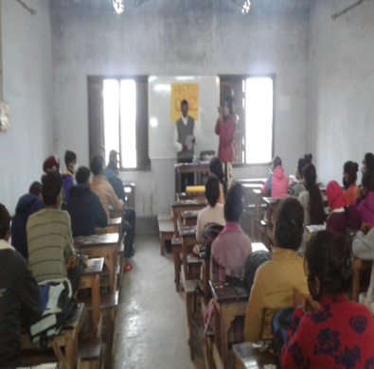

QUIZ COMPETETION: OFFLINE:SEMESTER:IV: DATE:18.03.2021)

(g). Writing articles: The college promotes creativity amongst students by encouraging them to publish articles in the college e- magazine and wall papers.
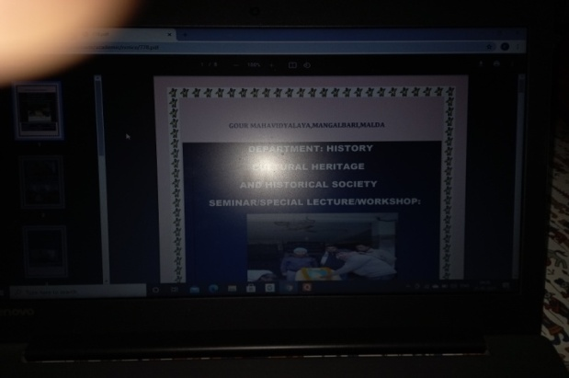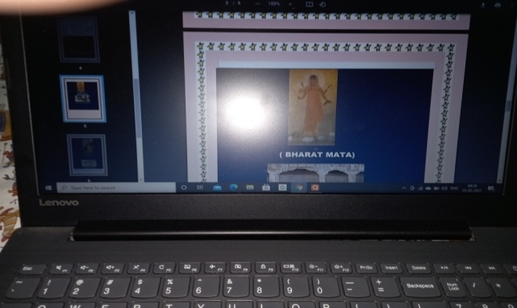

E- MAGAZINE- CULTURAL HERITAGE AND HISTORICAL SOCIETY:ARTICLE BY STUDENTS:SEMESTER-IV.

(h)Participation in extension activities: The National Service Scheme is a students’ empowerment programme through campus community interaction. Two units are vibrant and active. The N.S.S. volunteers have been working for the upliftment of the village community.They have identified the needs and problems of the villagers of Bhatra,Sahapur, Old Malda Block . They have developed a sense of social and civic responsibilities. They have gained skills in mobilizing community participation.They have placed community interest before individual interest. Programme officers have encouraged the volunteers to participate in the N.S.S activities through corporate living and cooperative action.
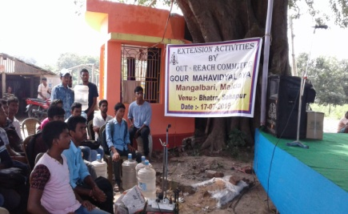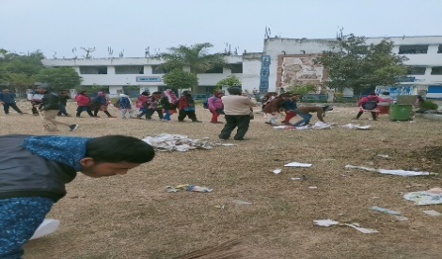
EXTENSION ACTIVITIES: AT VILLAGE BHATRA AND SWACCH BHARAT ABHIYAN:26.01.2021)

4.Problem solving Methods :19 Departments provide students tasks that inculcate in them problem solving skills.

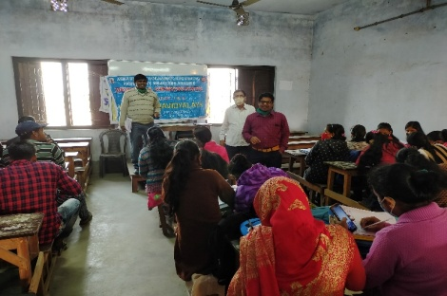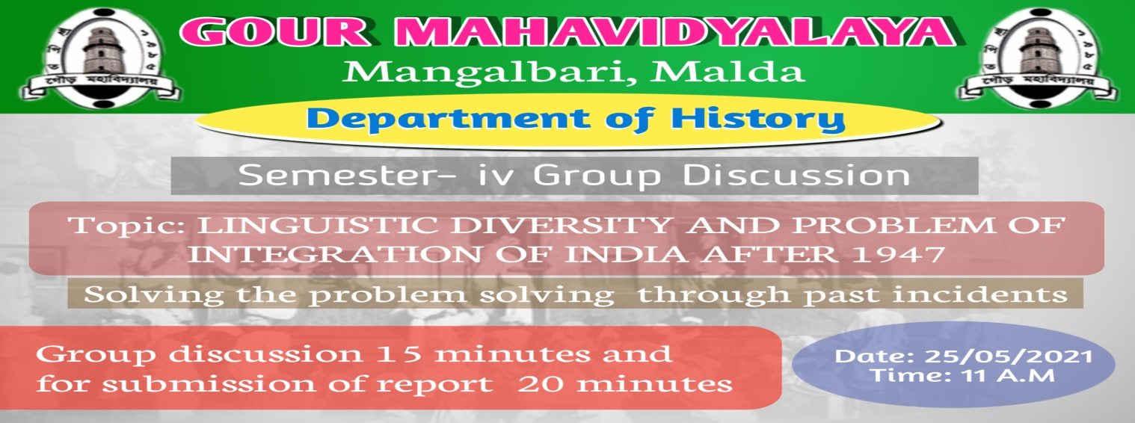
Attendance:
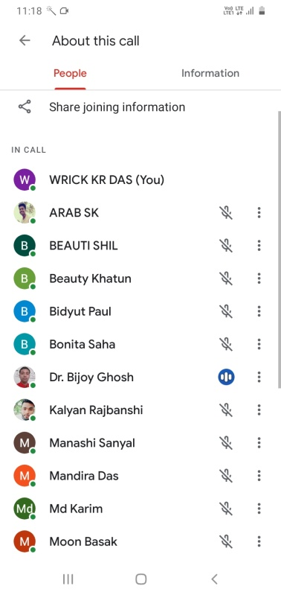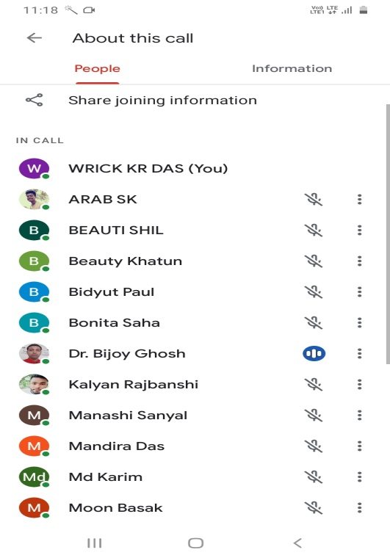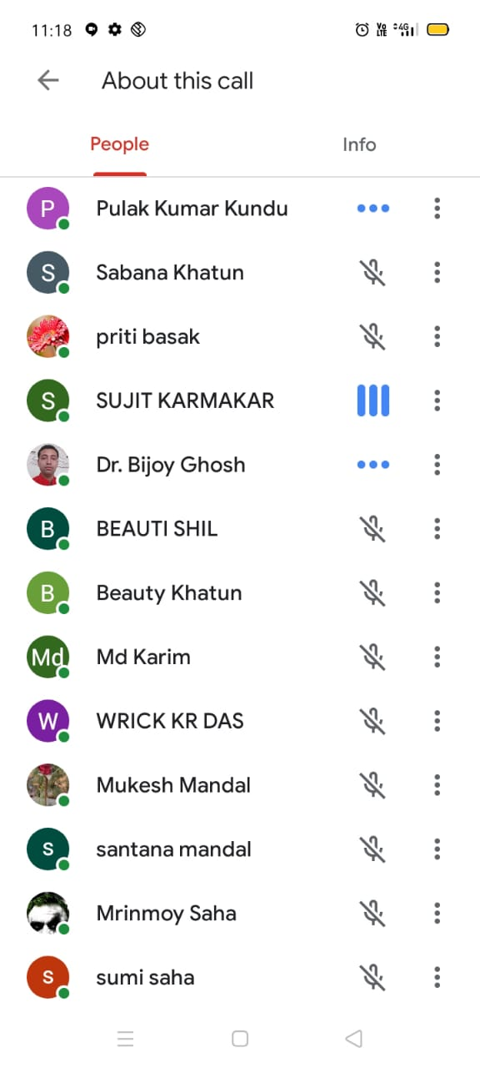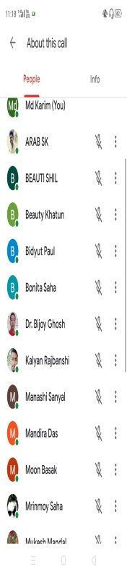

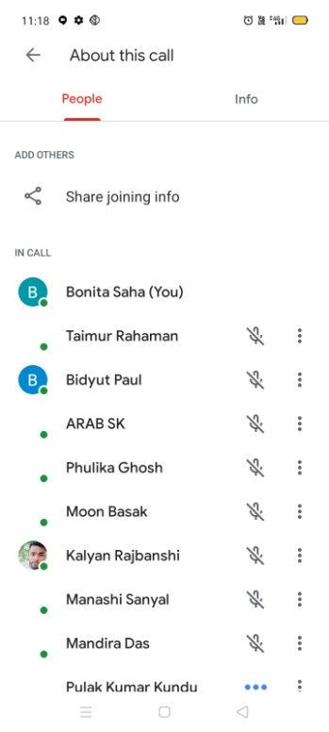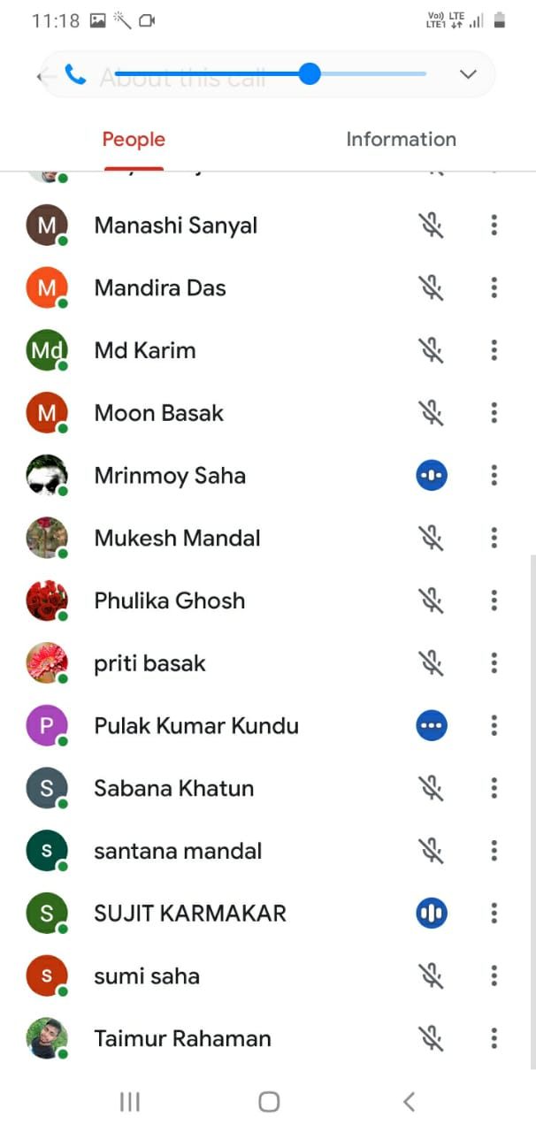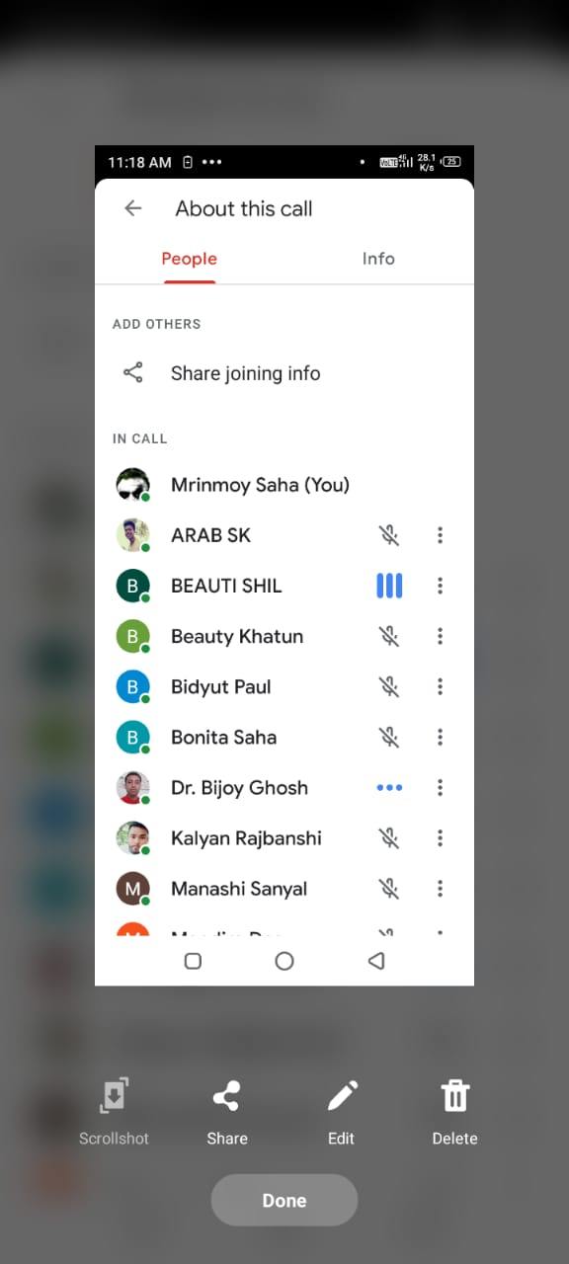

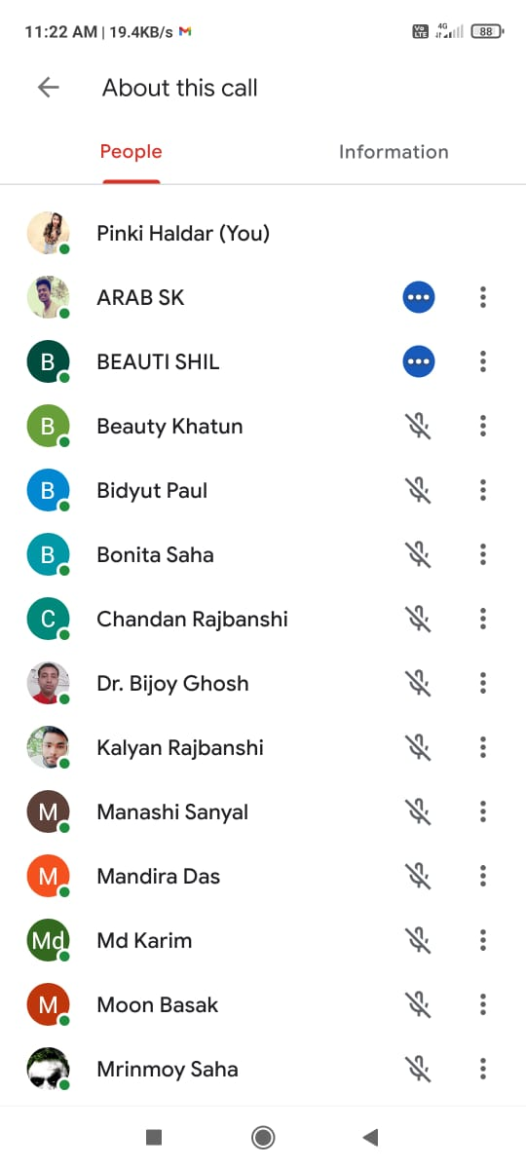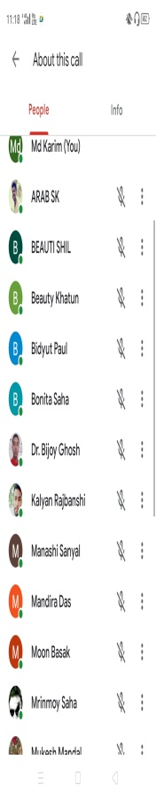
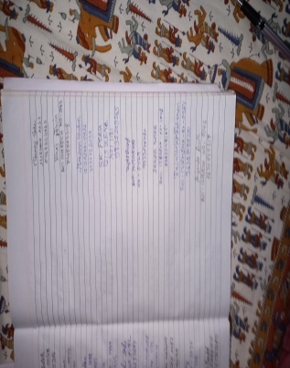 | 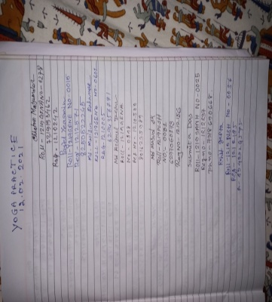 | 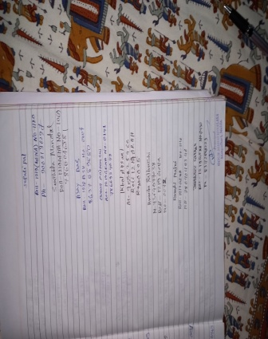
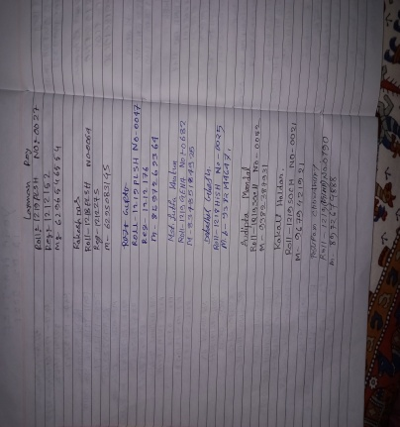 | 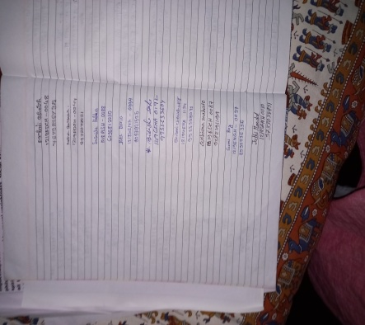 | 