GOUR MAHAVIDYALAYA,MANGALBARI,MALDA
DEPARTMENT: HISTORY
CBCS: SEMESTER
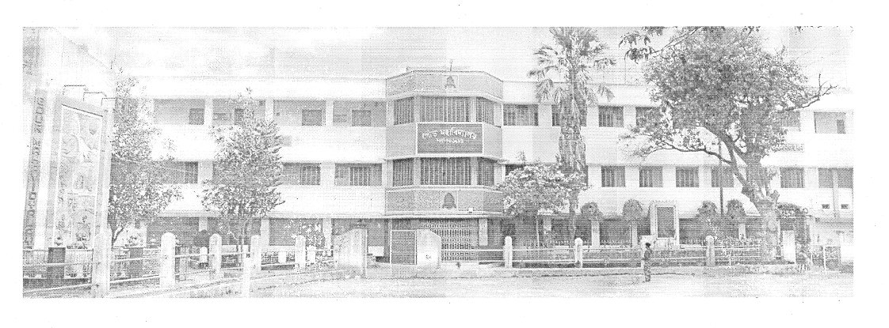
Process Manual for Slow Learners and Advanced Learners :Identification and Activities:2020-2021:
SPECIAL CLASS: ADVANCED AND SLOW LEARNERS:
Roles and Responsibilities of Subject Teacher: Subject Teacher is responsible for carrying out different aspects of slow leaner and advanced learner identification and activities to be conducted Subject Teachers will be responsible for: Conducting class test on unit 1 of 18 marks and duration of one hour.¬ Evaluation of class test answer sheets and preparing the class test result report of¬ class Preparing and maintaining report for whole class based on parameter decided for¬ assessment of the learning levels of the students with their weightage Preparing separate list of slow and advanced learners¬ Preparing schedule for extra sessions /problem solving sessions / revision sessions¬ for slow learners. Conducting the sessions for slow learners as per prepared schedule.
Maintaining the attendance of slow learners sessions and advanced learners:- Preparing the list of advanced assignment or list of tasks assigned to advanced learners. Preparing the report after university result declaration of current semester which shows- the improvement in performance of slow learners to close the loop. Maintain the all records for slow learners and advanced learners activity- Documents to be maintained- Cover page for Slow and Advanced learners Activity Report -result of class test / unit test- Report of marks obtained based on above parameter¬ List of slow learners- List of Advanced Learners- Schedule of activity for slow learners- Attendance record for session conducted for slow learners- Report of performance improvement for slow learners- List / Record of tasks given to advanced learners¬- Expected Outcome- Timely conduction of slow learners activities- Records based on student progress and observation.--- Improvement in University Result.
NEW AQAR AND SSR FORMAT:
2.2. Catering to Student Diversity:
2.2.1. The institution assesses the learning levels of the students and organises special Programmes for advanced learners and slow learners:
Answer:Yes, Gour Mahavidyalaya,Mangalbari,Malda, hasAssessment system of the students and special Programmes for advanced learners and slow learners.

a.After on line admission is over, Academic Council of GourMahavidyalaya fix the date of orientation programme in consultation with Coordinator of IQAC. All the Heads of 19 Departments convene meeting of Departmental Academic Council and chalk out a plan for teaching and learning.
b.Initially faculty members conduct orientation programme and interact with the students to ascertain their background, subject stream, medium of education, aptitude match for the current programme, subject combination, examination system and areas of their interest.Power point presentation is followed during orientation programme.
c.Faculty members use ICT tools during classes.
d.Moreover, each faculty during the class hours identifies the slow or advance learners by interacting with them.
e.During the course of time, a systematic evaluation process is used to assess the learning levels of the students. This evaluation process consist of written examination, open book test, group discussion and presentation, project report, practical examination with viva, written assignment, test and class performance.
f. Link for the proof of tutorial class schedule:
Special programs for slow learners
a.For Slow learners special classes and class test are conducted.
b.Slow learners take the advantage of tutorial classes conducted by the faculty for one to one interaction.
c.Faculty members conduct extra classes for slow learners after class hours like after 3 P.M.
d.Faculty members supply them study materials( Xerox copy).
e.Faculty members check their home task
f.Faculty mentors provide their mentees one to one counseling on improvement areas.
g. Remedial coaching class are arranged.
h. Link for the proof of tutorial class schedule and Remedial class schedule.
i.Online special classes from 4.8.2020 to 25.8.2020
and again from 19.05.2021 to 24.05.2021.
Special programs for advance learners
a.Tutorial examinations are conducted.
b.Learning needs of the advance student are further fulfilled by activities such as
c.Advanced learners also attend Workshops/ Seminars/ Symposiums to keep them updated on various advancements.
d.Academic Committees of 19 Departments of our Institute conduct special lectures,student seminar to improve skills of the students.
e.Advanced students can access INFLIBNET through faculty members’ assistance.

ADVANCED | AND SLOW | LEARNERS | MEWORK

 | FORMAT
SPECIAL CLASS | NOTICE | HEAD OF THE INSTITUTION
SPECIAL CLASS | NOTICE | HEAD OF THE DEPARTMENT
CLASS ROUTINE | RESULT ANALYSIS | IDENTIFICATION OF ADVANCED AND SLOW LEARNERS
SPECIAL CLASS | PHOTO | ATTENDANCE SHEET
STUDENT SEMINAR | NOTICE | PHOTO
ASSIGNMENT | NOTICE | COLLECTION AND DISCUSSION-PHOTO
ADVANCED LEARNERS | MATERIALS SUPPLY | SOURCE: REFRENCE BOO/INFLIBNET-PHOTO
SLOW LEARNERS | SHARING OF FULL ANSWERS | PHOTO
FINAL RESULT | ANALYSIS | REMARKS

NOTICE : HEAD OF THE INSTITUTION
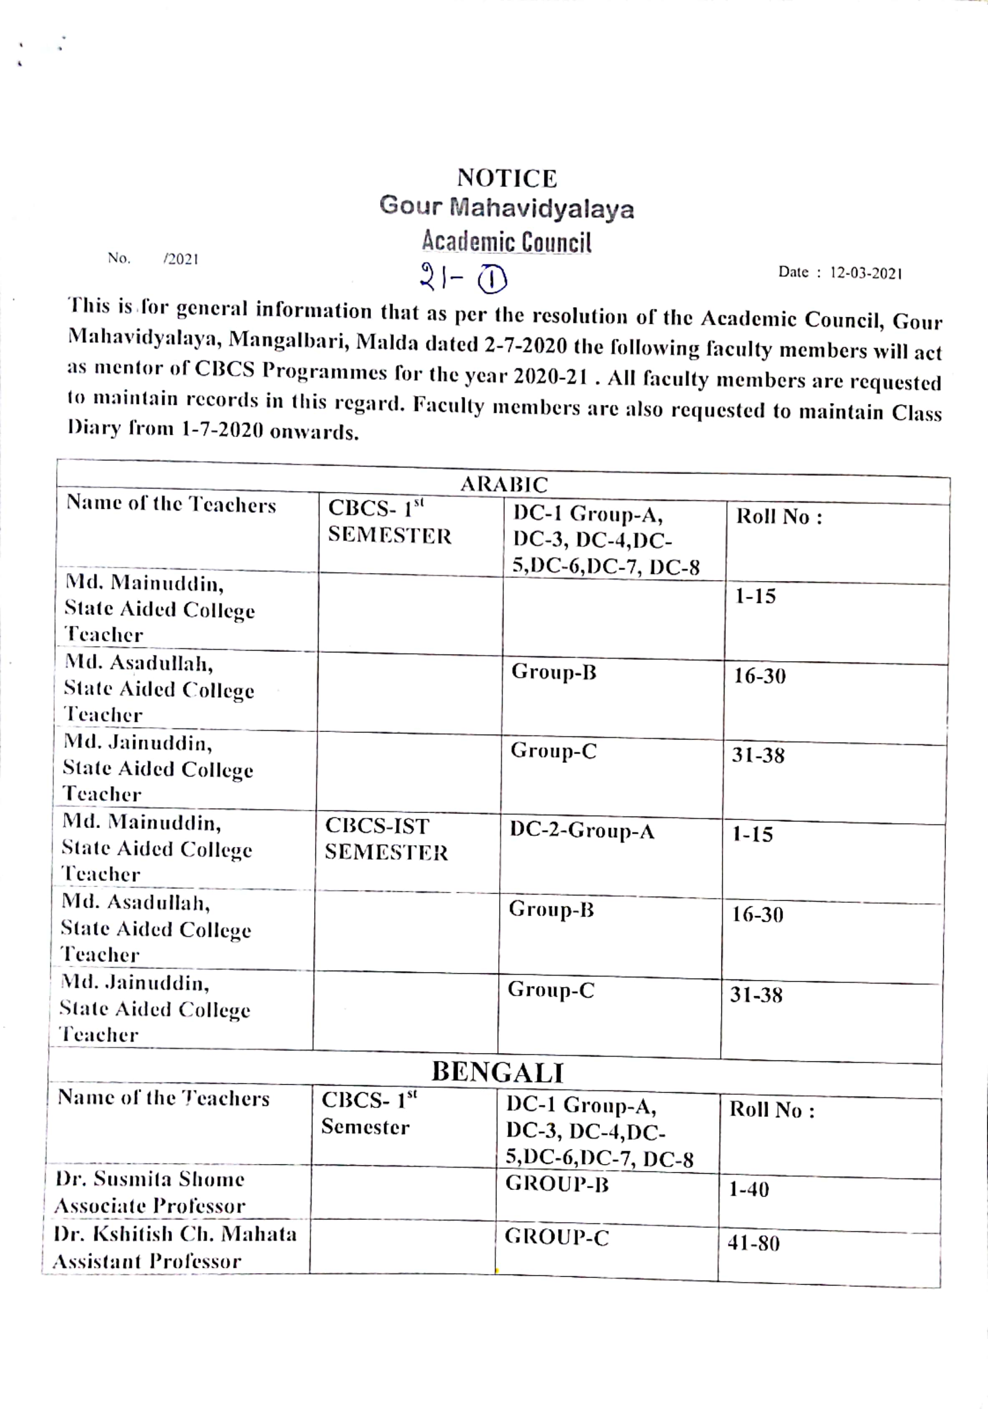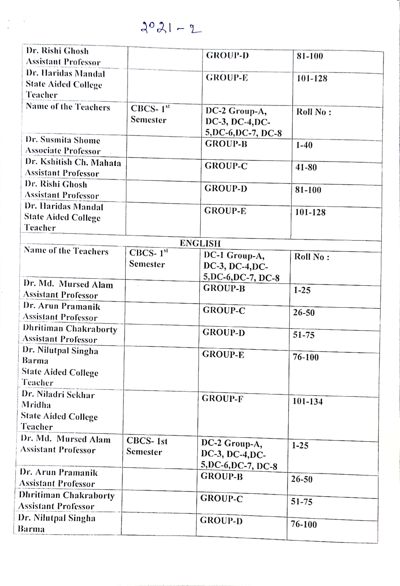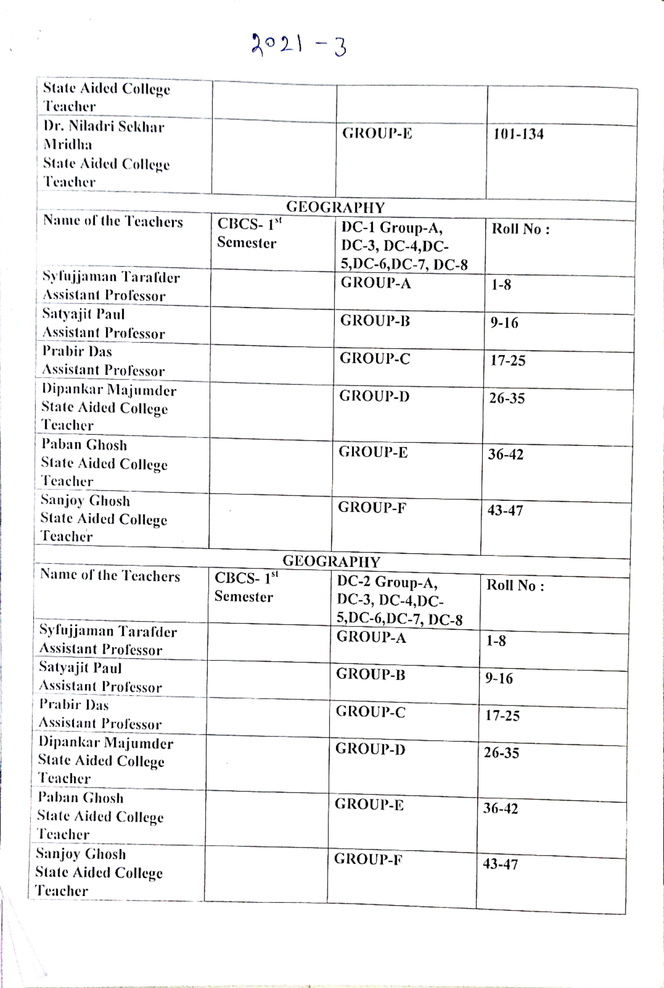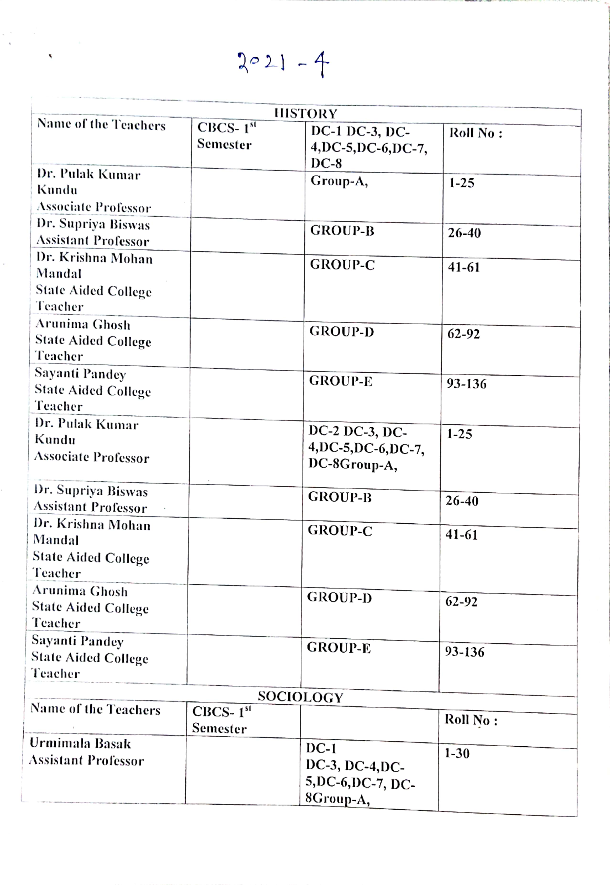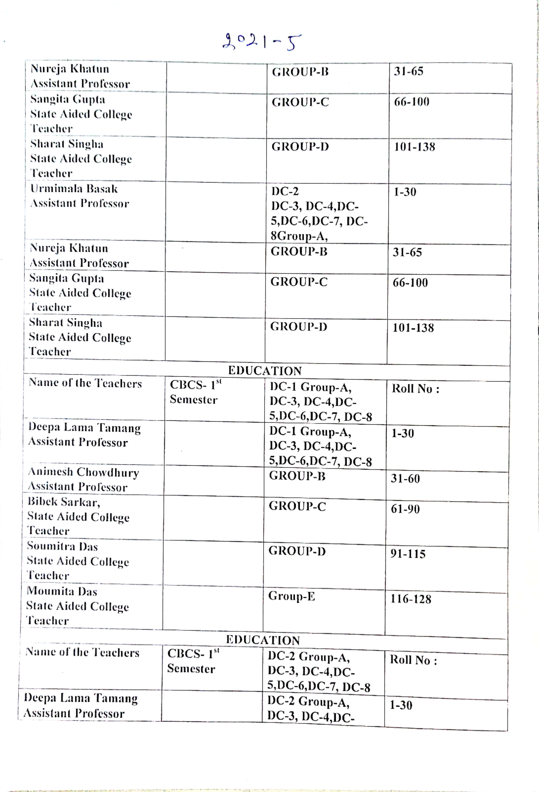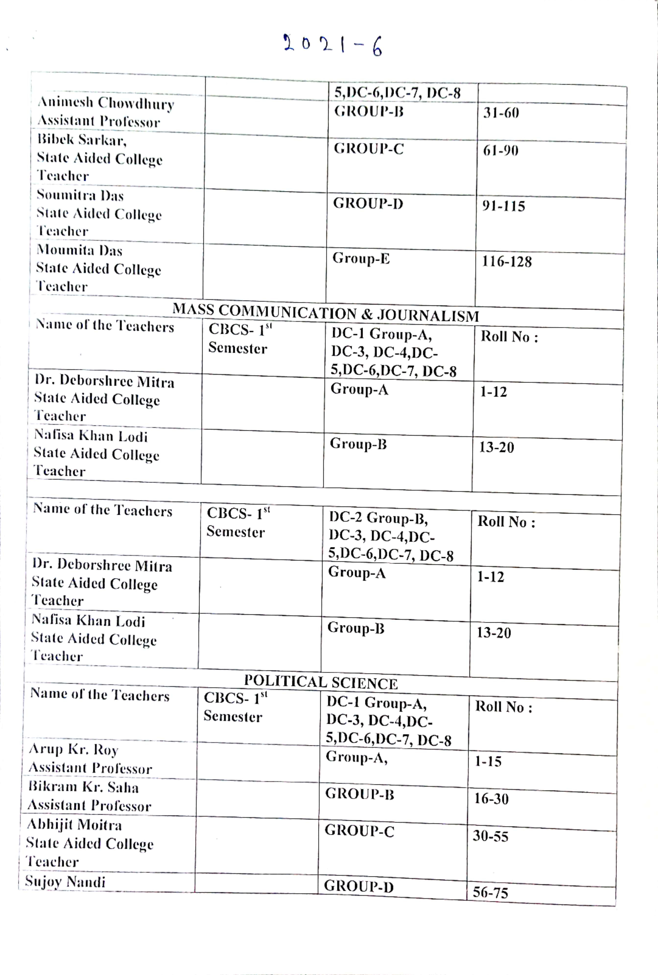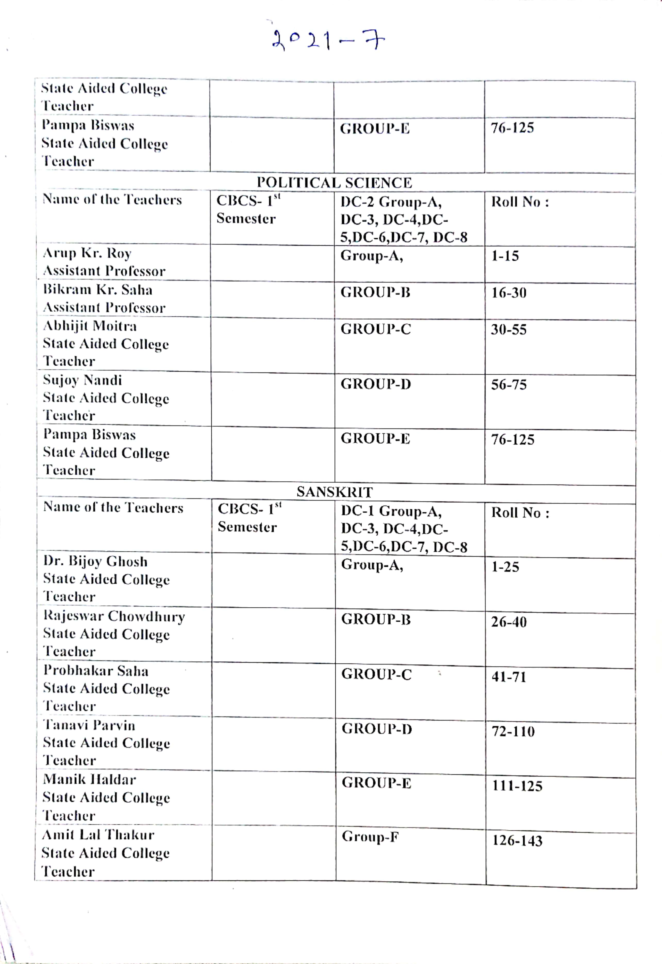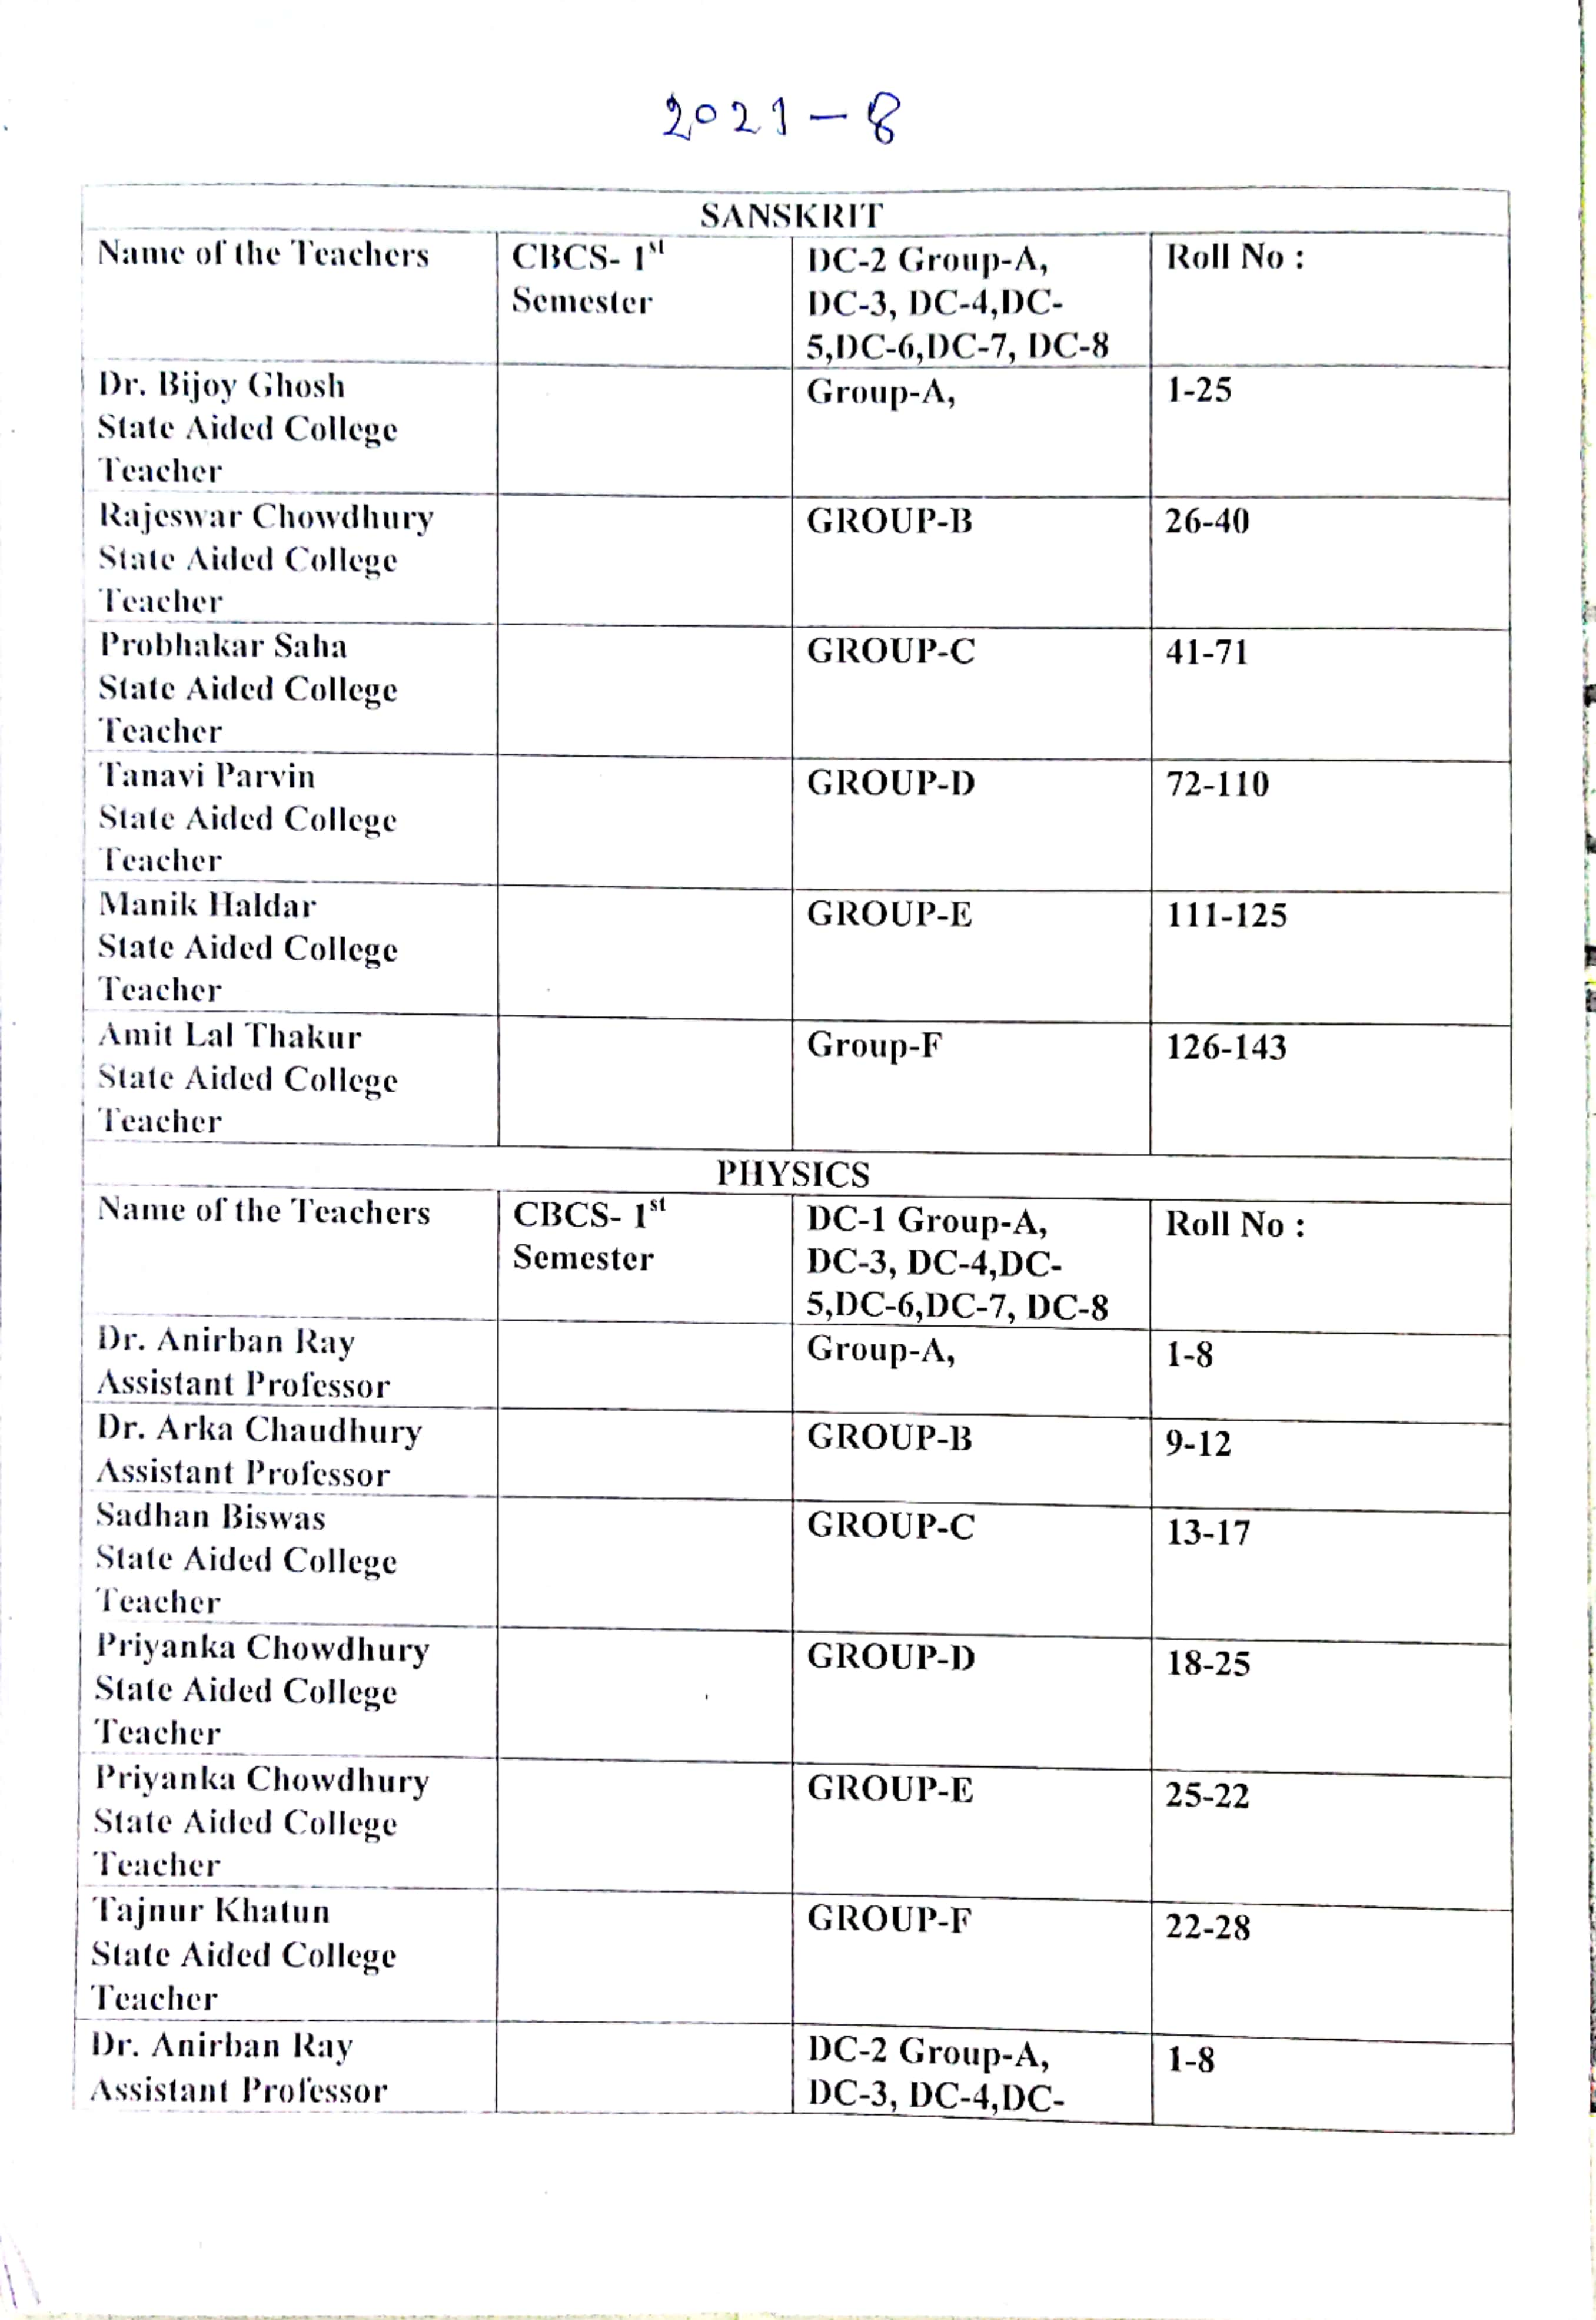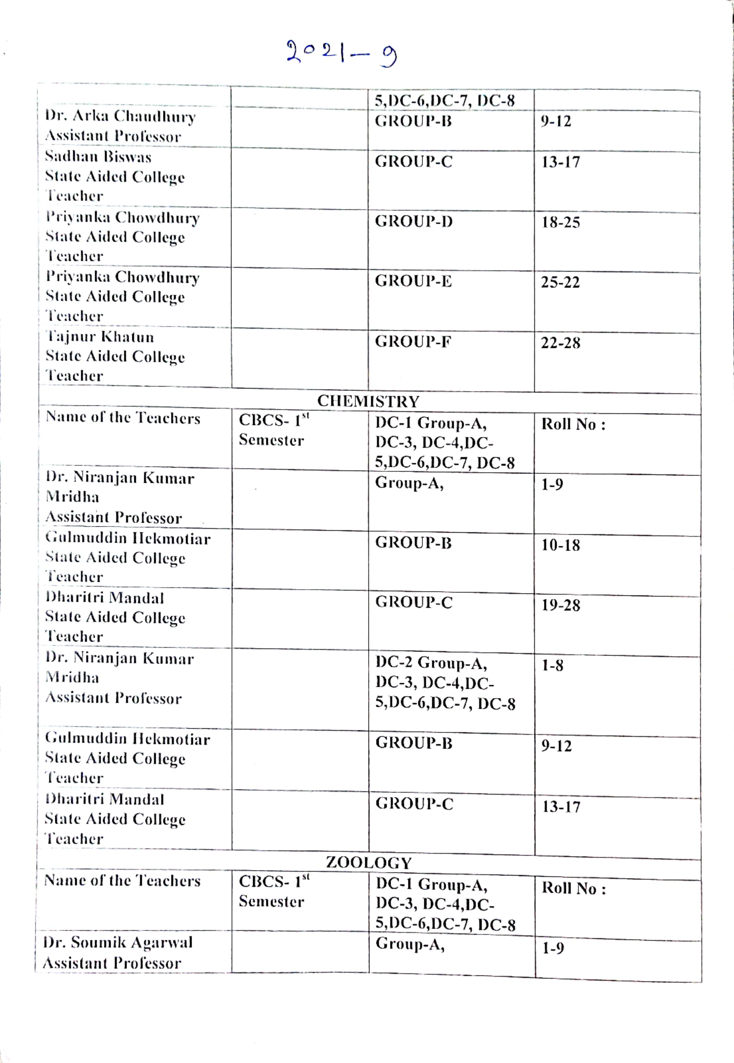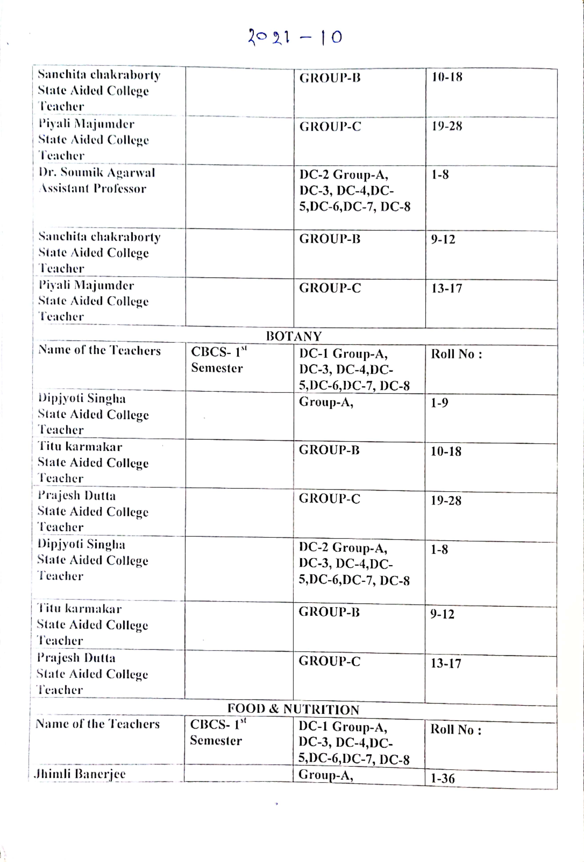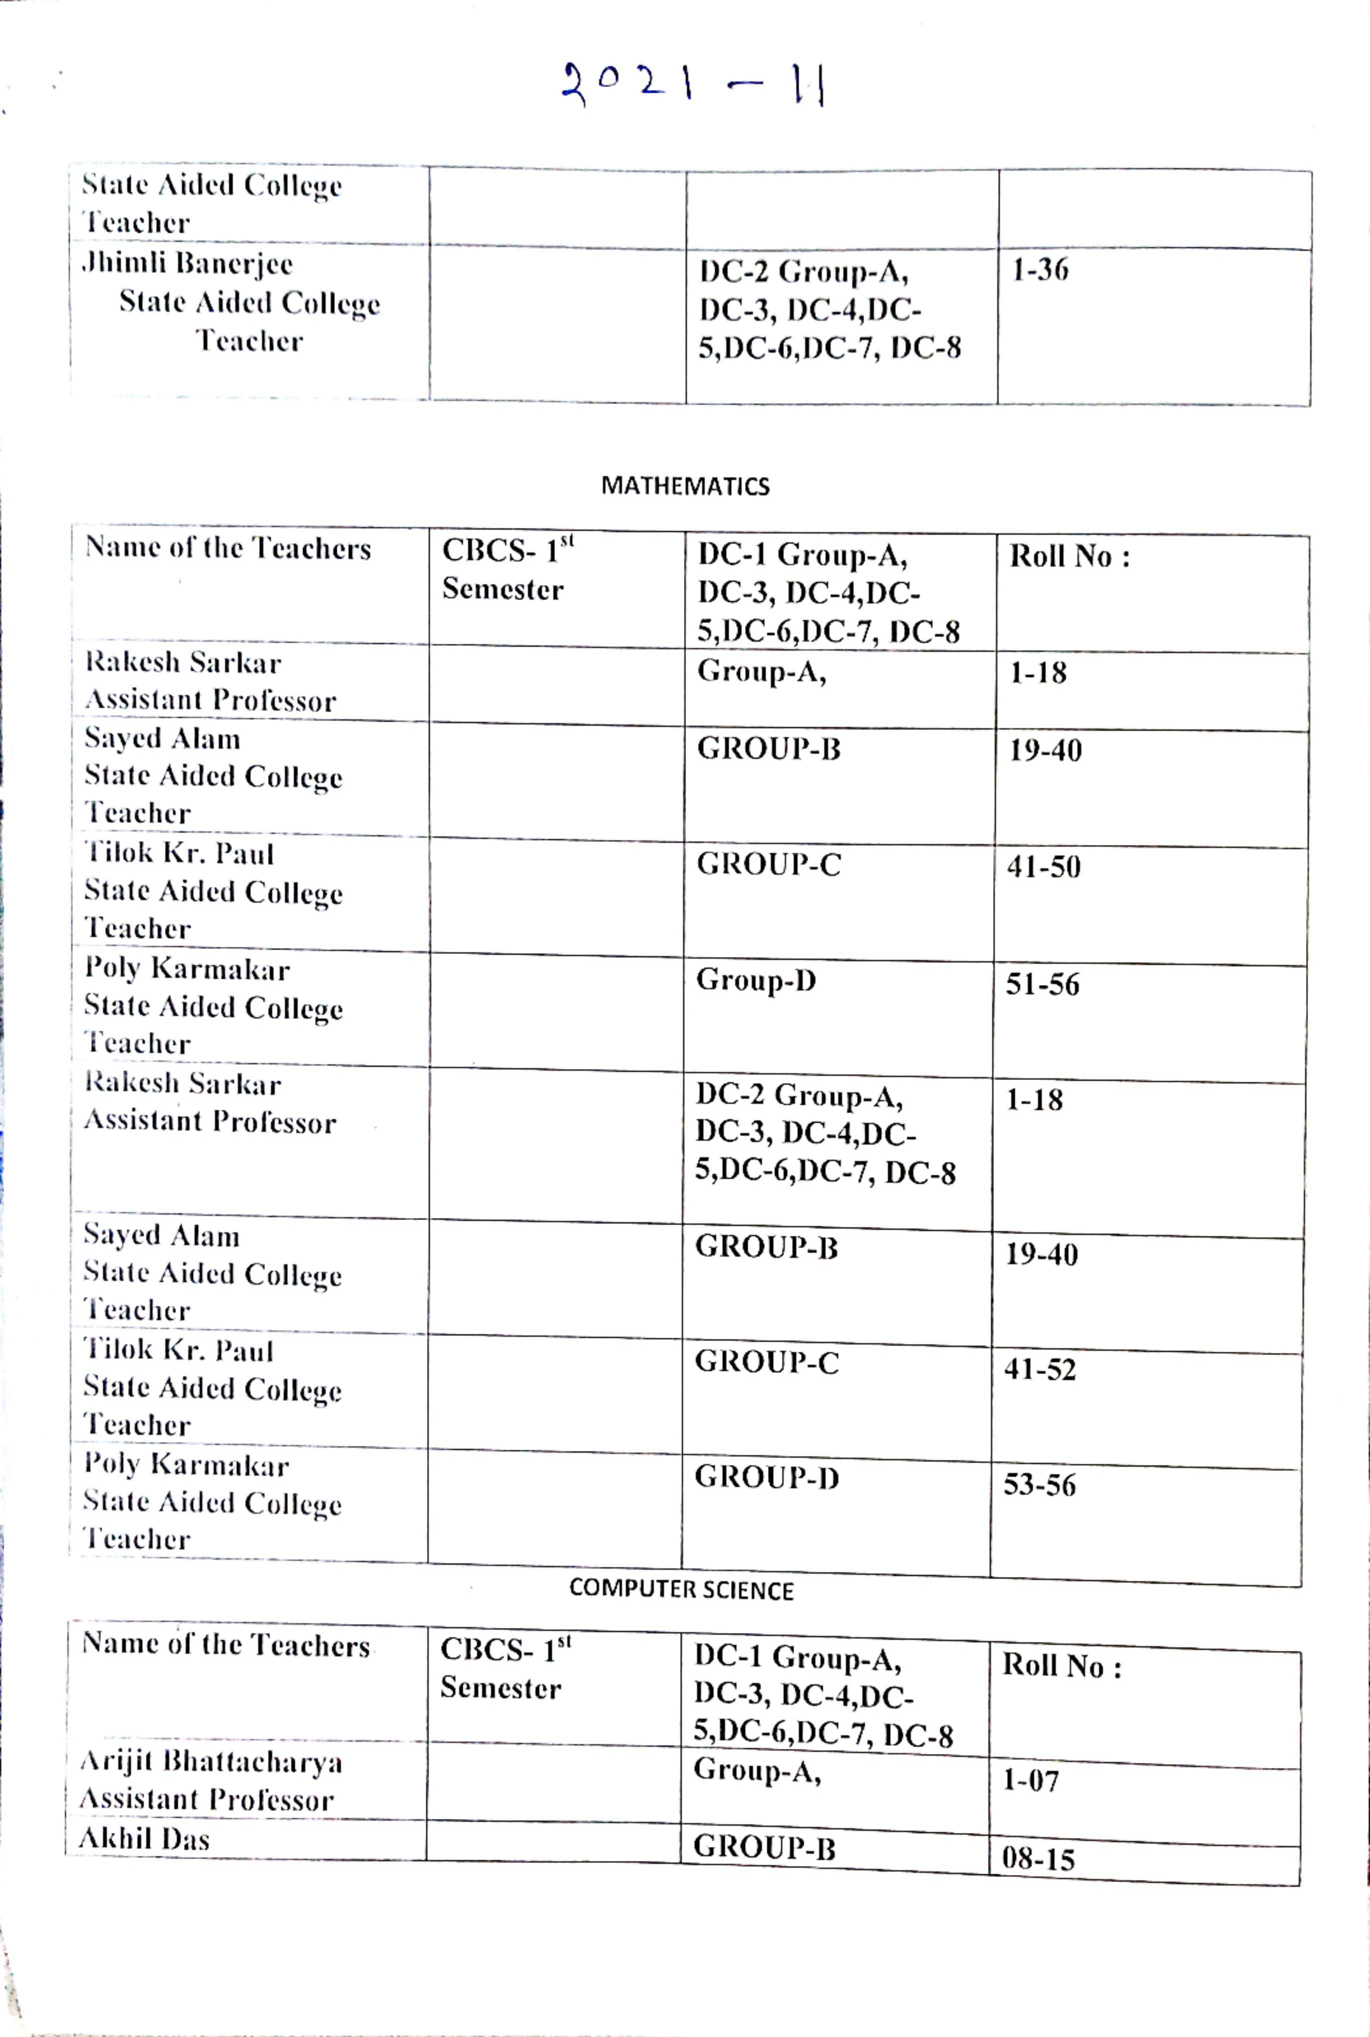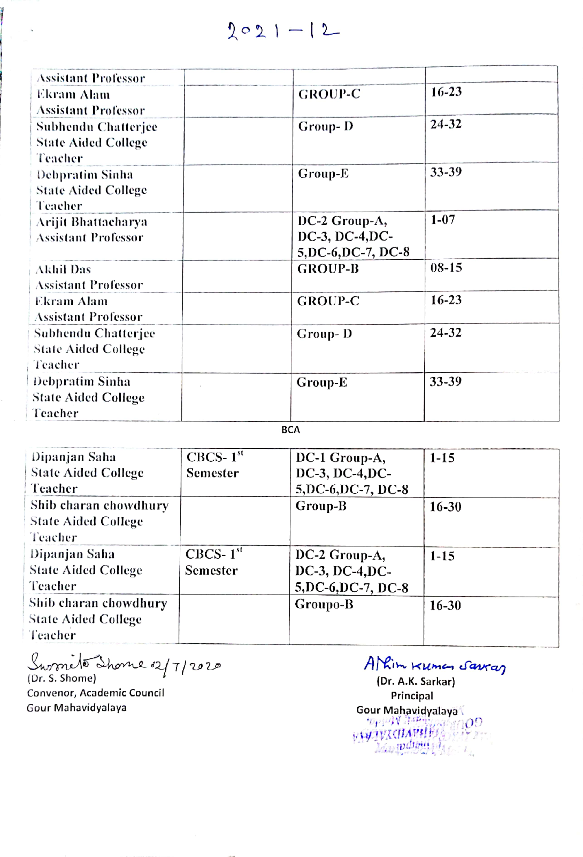

NOTICE

All the faculty members and students of History honours( 2nd Semester,3rd semester and 1st semester are asked to note that their special classes concerning Advanced and Slow learners teaching and learning process would be held from 12.12.2020 to 19.12.2020.
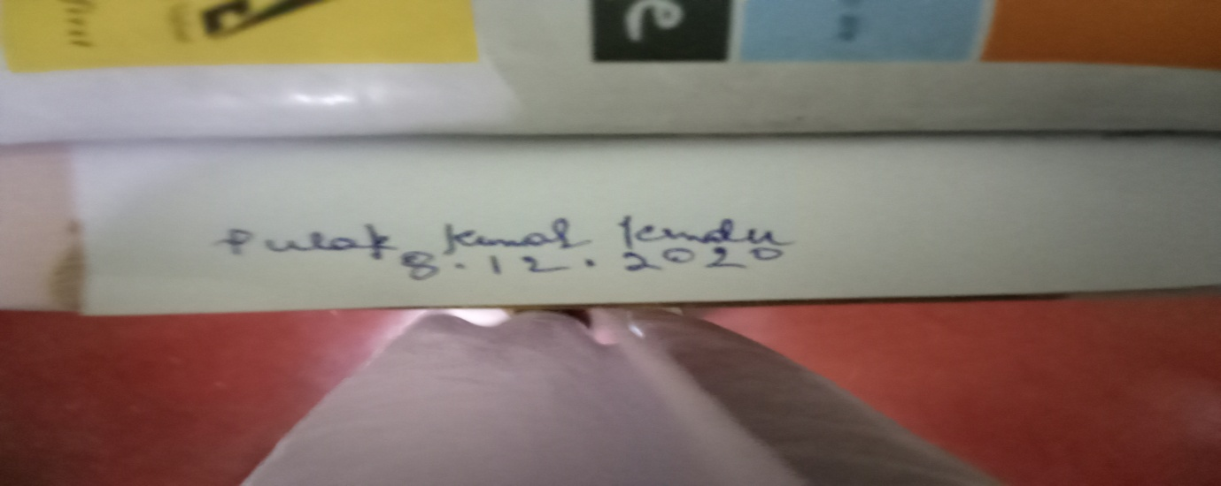

OFFLINE SPECIAL CLASS: ADVANCED AND SLOW LEARNERS:12.12.2020 to 26.12.2020

ADVANCE AND SLOW LEARNERS: CLASS ROUTINE
DATE AND TIME | 2nd SEMESTER | 2nd SEMESTER | 2nd SEMESTER
12.12.2020 | DR.P.K.KUNDU-GROUP-A- 12 Noon to 1 P.M.-DC-3-GROUP-A | DR.S.BISWAS-3 P.M. to 4 P.M.-DC-4-GROUP-B | DR.K.M.MANDAL2 P.M. to 3 P.M.( GROUP-C)
14.12.2020 | ARUNIMA GHOSH-GROUP-D-11 A.M. to 12 NOON- DC-3-GROUP-C |  | S. PANDEY- GROUP-2 P.M. to 3 P.M.-DC-4-GROUP-E
15.12.2020 | DR. P. K.KUNDU- SEM-1-DC-2- 2 P.M. to 3 P.M.-GROUP-A | DR.S.BISWAS-3 P.M. to 4 P.M. –SEM-1-DC-1-GROUP-B | D.K.M.MANDAL- SEM-1-DC-1-4 P.M. to 5 P.M.
16.12.2020 | DR. P.K.KUNDU- SEM-111-11 A.M. to 12 NOON-GROUP-A-DC-7 | DR.S.BISWAS- SEM-111- DC-5- 4 P.M> to 5 P.M. | DR. K.M>MANDAL-SEM-111-DC-6- 2 P.M> to 3 P.M.
17.12.2020 | ARUNIMA GHOSH- SEM-1- GROUP-D- 11 A.M> to 12 NOON | S .PANDEY- SEM-1-DC-11-GROUP-E-2 P.M> to 3 P.M.
18.12.2020 | DR. P.K.KUNDU- SEM-111-11 A.M. to 12 NOON-GROUP-A-DC-7 | DR.S.BISWAS- SEM-111- DC-5- 4 P.M> to 5 P.M. | DR. K.M>MANDAL-SEM-111-DC-6- 2 P.M> to 3 P.M.
19.12.2020 | DR. P.K.KUNDU- SEM-111-11 A.M. to 12 NOON-GROUP-A-DC-7 | DR.S.BISWAS- SEM-111- DC-5- 4 P.M> to 5 P.M. | DR. K.M>MANDAL-SEM-111-DC-6- 2 P.M> to 3 P.M.

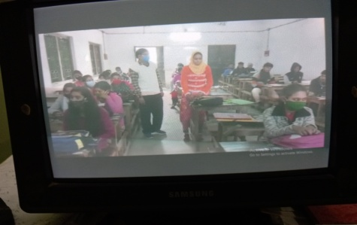  SEMESTER: 1:ADVANCED LEARNERS  12.12.2020: OFFLINE | 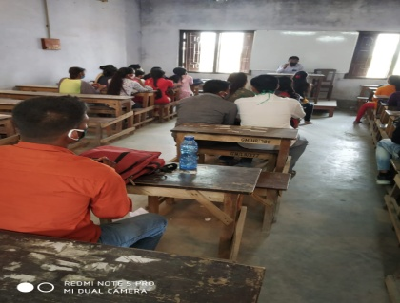  2nd SEMETER: SLOW LEARNERS:18.12.2020: OFFLINE | 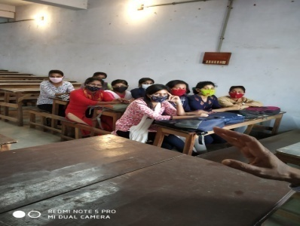  3rd SEMESTER: OFFLINE:14.12.2020

STUDENT-SEMINAR:SUBMISSION OF ASSIGNMENT:2020-2021
NOTICE: HEAD OF THE DEPARTMENT: HISTORY
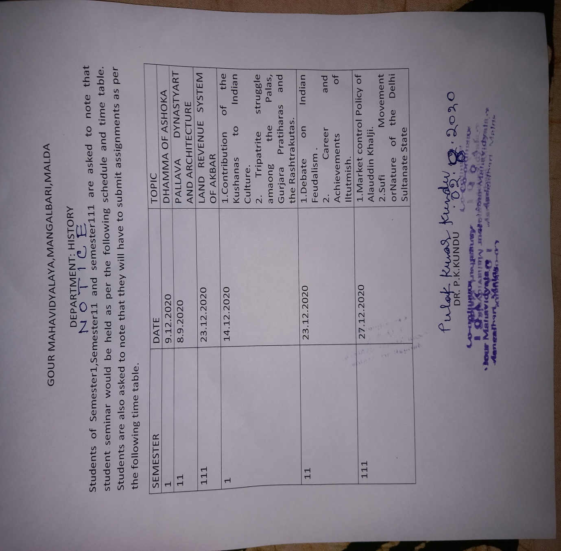

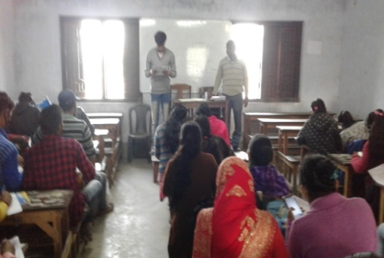
HISTORY:CBCS: STUDENT SEMINAR:OFFLINE:FIRSTSEMESTER:DHAMMA OF ASOKA:09.12.2019
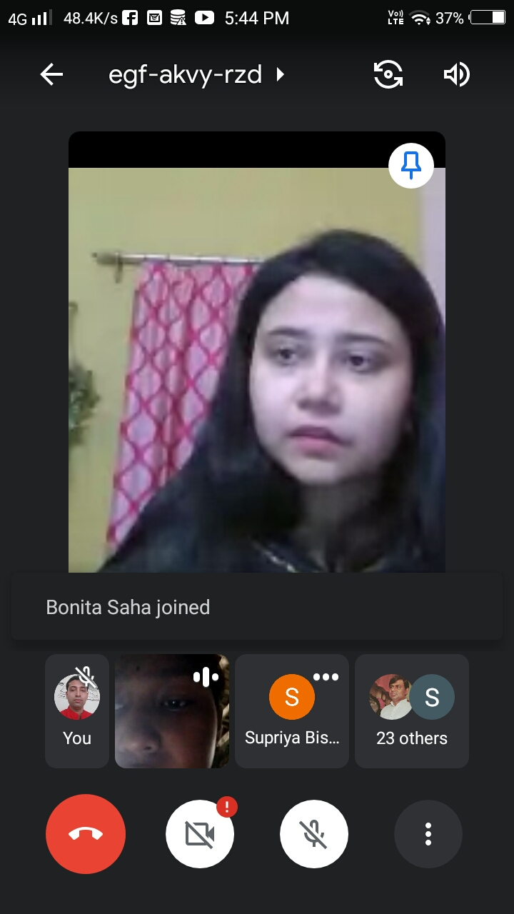
HISTORY:ONLINE:STUDENT SEMINAR:PALLAVA ART:2nd SEMESTER:08.09.2020: GOOGLE MEET: ONLINE
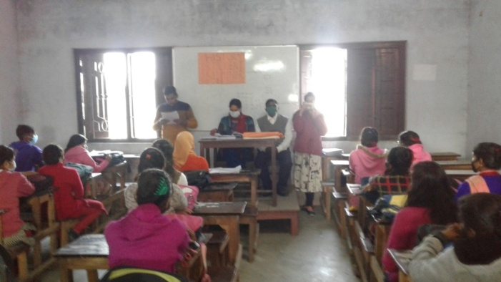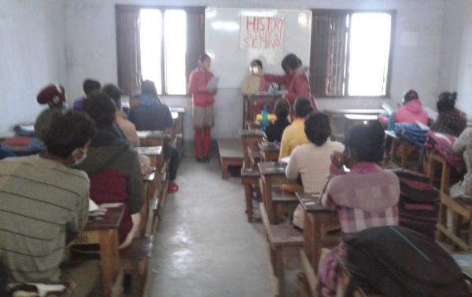
HISTORY:CBCS: STUDENT SEMINAR:OFFLINE:FIRSTSEMESTER:DHAMMA OF ASOKA:09.12.2019
HISTORY:SONLINE:STUDENT SEMINAR:PALLAVA ART:2nd SEMESTER:08.09.2020: GOOGLE MEET: ONLINE.
SEMESTER-111- TOPIC:DC-4:MUGHAL LAND
RVENUE SYSTEM OF AKBAR:23.12.2020.OFFLINE

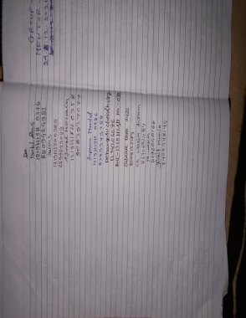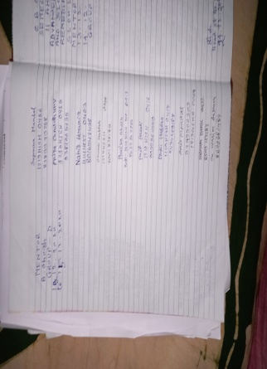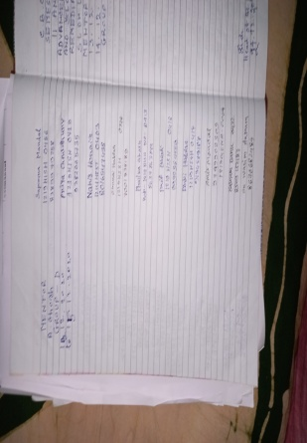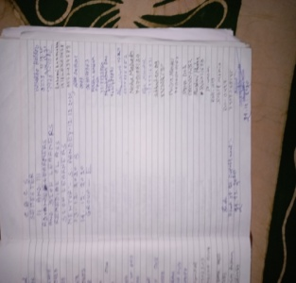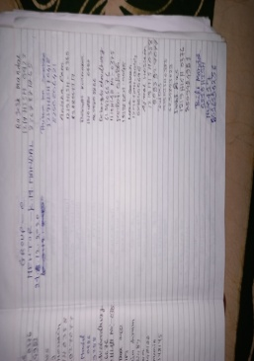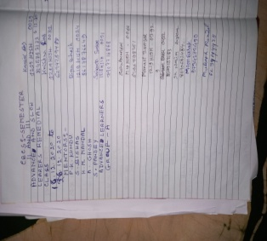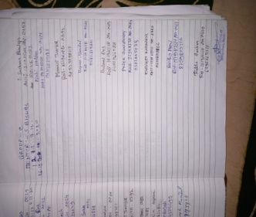
ATTENDANCE: STUDENT: SIGNATURE:

ADVANCED AND SLOW LEARNERS:IDENTIFICATION ON THE BASIS OF RESULT-2020-21
CBCS-SEMESTER-1,11
GROUP-A- TEACHER/MENTOR-DR. PULAK KUMAR KUNDU,ASSOCIATE PROFESSOR
NAME | SEMESTE-1-% -MARKS | CREDIT | SEMESTER-11-% -MARKS | CREDIT | REMARKS
UMME KULSUM | 71% | 133.800 | 84% | 165.000 | IMPROVED-ADVANCED LEARNER
AMAN NANDI-0359 | 71% | 132.800 | 84 | 164.800 | IMPROVED-ADVANCED LEARNER
MOHITOSH SINGHA-0398 | 67% | 123.200 | 80.5% | 159.800 | IMPROVED-SLOWADVANCED LEARNER
SUMI SAHA-0455 | 62% | 132.200 | 82% | 162.800 | IMPROVED-SLOW ADVANCED LEARNER
MOON BASAK-0399 | 65% | 136.800 | 80% | 161.600 | IMPROVED-ADVANCED LEARNER
MUKESH MANDAL-0420 | 64% | 140.000 | 84% | 164% | IMPROVED-ADVANCED LEARNER
POULAMI DAS-0415 | 66% | 134.200 | 82% | 161.200 | IMPROVED-SLOWADVANCED LEARNER
BAPAN MANDAL-0365 | 68% | 132.200 | 82% | 161.200 | IMPROVED-SLOWADVANCED LEARNER
MANASI SANYAL-0392 | 64% | 132.400 | 83% | 162.400 | IMPROVED-SLOWADVANCED LEARNER
CBCS-SEMESTER-1,11
GROUP-B- TEACHER/MENTOR-DR. SUPRIYA BISWAS,ASSISTANT PROFESSOR: ADVANCED AND SLOW ADVANCED LEARNER
NAME | SEMESTE-1-% -MARKS | CREDIT | SEMESTER-11-% -MARKS | CREDIT | REMARKS
JAHANGIR ALAM-0382 | 63% | 133.200 | 74% | 153.600 | SLOW ADVANCED LEARNER
DEBI DAS-0376 | 62% | 132.400 | 80% | 160.400 | ADVANCED LEARNER
MASIDUR ISMAM- | 63% | 133.200 | 80% | 160.400 | ADVANCED LEARNER
AJMAL HOSSAIN-0358 | 64% | 128.400 | 80 | 160.400 | ADVANCED LEARNER
CHOTAN MANDAL-0373 | 66% | 129.400 | 80 | 160.400 | ADVANCED LEARNER
CHAITALI SARKAR | 62% | 132.200 | 82% | 161.600 | ADVANCED LEARNER
PARTHO MANI-0411 | 63% | 134.000 | 82% | 162.800 | ADVANCED LEARNER
JUI DAS-0325 | 67% | 138.000 | 82% | 162.800 | ADVANCED LEARNER
MASIDUR | 63% | 134.000 | 80 | 160.400 | ADVANCED LEARNER
CBCS-SEMESTER-1,11
GROUP-C- TEACHER/MENTOR-DR. KRISHNO MOHAN MANDAL: SLOW LEARNER
NAME | SEMESTE-1-% -MARKS | CREDIT | SEMESTER-11-% -MARKS | CREDIT | REMARKS
SUJIT KARMAKAR-0452 | 52% | 120.800 | 76% | 152.800 | SLOW LEARNER- PROGRESSING
P.GHOSH-0410 | 55% | 123.600 | 76% | 155.200 | SLOW LEARNER- PROGRESSING
P.RAHAMAN | 56% | 122 | 76% | 155.200 | SLOW LEARNER- PROGRESSING
SANTANA MANDAL-0437 | 52% | 112.400 | 76% | 155.200 | SLOW LEARNER- PROGRESSING
SUCHITRA DAS-0448 | 50% | 110.000 | 72% | 147.200 | SLOW LEARNER- PROGRESSING
BIDYUT PAUL--0369 | 56% | 117.200 | 76% | 155.400 | SLOW LEARNER- PROGRESSING
MANDIRA DAS_0393 | 59 | 129.200 | 78% | 158.200 | SLOW LEARNER- PROGRESSING
PHULIKA GHOSH-0413 | 54% | 122.400 | 76% | 155.400 | SLOW LEARNER- PROGRESSING
ABHIJIT HALDAR-0357 | 60% | 123.600 | 76% | 155.400 | SLOW LEARNER- PROGRESSING
BANYATA BASAK-0371 | 57% | 115.200 | 76 | 155.400 | SLOW LEARNER- PROGRESSING
JAYA CHOWDHURY-0781 | 53% | 130 | 78 | 160 | SLOW LEARNER-IMPROVED
BHAGYALIPI MANDAL-0368 | 54% | 123.600 | 76% | 155.400 | SLOW LEARNER- PROGRESSING
BISWAJIT SAMMADAR-0370 | 55% | 134 | 74% | 153.000 | SLOW LEARNER-IMPROVED
SABANA KHATUN | 58% | 136 | 76.5% | 155.600 | SLOW LEARNER- PROGRESSING
TAMA BAIDYA-0460 | 66% |  | 83% | 162.400 | SLOW LEARNER-IMPROVED
CBCS-SEMESTER-1,11
GROUP-D- TEACHER/MENTOR-ARUNIMA GHOSH,STATE AIDED COLLEGE TEACHER: SLOW LEARNER
NAME | SEMESTE-1-% -MARKS | CREDIT | SEMESTER-11-% -MARKS | CREDIT | REMARKS
MRINMOY SAHA-0401 | 53% | 117.600 | 74% | 153.200 | SLOW LEARNER-IMPROVED
WRICK KUMAR DAS-0464 | 54% | 128.800 | 76% | 156.400 | SLOW LEARNER-IMPROVED
SUJIT KARMAKAR-0452 | 52% | 120.800 | 76% | 156.400 | SLOW LEARNER-IMPROVED
JAYA CHOWDHURY-0381 | 53% | 130.000 | 78% | 160.000 | SLOW LEARNER-IMPROVED
SUJIT MANDL-0453 | 59% | 131.600 | 82% | 162.400 | SLOW LEARNER-IMPROVED
RUKSENA KHATUN | 54% | 120.200 | 72% | 150.800 | SLOW LEARNER-IMPROVED
NITYANANDA GHOSH-0406 | 59% | 125.000 | 63.05% | 120.300 | SLOW LEARNER-IMPROVED
SABANA KHAN-0431 | 58.06% | 122.000 | 76.05% | 153.200 | SLOW LEARNER-IMPROVED
BISWAJIT SAMADDAR-0370 | 55% | 124.800 | 74% | 154.000 | SLOW LEARNER-IMPROVED
RUKSENA KHATUN-0428 | 54% | 122.800 | 72% | 150.8000 | SLOW LEARNER-IMPROVED
BANYATA BASAK-0371 | 57% | 125.000 | 76% | 154.800 | SLOW LEARNER-IMPROVED
TAIMUR RAHAMAN-0459 | 56% | 122.400 | 76% | 154.800 | SLOW LEARNER-IMPROVED
P.RAHAMAN-0459 | 56% | 122.400 | 76% | 154.800 | SLOW LEARNER-IMPROVED
CBCS-SEMESTER-1,11
GROUP-E- TEACHER/MENTOR-SAYANTI PANDEY,STATE AIDED COLLEGE TEACHER: SLOW LEARNER
NAME | SEMESTE-1-% -MARKS | CREDIT | SEMESTER-11-% -MARKS | CREDIT | REMARKS
JAYEETA GHOSH-0384 | 49% | 106.800 | 76% | 154.800 | SLOW LEARNER-IMPROVED
PRITAM KUMAR SARKAR | 49% | 107.200 | 68% | 145.600 | SLOW LEARNER-IMPROVED
BEAUTY SHIL-0366 | 50% | 110.400 | 76% | 154.800 | SLOW LEARNER-IMPROVED
ARAB SK-0362 | 43% | 93.200 | 66% | 142.400 | SLOW LEARNER-IMPROVED
PABITRA BARMAN- | 43% | 101.600 | 64% | 138.400 | SLOW LEARNER-IMPROVED
SUJIT MANDAL-0453 | 59% | 131.600 | 82% | 162.400 | SLOW LEARNER-IMPROVED
SUCHITRA DAS-0448 | 50% | 110.400 | 72% | 147.600 | SLOW LEARNER-IMPROVED
RUMA RAJBANSHI | 49% | 110.400 | 76% | 154.800 | SLOW LEARNER-IMPROVED
KAINAJ KHATUN-0386 | 54% | 124.800 | 76% | 154.800 | SLOW LEARNER-IMPROVED
SK WASIM AKRAM-0441 | 52% | 118.000 | 72% | 153.200 | SLOW LEARNER-IMPROVED
ANISHA RAM-0360 | 61.1% | 121.400 | 80% | 150.200 | SLOW LEARNER-IMPROVED
PUJA MANDAL-0421 | 48% | 120.000 | 77% | 157.000 | SLOW LEARNER-IMPROVED
SABNAM BANU-0432 | 59% | 113.200 | 80% | 158.800 | SLOW LEARNER-IMPROVED
PINKI HALDAR-0414 | 56% | 119.600 | 78% | 155.200 | SLOW LEARNER-IMPROVED
SUJAY GHOSH-0451 | 59.05% | 105.200 | 80.05% | 156.400 | SLOW LEARNER-IMPROVED
NAKIR HOSSAIN-0403 | 58% | 103.100 | 76.05% | 153.000 | SLOW LEARNER-IMPROVED
ARINDAM SINGHA-0363 | 54% | 105.200 | 81% | 168.000 | SLOW LEARNER-IMPROVED

NOTICE

All the faculty members and students of History honours( 4th semester and 2nd semester are asked to note that their special classes concerning Advanced and Slow learners teaching and learning process would be held from 19.05.2021 to 22.05.2021.

ADVANCED AND SLOW LKEARNERS: CLASS ROUTINE
DATE AND TIME | SEM-IV-DC-8  DR P.K.KUNDU | SEM-IV-DC-9  DR.S/. BISWAS | SEM-IV-DC-10:  DR. K.M.MANDAL
19.05.2021 | 11.30A.M. to 12.15 P.M.( GROUP-A) | 3 P.M. to 4 P.M.( GROUP-B) | 2 P.M. to 3 P.M.( GROUP-C)
20.05.2021 | ARUNIMA GHOSH-GROUP-D-10 A.M. to 11 A.M. | GROUP- A- DR.P.K.KUNDU-10 A.M.to 11 A.M. | 10. A.M. to 11 A.M. S.PANDEY- GROUP-E
21.05.2021 | 11.30A.M. to 12.15 P.M.( GROUP-A) | 3 P.M. to 4 P.M.( GROUP-B) | 2 P.M. to 3 P.M.( GROUP-C)
22.05.2021 | ARUNIMA GHOSH-GROUP-D-10 A.M. to 11 A.M. | GROUP- A- DR.P.K.KUNDU-10 A.M.to 11 A.M. | 10. A.M. to 11 A.M. S.PANDEY- GROUP-E
22.05.2021 | -- | -- | STUDENT SEMINAR-SEMESTER-IV-3 P.M. to 4 P.M.
20.05.2021 | ARUNIMA GHOSH-GROUP-D-11 A.M. to 12 NOON- SEMESTER-11-DC-3-GROUP-D | GROUP- A- DR.P.K.KUNDU-10 A.M.to 11 A.M.-SEMESTER-11-GROUP- A AND B-DC-4 | SEMESTER-11-10. A.M. to 11 A.M. S.PANDEY- GROUP-E-DC-4
22.05.2021 | DR.P.K.KUNDU-SEMESTER-11- 10 A.M. to 12 NOON- SEMESTER-11-DC-4-GROUP-A | GROUP- A- DR.S.BISWAS-2 P.M.to 3 A.M.-SEMESTER-11-GROUP- B -DC-3 | SEMESTER-11-4 P.M. to 5 P.M. S.PANDEY- GROUP-E-DC-4

ONLINE SPECIAL CLASS:ADVANCED AND SLOW LEARNERS:19.05.2021 to 24.05.2021
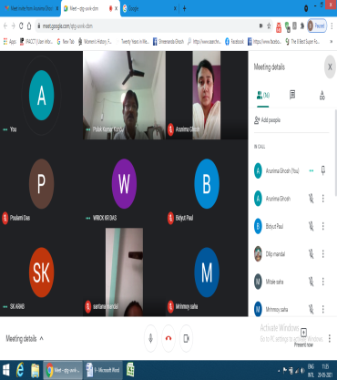  (ClASS: ADVANCED LEARNERS:DR.P.K.KUNDU,ASSOCIATE PROFESSOR: 4-SEMESTER-20.5.2021) | 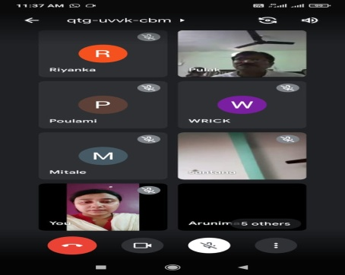  Dr.S.BISWAS, ARUNIMA GHOSH, S.PANDEY: 4th SEMESTER;21.05.2021 | 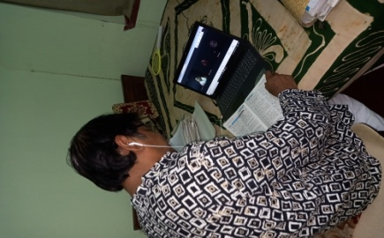  ONLINE CLASS:SEMESTER-2-P.K.KUNDU:21.05.2021
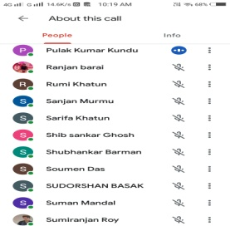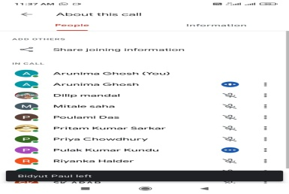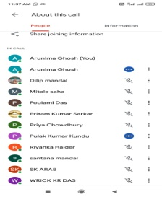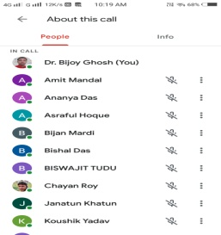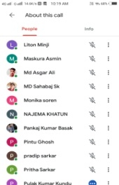
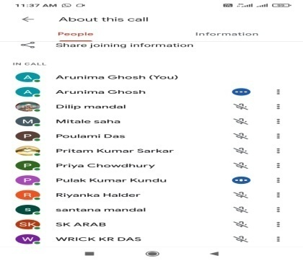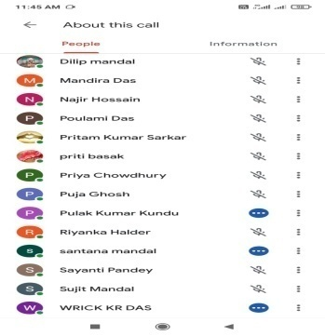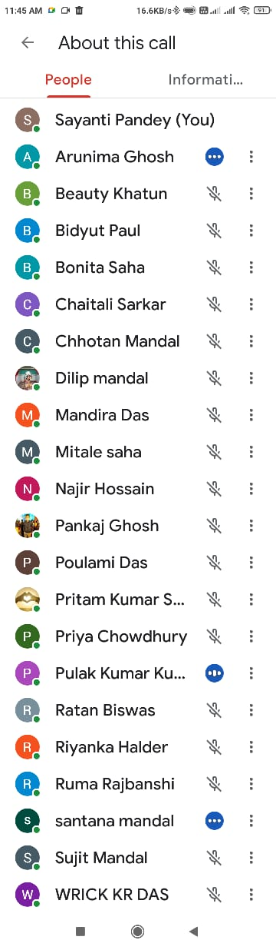

STUDENT SEMINAR-2020-21
NOTICE: HEAD OF THE DEPARTMENT
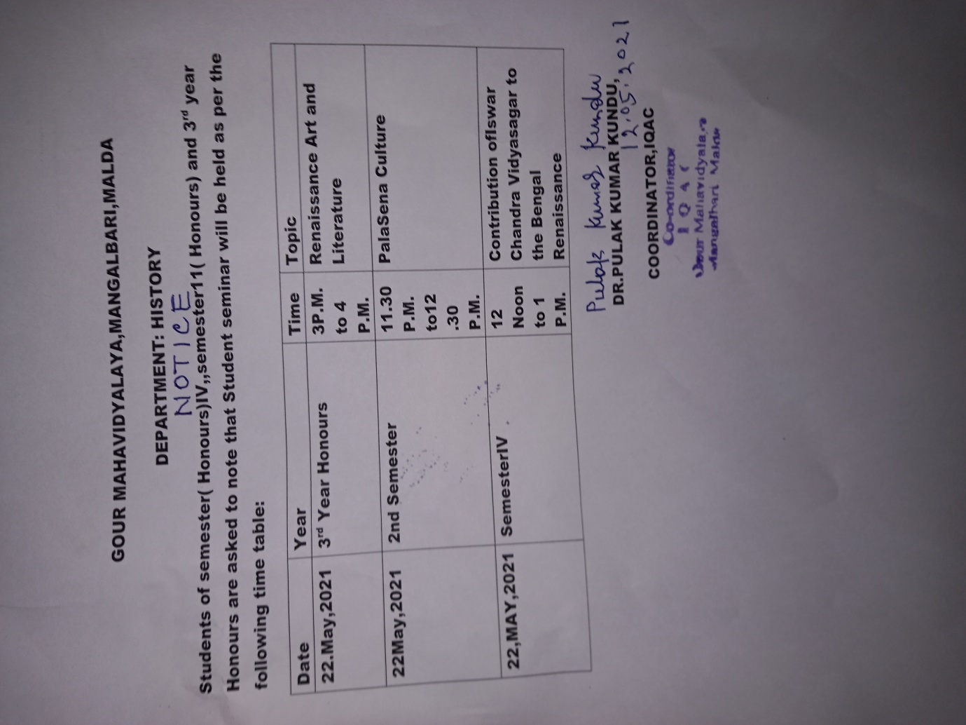
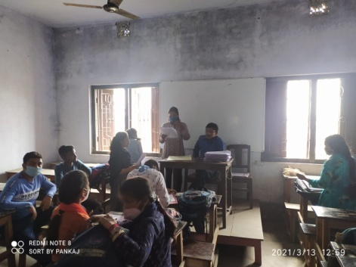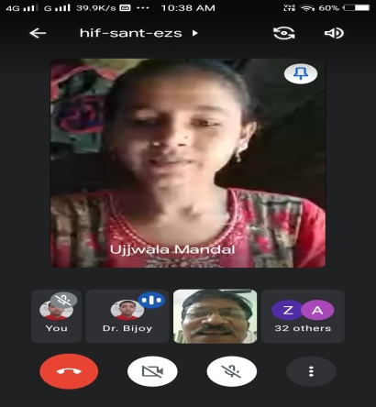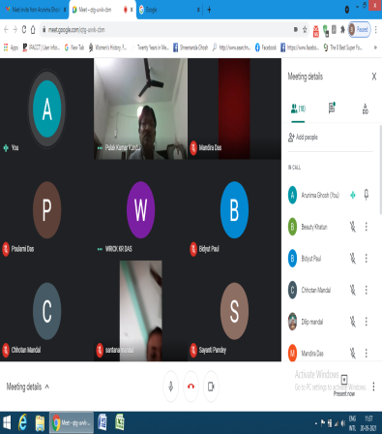
(HISTORY: SEMESTER-1-CEBCS-STUDENT SEMINAR: TOPIC:TOWN PLANNING OF THE HARAPPA CIVILIZATION:20.03.2021: OFFLINE.)
( CBCS: SEMESTER:11: STUDENT SEMINAR: ONLINE: DATE:21.05.2021: TOPIC: EFFECT OF ARAB INVASION)
(STUDENT SEMINAR:SEMESTER:V:TOPIC: NON-COOPERATION MOVEMENT: DATE 20.05.2021: ONLINE)
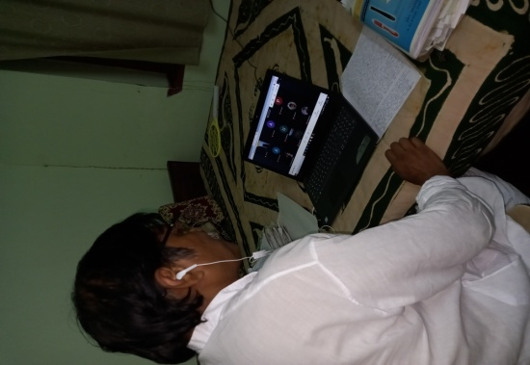 | 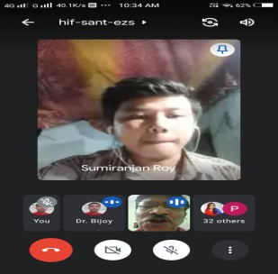 | 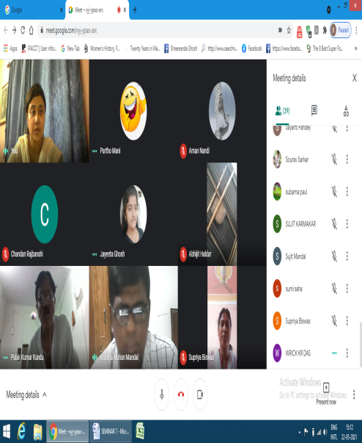
STUDENT-SEMINAR:21.05.2021:3RD YEAR-RANCE ART AND LITERATURE.
STUDENT-SEMINAR:21.05.2021:2ND –SEMESTER-PALA-SENA CULTURE.
STUDENT SEMINAR: SEMESTER-IV- BENGAL RENAISSANCE AND ROLOF ISWAR CHANDRA VIDYASAGAR:22.05.2021
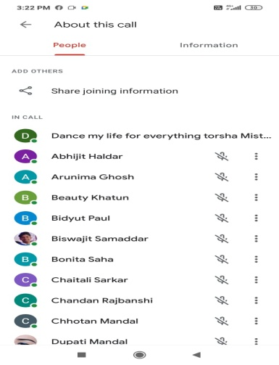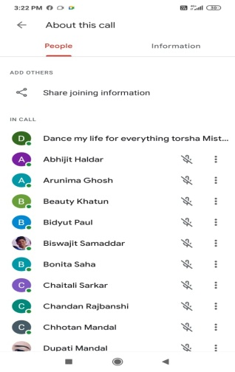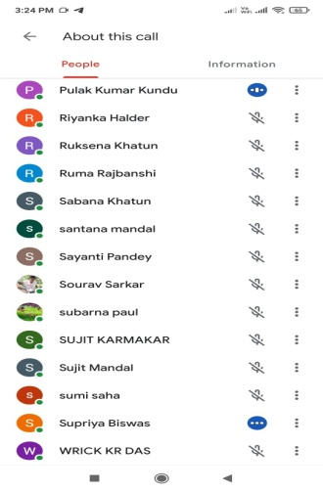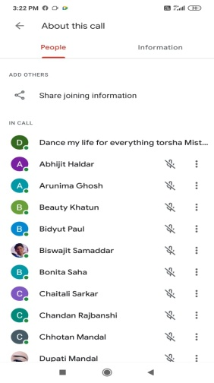
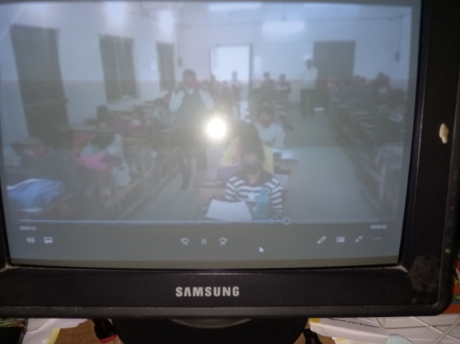
( ASSIGNMENT COLLECTION AND DISUSSION)
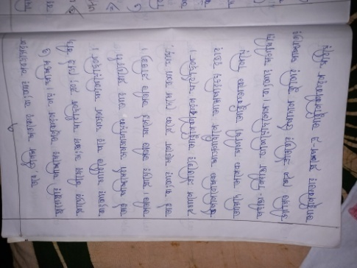
( SEMESTER:4-SHARED FULL ANSWERS OF 12 QUESTIONS-DC-8-DC-9-DC-10-ADVANCED AND SLOW LEARNERS-GOROUP-C,D.E)
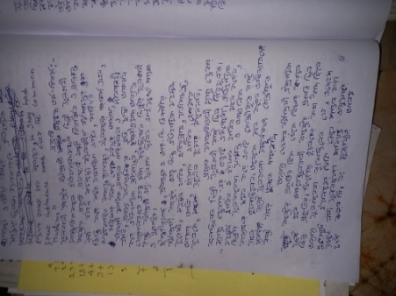
( SEMESTER-11-SHARED FULL ANSWERS OF 4 QUESTIONS-DC-11-SLOW LEARNERS- GROUP-D,E.)
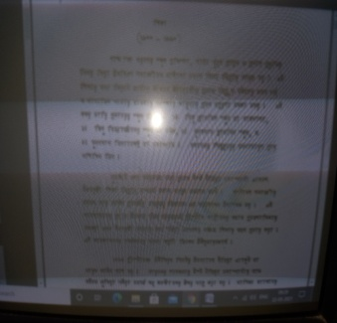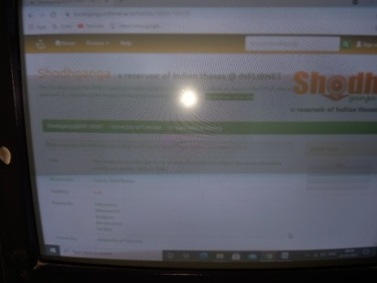
(SEMESTER-4-SHARED STUDY MATERIALS:TOPIC:BENGAL RENAISSANCE:INFLIBNET)
The institution assesses students’ learning levels and organises special programmes for both slow and advanced learners
