Model exhibition on Food & Nutrition depertment

INTRODUCTION:
Exhibition models are a fantastic way to attract customers and explain your products at a trade show or meeting. Exhibition models showcase your products to a client in a clear, simple and compelling way. We use a range of materials, styles, scales and technologies to bring our designs to life.

What Makes a Good Scientific Model?
- Based on reliable observations.
- Able to explain the characteristics of the observations used to formulate it.
- Predictive.
- Able to explain phenomena that were not used to develop the model.
- Able to be refined when new, credible, conflicting observations arise.

PURPOSE OF A MODEL:
1. Models are representations that can aid in defining, analyzing, and communicating a set of concepts. System models are specifically developed to support analysis, specification, design, verification, and validation of a system, as well as to communicate certain information.
2. Exhibitions are typically designed to encourage students to think critically, solve challenging problems, and develop skills such as oral communication, public speaking, research, teamwork, planning, self-sufficiency, goal setting, or technological and online literacy—i.e., skills that will help prepare them
3. A science exhibition is a wonderful tool that engages students in learning new facts. It develops in them the curiosity to learn more which otherwise is not developed by listening to boring lectures. It provides a platform for the students to use their scientific knowledge and bring the best invention from their brains. It also allows students to work together in groups and learn from each other. They share their ideas and collectively galvanize those ideas to bring something innovative into implementation. This further allows the students to develop their social and moral skills and make them a better team player.
4. Modern exhibitions may be concerned with preservation, education and demonstration; early exhibitions were designed to attract public interest and curiosity. Before the widespread adoption of photography the exhibition of a single object could attract large crowds. Visitors might even be overcome with feeling dizzy or overwhelmed by the intense sensory experience of an exhibit. Today, there is still tension between the design of exhibits for educational purposes or for the purpose of attracting and entertaining.
5. Scientific models are used to explain and predict the behaviour of real objects or systems and are used in a variety of scientific disciplines, ranging from physics and chemistry to ecology and the Earth sciences. ... Other models are intended to describe an abstract or hypothetical behavior or phenomenon.

Food & Nutrition MODEL EXIBITION:
Model exhibition meeting: 23/11/21
Date of exhibition: 15 Dec 2021

With a view to encourage, popularize and inculcate scientific temper among the students, Gour Mahavidyalaya organizes college level science exhibition every year where students showcase their thoughts in science and social issues and their applications in different areas related with our everyday life. Students of Dept. of Zoology participate in this exhibition with great enthusiasm.
These exhibitions are real-time demonstrations of how science actually works, or it associates with our daily life. Our students come with various models pertaining to biological sciences. They not only get the opportunity to learn biological concepts in-depth, but they also become habituated to using scientific principles in real life.

Outcome:
The Exhibition encouraged students to think critically and helped to develop oral communication skills, public speaking, research, teamwork, planning, self-sufficiency, goal setting, or technological skills that will help prepare them for future endeavors.

Our models are:
- Eternal Feeding
Presented by students:
Aditi Roy
Karisma Sultana Kadhrin
Sumi Paul
Susmita Rajbanshi
Ananya Dutta
Dipti Paul
- WEIGHT IMBALANCE

Presented by students:

Wasima Sultana
Junayed Jigar
Bidisha Mandal
Priya Biswas
Saikat Poddar
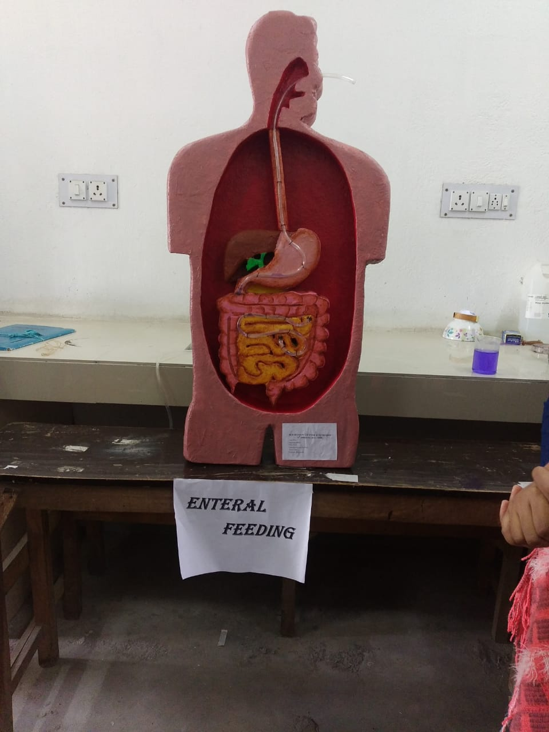
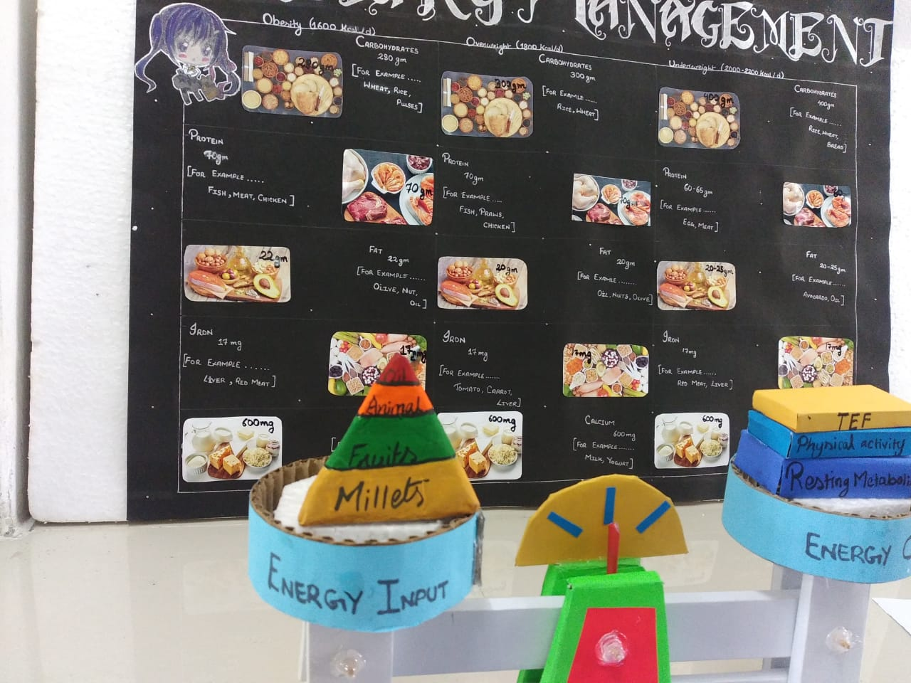
Riju Bhowmick
FIGURE: MODEL EXIBITION AT DEPERTMENT Food & Nutrition

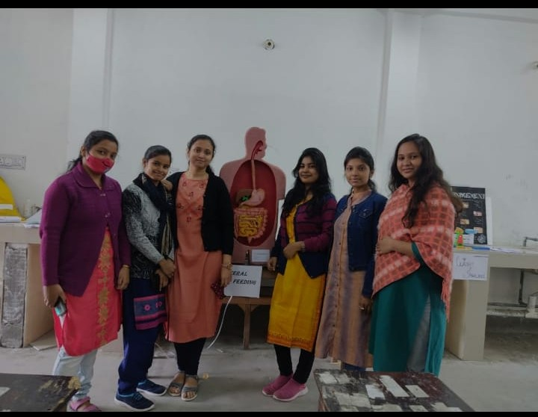
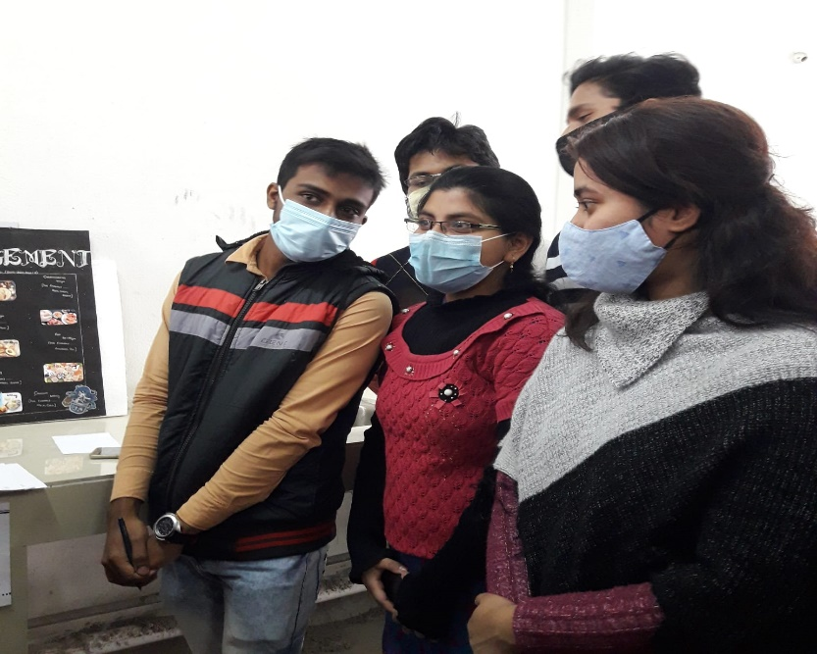
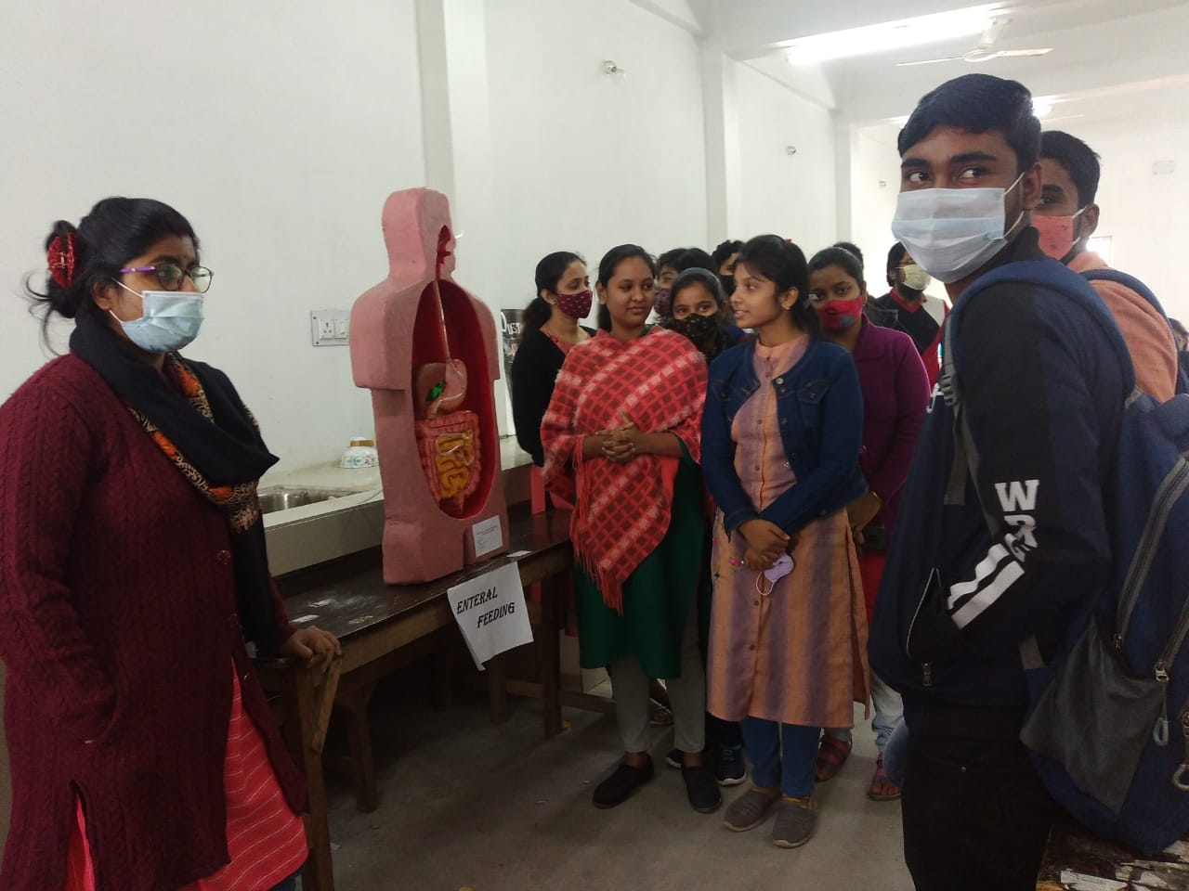
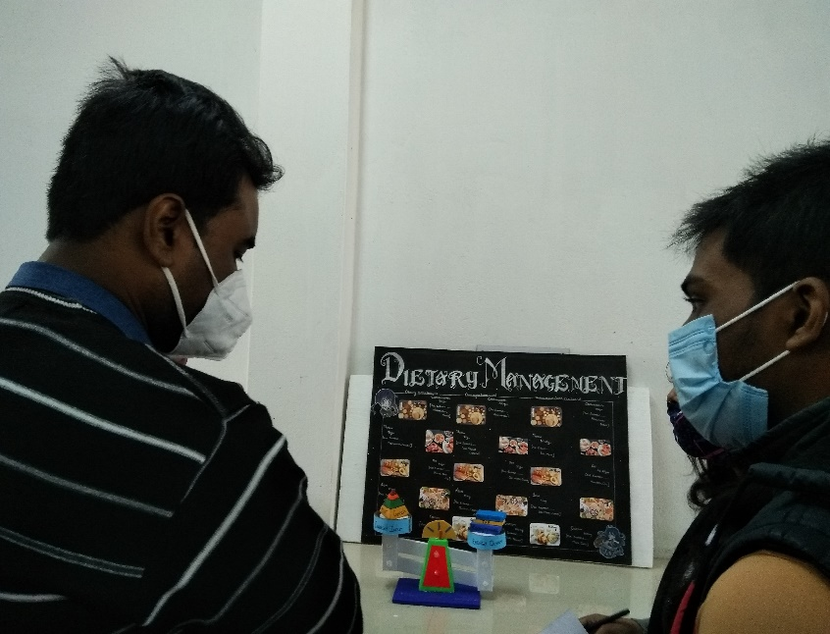
FIGURE: MODEL EXIBITION AT DEPERTMENT Food & Nutrition

FIGURE: MODEL EXIBITION AT DEPERTMENT OF ZOOLOGY

