Student seminar in Department of Food & Nutrition and Zoology
Seminar Theme
This seminar will explore hot topics of biology, study of living things and their vital processes. The majority of the seminar will be focused on written and oral debates on questions concerning the field deals with all the physicochemical aspects of life. It provides an in-depth, scientific understanding of how all living and non-living organisms interact with each other and gives insights into how diverse life forms are. Moreover, biology encompasses other fields of research that are related to the sustainability of life, including the environment, ecosystem, food quality, causes of illnesses, the development of medicines, the study of the human body. The modern tendency toward cross-disciplinary research and the unification of scientific knowledge and investigation from different fields has resulted in significant overlap of the field of biology with other scientific disciplines. Modern principles of other fields—chemistry, medicine, and physics, computer for example—are integrated with those of biology in areas such as biochemistry, bio medicine, biophysics and bioinformatics.

Food & Nutrition Student Seminar
Seminar meeting notice: 21/12/21
Seminar meeting: 23/12/21
Date of Seminar: 18/12/22 and 20/12/22

Student Learning Outcomes

The seminar in Biological Science is intended to be the capstone for BSC’s bachelors’ programs in Zoology and Food & Nutrition. Students completing the seminar should be able to: 1. organize and orally communicate comprehensive scientific information in a logical and effective manner to peers. 2. demonstrate an ability to critically read, reflect upon, and summarize science essays. 3. demonstrate the ability to evaluate oral presentations of peers.

Documents Related Student Seminar
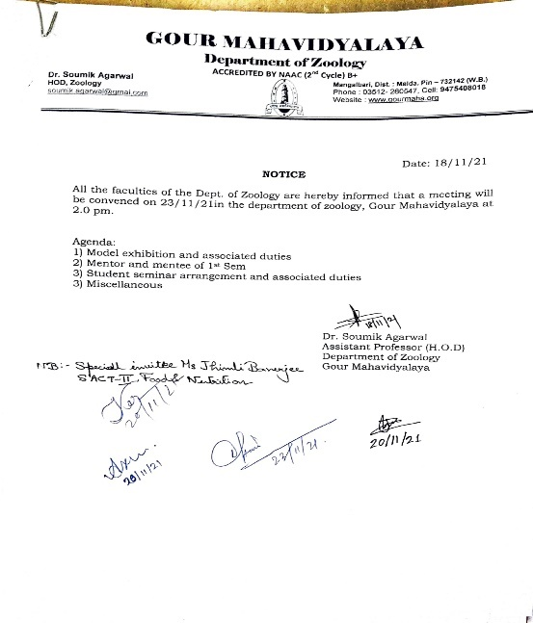
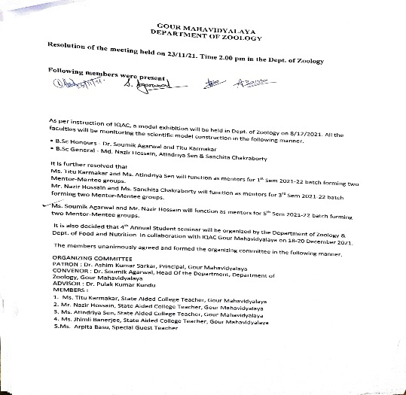
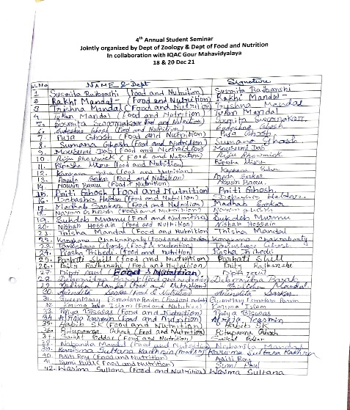
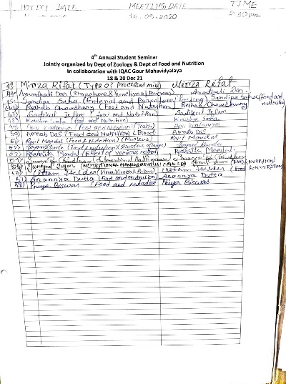
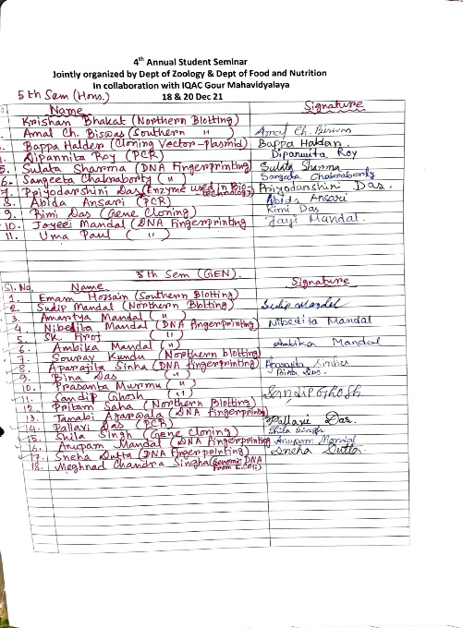
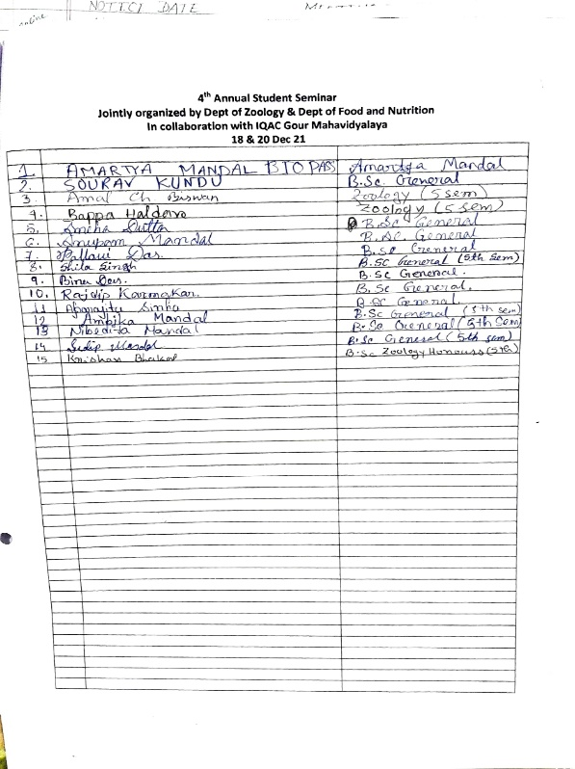

Pictures of Student seminar
