STUDENT FILM FESTIVAL 2019
  - organised by cinebus, Gour mahavidyalaya Cine-club (A Department of English Initiative)
(
  - Cinebus
Watch Think Resist
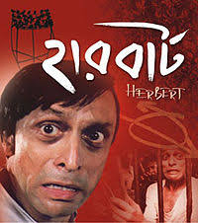
Date- 26-02-2019

Schedule

Session 1

Opening Address by the Principal, Gour Mahavidyalaya
What is Cinema? Why Cinema? 10.30 – 10.45 A.M.

Herbert (2005, Suman Mukhopadhyaya) 10.45 A. M. - 1 P.M.
Discussion by A. Sarkar, N.S. Barma & N.S. Mridha 1- 1.15 P.M.

Lunch Break (self-sponsored)

Session 2

Fandry (2013, Nagraj Manjule) 2 P.M. to 3.45 P.M.
Discussion by M. Alam & K. Goswami 3.45-4 P.M.

Tea Break

Session 3

The Employment (short film) 4.30 P.M.- 4.35 P.M.
(Image Courtesy Google)

